

1. Windows Server 2008 R2 Developer Lab Series
2. Solving Concurrency Issues with the Parallel Debuger and Parallel Performance Analyzer
3. Lab version: 1.0.0
4. Last updated: 4/16/2010
5. 

Contents

Introduction 5

Exercise-1 Background 6

Debugging Basics 8

Parallel Stacks 10

Parallel Tasks 13

Leap Years 16

Leap Year Implementation 18

Exercise-1: Single Stepping with the Parallel Debugger 20

Part 1: Running the application 21

Part 2: Debugging the application 25

Part 3: Fixing the application 35

Part 4: Extra Credit 37

Exercise-1 Conclusion 38

Exercise-2 Background 39

Critical Section 40

Semaphores 41

Locks 42

Deadlocks 43

Deadlock Conditions 45

Exercise-2: Visualizing Deadlocks 47

Part 1: Running the application 48

Part 2: Debugging the Application 51

Part 3: Fix the Application 61

Part 4: Extra Credit 63

Exercise-2 Conclusion 65

Exercise-3 Background 66

Lock overhead 66

Locks granularity 66

Lock contention 66

Mutual exclusion 67

Locks disadvantages 68

Lock Convoys 70

Concurrency Visualizer 72

Lock Contention under Concurrency Visualizer 74

Lock Convoys under Concurrency Visualizer 76

Commands to protect critical sections 79

Exercise-3: Lock Convoys 81

Part 1: Running the application 82

Part 2: Debugging the Application 87

Part 3: Using the Performance Profiler Analyzer 95

Part 4: Fix the application 110

Part 5: Extra Credit 117

Exercise-3 Conclusion 121

Exercise-4 Background 122

Oversubscription 123

Context switches 124

Oversubscription under Threads View 125

Concurrency Runtime 127

Task Parallel Library 128

PLINQ 130

Exercise-4: Oversubscription 131

Part 1: Running the application 132

Part 2: Debugging the Application 136

Part 3: Using the Performance Profiler Analyzer 139

Part 4: Tune up the application 146

Part 5: Extra Credit 152

Exercise-4 Conclusion 154

Exercise-5 Background 156

Exercise-5: Increasing Efficiency with Parallel Containers 157

Part 1: Fixing the Data Race 158

Part 2: Running the PPA 160

Part 3: Fixing the Synchronization Problem 166

Exercise-5 Conclusion 168

* 1. 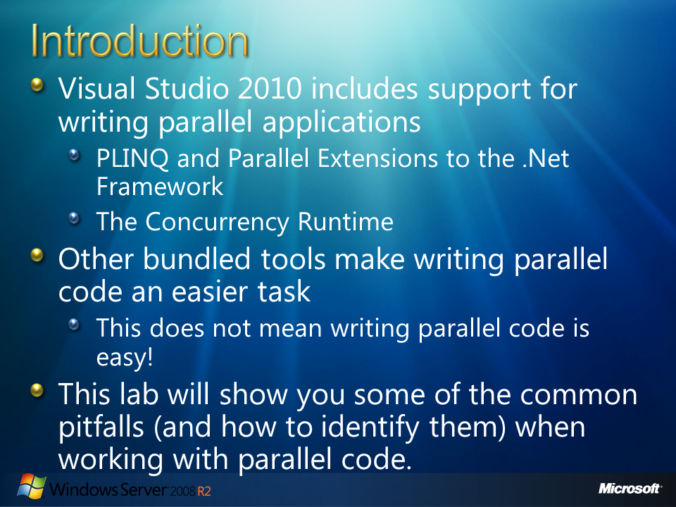
  2. Figure

# Introduction

* 1. One of the clear differences between the release of Visual Studio 2010 and any of its predecessors is the support that is included for developing parallel applications. If you are a .Net developer, the 4.0 .Net Framework includes PLINQ and the Parallel Extension Support. If you are a C++ developer, you can take advantage of the Concurrency Runtime to make the most out of any multi-core machine.
  2. Regardless of your programming platform, if you want your application to scale with new many-core machines, you must write code that executes in parallel. If you ask anyone who has ever worked with parallel code, they will undoubtedly testify that writing, testing, and debugging parallel code is not easy endeavor. This is oftentimes true, as we do not tend to think in parallel and, to make matters worse, parallel programming includes a new set of programming pitfalls that we, as serial developers, can easily fall prey to.
  3. In this lab we will become acquainted with some of these pitfalls. The examples provided here are simple and in resemble in a small scale the issues that you may face when writing your next application. The purpose of this lab is to show you common patterns that you may face when writing parallel code and how to efficiently identify them. Even though the fixes to the problems presented in this lab are simple, keep in mind that your real-life problems will be a lot more complex to figure out.
  4. 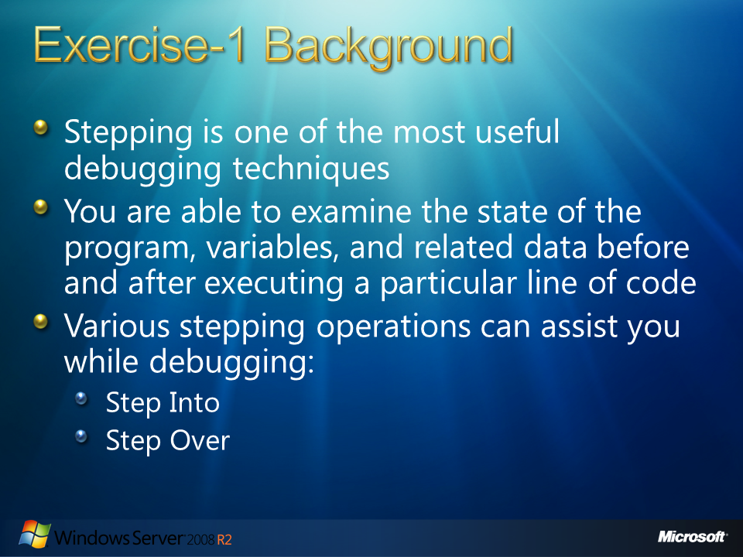
  5. Figure

# Exercise-1 Background

* 1. One of the most common debugging procedures is **stepping**. Stepping means to execute code line per line at a time. When you are debugging under this scheme, you are able to examine the state of the program, variables, and related data before and after executing a particular line of code. This allows you to evaluate the effects of an instruction in isolation, understanding the behavior of the program. In order to use stepping debugging, you can access the Debug menu and make use of any of the three commands: Step Into, Step Over, or Step Out.
  2. Step Into and Step Over instructs the debugger to execute the next line of code, if the line corresponds to a function, Step Into executes only the call itself, then halts at the first line of code inside the function. On the other hand, Step Over executes the entire function, then halts at the first line outside the function.
  3. You use Step Into if you want to look inside the function call. But, if you want to avoid stepping into functions, you use Step Over. On a nested function call, Step Into steps into the most deeply nested function.
  4. When you are inside a function call and want to return to the calling function, you use Step Out. Step Out resumes execution of your code until the function returns, then it breaks at the return point in the calling function.
  5. You cannot access the Step commands if your application is running. Step commands are valid only in break mode or before you start the application.
  6. For detailed information about stepping under Visual Studio visit the MSDN site at <http://msdn.microsoft.com/en-us/library/ek13f001(VS.71).aspx>
  7. 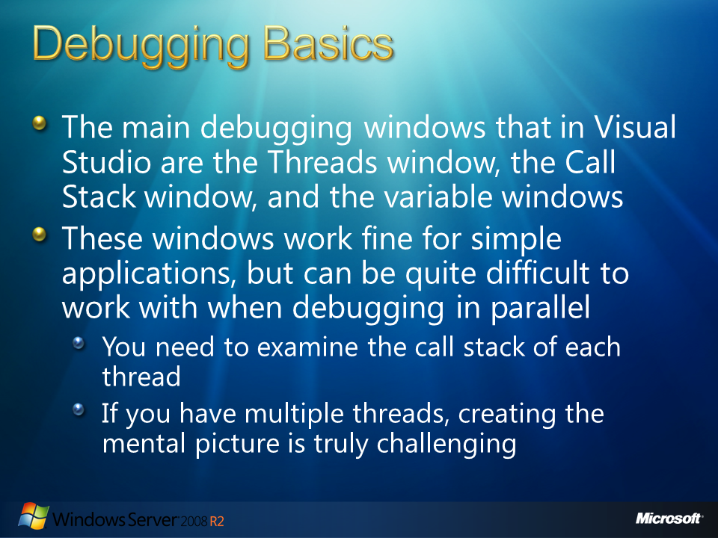
  8. Figure

## Debugging Basics

* 1. When you plan to start debugging an application with Visual Studio, you can either attach to an open project in Visual Studio (by pressing F5 or Debug > Start Debugging command) or you can also manually attach the debugger to a process by choosing Debug > Attach to Process. Once the debugger is attached, the next step is to break into the debugger. This can occur by including a user-defined break point, manually breaking (Debug > Break All command), the process requests the breakpoint (in managed code the application can call to the System.Diagnostics.Debugger.Break method), or even when an exception is thrown.
  2. After the process breaks into the debugger, all the threads in your application are halted. This halt in execution allows you to inspect the state of your application at a particular moment.
  3. The main debugging windows that developers use in Visual Studio are the Threads window, the Call Stack window, and the variable windows (Locals, Autos, Watch respectively). The Threads window displays a list of all the threads in your process, including the thread ID and thread priority and an indication (a yellow arrow) of the current thread, which by default is the thread that was executing when the debugger broke into the process. The Call Stack reveals the method calls that the thread was in the process of executing before reaching the current location.
  4. The variable windows are used to inspect the values of variables in your application. The variables of local methods are usually browsed in the Locals and Autos windows; global state (variables not declared in a method) can be examined by adding them to the Watch window. You can also hover your mouse pointer over a variable of interest and review the resulting pop-up.
  5. To examine variables that were in-scope earlier in the call stack of the thread, you need to change the current stack frame by double-clicking the stack frame you want to examine in the Call Stack window. The new current stack frame is indicated by a green curved tail arrow, while the active stack frame retains the yellow arrow.
  6. The problem with this window, under Parallel applications, is that in order, to create a complete picture of where all your threads are executing you need to individually examine the calls stack of each thread by double-clicking each thread to make it current. Once you have done that, you must look at the Call Stack window, and so on try to create the complete mental picture of your concurrent application. When applications use more threads, you need to be able to see in a single view where those threads are executing at any given moment, here is where Parallel Stacks and Parallel Tasks come to help.
  7. 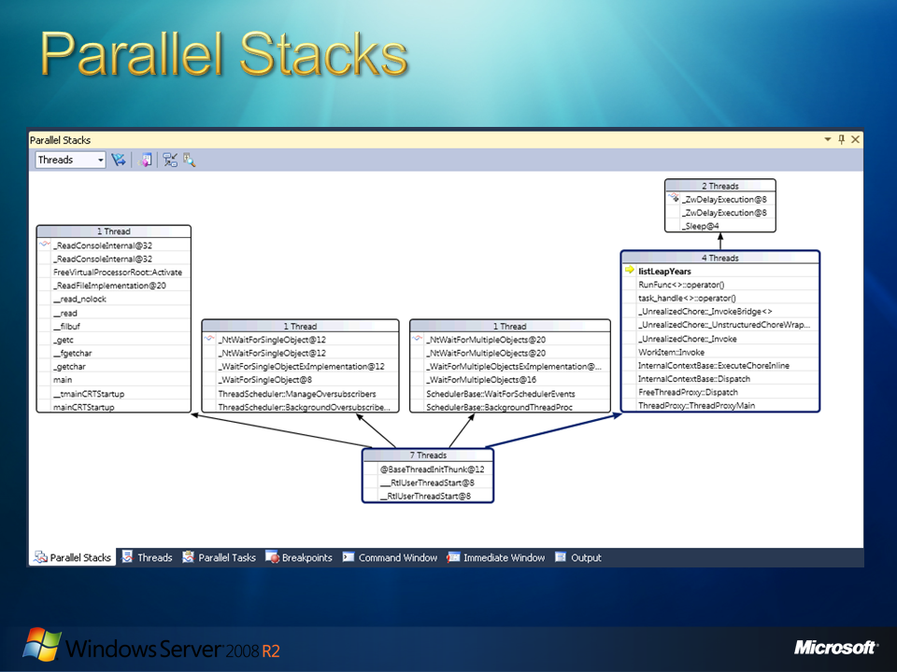
  8. Figure

## Parallel Stacks

* 1. The Parallel Stacks window under Visual Studio 2010 is useful when you are debugging multithreaded applications. Its **Threads View** shows call stack information for all the threads in your application.
  2. Parallel Stacks lets you navigate between threads and stack frames on those threads. In order to indicate methods of particular interest to parallelism scenarios, the window coalesces into the same node the call stack segments that are common among threads at their root.
  3. 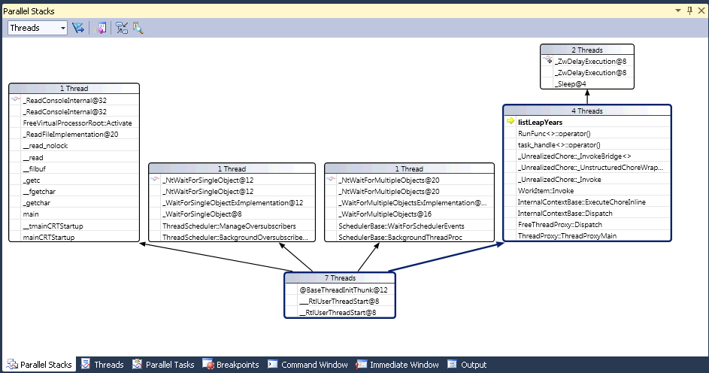
  4. Figure
  5. Parallel Stacks -
  6. In the previous figure, you can see the call stacks of various threads in a single view. This window supports zoom, filtering of threads via flagging, and most of the same functionality already available in the Call Stack window.
  7. If your application creates tasks rather than threads, you can switch to a task-centric view.
  8. 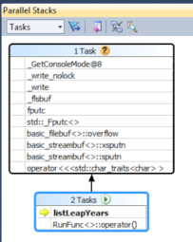
  9. Figure
  10. Parallel Stacks, Task Centric View
  11. With this view, call stacks of threads not executing tasks are omitted. Additionally, call stacks for threads are trimmed to represent the real call stacks of tasks. A special feature of the Parallel Stacks window allows you to pivot the diagram on a single method and clearly observe the callers and callees of that method context.
  12. For a full description on Parallel Stacks, visit the MSDN information named **Using the Parallel Stacks Window:** <http://msdn.microsoft.com/en-us/library/dd998398%28VS.100%29.aspx>
  13. 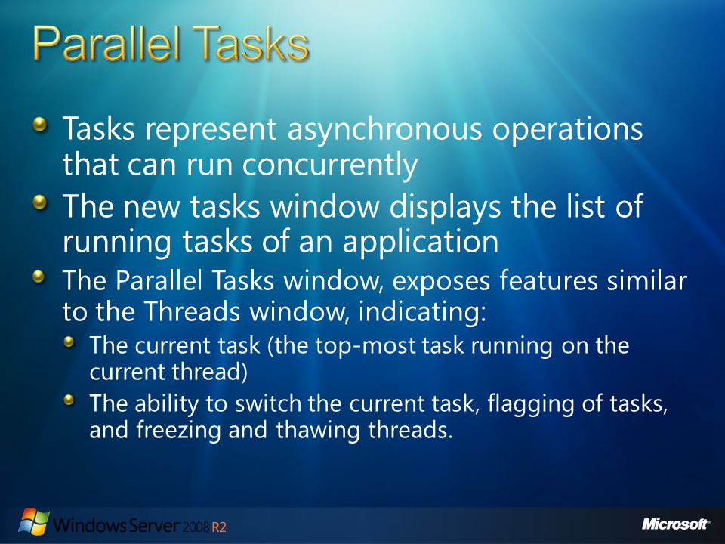
  14. Figure

## Parallel Tasks

* 1. In order to support the task-based programming model introduced with Visual Studio 2010, a new debugger window has been introduced. This debugger window is the **Parallel Tasks**. You can use the Parallel Tasks window whenever you break into the debugger. You can access it by clicking Windows on the Debug menu and then clicking Parallel Tasks.
  2. The Parallel Tasks window is very similar to the Threads window, except that it shows information about each **System.Threading.Tasks.Task** or **task_handle** object, instead of each thread. Like threads, tasks represent asynchronous operations that can run concurrently; however, multiple tasks may run on the same thread.
  3. Remember that **managed code** is code that has its execution managed by the .NET Framework Common Language Runtime. Managed Code is what Visual Basic .NET and C# compilers create and it compiles to Intermediate Language (IL). Managed code runs in the Common Language Runtime. Visual Basic .NET and C# can produce only managed code. At any point of execution, the runtime may stop an executing CPU and retrieve information specific to the current CPU instruction address. In managed code, you can use the Parallel Tasks window when you work with **System.Threading.Tasks.Task** objects.
  4. Under Visual C++ you can deliberately choose not to use the runtime. Instead, the code runs natively on the machine. This is known as **native code**. In native code, you can use the Parallel Tasks window when you work with task groups, parallel algorithms, asynchronous agents, and lightweight tasks.
  5. In this window, a list of the running Tasks is presented. You can read each task ID, the ID and name of the thread that runs it, and its location (hovering over that displays a tooltip that has the whole call stack). Also, under the Task column, you can see the method that was passed into the task (the entry point, known as the **delegate**, passed to the task at creation).
  6. 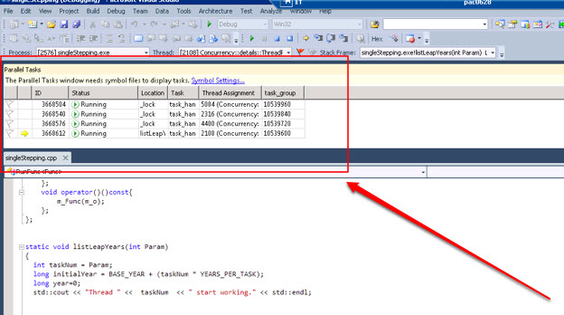
  7. Figure
  8. Parallel Tasks Window
  9. Within the parallel tasks windows, you can sort any column. You can also reorder the columns by dragging them left or right. The yellow arrow indicates the current task. You can switch tasks by double-clicking a task or by using the shortcut menu. When you switch tasks, the underlying thread becomes current and the other windows are updated. If you manually switch from one task to another, the yellow arrow moves, but a white arrow still shows the task that caused the debugger to break.
  10. The Parallel Tasks window, exposes features similar to the Threads window, like indicating the current task (the top-most task running on the current thread), the ability to switch the current task, flagging of tasks, and freezing and thawing threads.
  11. 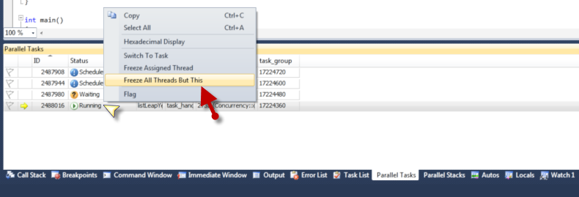
  12. Figure
  13. Parallel Tasks
  14. One of the biggest value to developers is the Status column. The information provided in the Status column allows you to distinguish running tasks and tasks that are waiting on another task or on a synchronization primitive. It also helps you identify tasks that are deadlocked. Scheduled tasks are also displayed (tasks that have not run yet but are sitting in some queue waiting to be executed by a thread)
  15. For a full description on Parallel Stacks, visit the MSDN article: **Using the Parallel Tasks Window** at <http://msdn.microsoft.com/en-us/library/dd998369(VS.100).aspx>
  16. 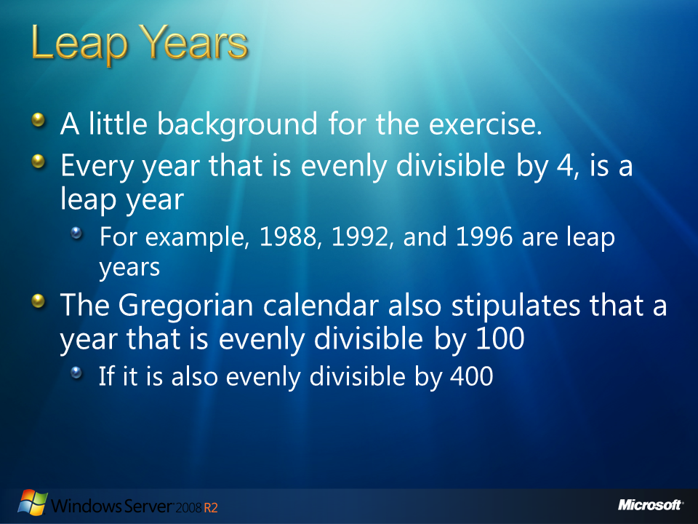
  17. Figure

## Leap Years

* 1. For the purpose of the first exercise we are going to work on an application intended to generate leap years within a specific range of years. Let's see some of the definitions for working with leap years.
  2. In the Gregorian calendar, a normal year consists of 365 days. But the time required for the Earth to revolve once about the Sun is actually 365.25635 days (also Known as a sidereal year). A **leap year** of 366 days is used once every four years to eliminate the error caused by three normal years (365 days). For this reason, every year that is evenly divisible by 4, is a leap year. For example, 1988, 1992, and 1996 are leap years.
  3. However, there is still a small accumulative error that must be accounted for. In order to eliminate this error, the Gregorian calendar stipulates that a year that is evenly divisible by 100 (for example, 1900) is a leap year only if it is also evenly divisible by 400.

For this reason, the following years are not leap years:

* + 1. 1700, 1800, 1900, 2100, 2200, 2300, 2500, 2600
  1. (This is because they are evenly divisible by 100 but not by 400.)
  2. On the other hand, the following years are leap years:
     1. 1600, 2000, 2400
  3. (This is because they are evenly divisible by both 100 and 400.)
  4. To determine whether a year is a leap year, follow these steps:
  5. 1. If the year is evenly divisible by 4, go to step 2. Otherwise, go to step 5.
  6. 2. If the year is evenly divisible by 100, go to step 3. Otherwise, go to step 4.
  7. 3. If the year is evenly divisible by 400, go to step 4. Otherwise, go to step 5.
  8. 4. The year is a leap year (it has 366 days).
  9. 5. The year is not a leap year (it has 365 days).
  10. For additional information please visit the following Microsoft article: <http://support.microsoft.com/kb/214019>
  11. 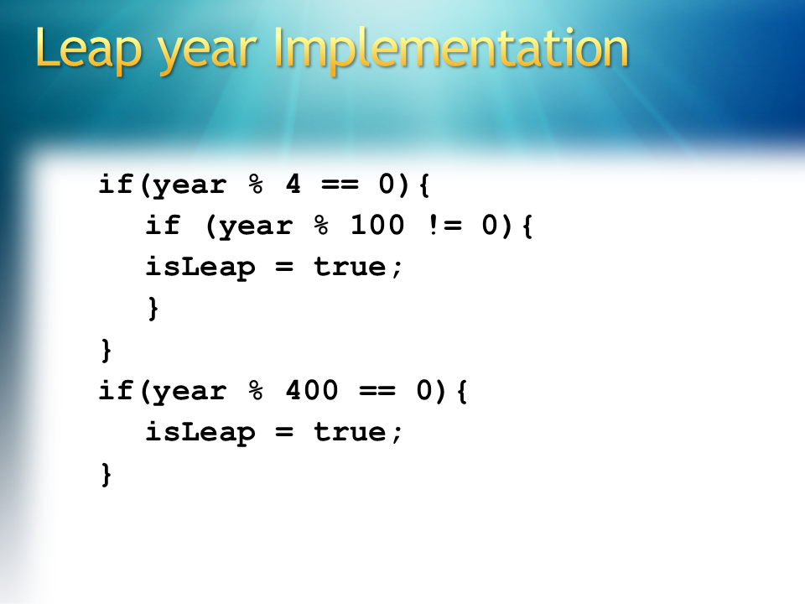
  12. Figure

## Leap Year Implementation

* 1. Based on the definition, a leap year is divisible by 4, but not by 100 (except if divisible by 400.) . Under Visual Studio C++ we could implement this comparisons as follows:
  2. C++
  3. if(year % 4 == 0){
  4. if (year % 100 != 0){
  5. isLeap = true;
  6. }
  7. }
  8. if(year % 400 == 0){
  9. isLeap = true;
  10. }
  11. The **%** operator known as modulus or mod operator in computer languages is simply the remainder of a division. For example,
  12. 17 % 3 = 2
  13. because
  14. 17 / 3 = 5 reminder 2
  15. which in turn means
  16. 17 = 3 * 5 + 2
  17. 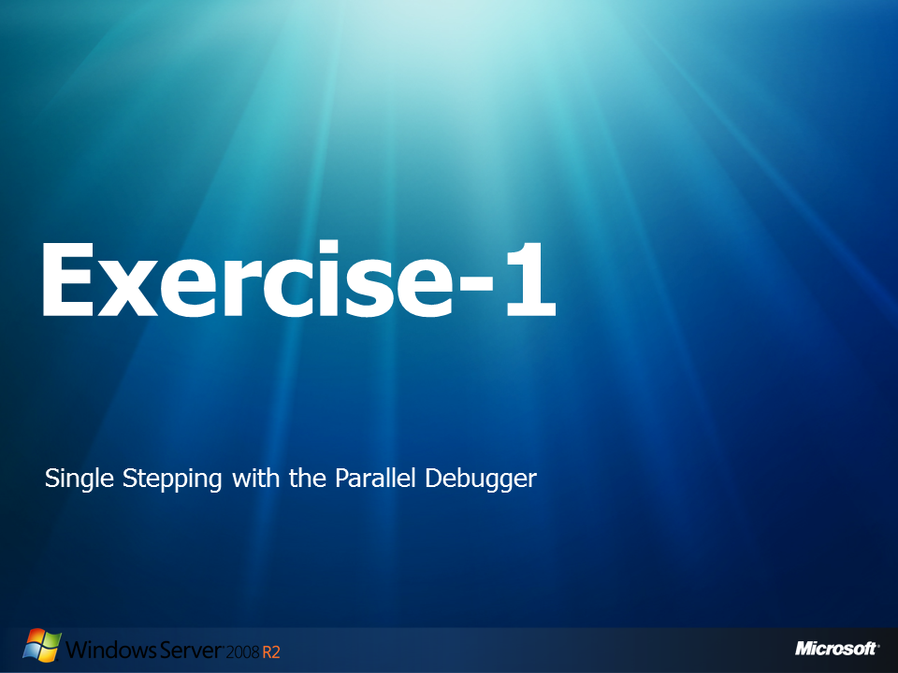
  18. Figure

## Exercise-1: Single Stepping with the Parallel Debugger

1. In this exercise you will work with a C++ application to start visualizing the challenges of debugging a simple but threaded application. This application will help us understand how the Parallel Debugger can help in finding, understanding , and fixing a bug under parallelized applications. The application to be used calculates leap years between a range of dates. As you will see, the application is almost working but it is not generating some leap years with certain characteristics. The problem seems easy to catch, but when working in parallel, you will need extra tricks to find the solution.

### Part 1: Running the application

* 1. Open **Microsoft Visual Studio 10.0** as administrator:
     1. 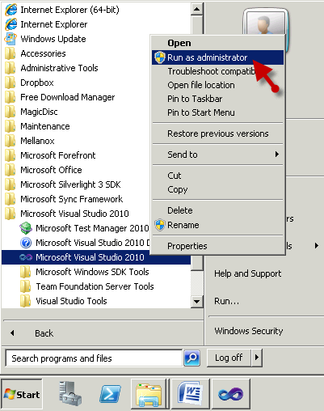
     2. Figure
     3. Run as administrator option
  2. Navigate to **File -> Open -> Project Solution** and open the solution that will be used in this lab:
     1. "C:\Server 2008 R2 Labs\Solving Concurrency Issues\Exercise-1\singleStepping.sln"
  3. From the **Solution Explorer**, double click the **singleStepping.cpp** file.
  4. Navigate to the main function and examine the source code.
     1. **Note:** The application is intended to calculate the leap years between years 1990 and 2190. The code starts off by generating four tasks. Each of the tasks calculates 50 years, concurrently, making use of the four cores available on this demo machine. Accordingly to the present configuration the application will operate on a 200 years range.

First, the code starts by creating four tasks that are going to execute the **listLeapYears()** function :

* + 1. C++

1. task_group tasks;
2. task_handle<RunFunc<decltype(listLeapYears)>> t1(RunFunc<decltype(listLeapYears)>(listLeapYears,0));
3. task1.run(t1);
4. task_handle<RunFunc<decltype(listLeapYears)>> t2(RunFunc<decltype(listLeapYears)>(listLeapYears,1));
5. task2.run(t2);
6. task_handle<RunFunc<decltype(listLeapYears)>> t3(RunFunc<decltype(listLeapYears)>(listLeapYears,2));
7. task3.run(t3);
8. task_handle<RunFunc<decltype(listLeapYears)>> t4(RunFunc<decltype(listLeapYears)>(listLeapYears,3));
9. task4.run(t4);

Then, on the **listLeapYears** function, each of the 50 years is analyzed to see if it is divisible by 4 (year % 4 == 0). If it is, the year is compared to see if it is 100 divisible (year % 100 == 0). According to our definition of leap year, having this both statements we have found a leap year.

After this first verification, the application simulates doing some job by sleeping for a second.

Finally, the application should analyze the year to see if it is 400 divisible, in which case, it will be identified as a leap year too.

* + 1. C++

1. static void listLeapYears(int Param)
2. {
3. int taskNum = Param;
4. long initialYear = BASE_YEAR + (taskNum * YEARS_PER_TASK);
5. long year=0;
6. std::cout << "Thread " << taskNum << " start working." << std::endl;
7. //Start from the initial date from which the thread should calculate leap years
8. for(year=initialYear ; year<=initialYear+YEARS_PER_TASK ;year++)
9. {
10. boolean isLeap = false;
11. if(year % 4 == 0){
12. if (year % 100 != 0){
13. isLeap = true;
14. }
15. }
16. Sleep(1);
17. //There is an error in the isLeap function: "year % 400" was changed to "year / 400" in order to illustrate debugging
18. if(year / 400 == 0){
19. isLeap = true;
20. }
21. if(isLeap) std::cout << "Task " << taskNum << ") year: " << year << " ." << std::endl;
22. }
23. }
    1. **Rebuild** the solution and run the code by selecting **Debug 🡪 Start Without Debugging** , from the main menu.
       1. 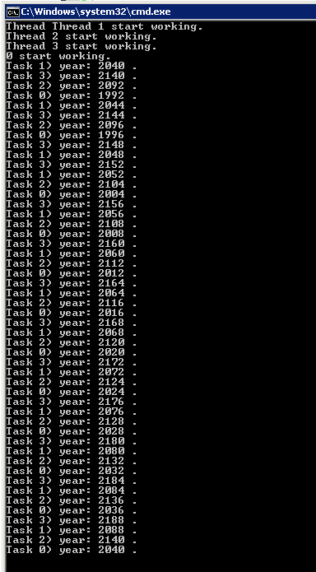
       2. Figure
       3. Application results - Leap years list
       4. **Note:**  if you want, you could increase the number of YEARS_PER_TASK and open a **Task Manager** to visualize the work done by the processors.
       5. 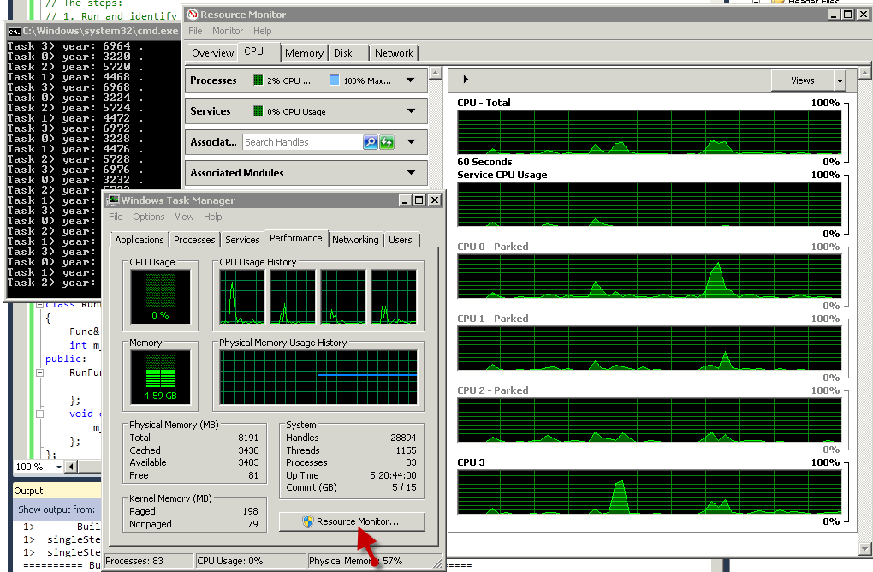
       6. Figure
       7. Processors work on Task Manager
    2. Analyze the results - are all the leap years shown in the list?
       1. **Note:** It seems that all the leap years, on our 200 years range, are present, except for year 2000. The years are shown unordered because they are calculated concurrently by the four cores. As a hint, year 2000 is one of the years that are 400 divisible. The year 2000 is a leap year that didn't appear on this list, but if you extend the 200 years range you will find that none of the 400 divisible years will be listed by our application.
    3. Close any **command** windows that the program may have opened.

### Part 2: Debugging the application

* 1. Back in the **Microsoft Visual Studio 10.0** go to the **listLeapYears** function and, around line **55**, add a breakpoint on the **For** cycle.
     1. 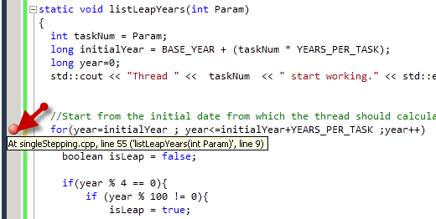
     2. Figure
     3. Inserting a breakpoint for debugging
  2. **Rebuild** the solution and debug the code by selecting **Debug 🡪 Start Debugging**, from the main menu.
  3. On the command prompt press the **enter** key if required.
     1. **Note:** The application should start executing. Then it will stop at the breakpoint inserted in previous steps.
  4. **Right Click** over the **taskNum** variable (around line 51) and select **Pin To Source** .
     1. 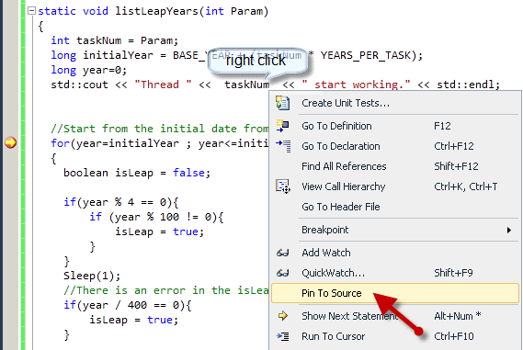
     2. Figure
     3. Pin to source a variable
     4. **Note:** When you want to inspect a variable, Pin to source will leave a DataTip hanging around in the code window. This little box will show you the current value of your variable while you continue debugging.
  5. Place your mouse over one of the **year** variables (around line 55), in order to show up its Datatip, then click on the **pin** symbol.
     1. 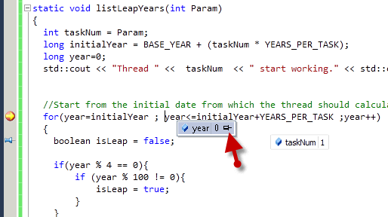
     2. Figure
     3. Pin another variable using mouse over.
  6. Select **Debug -> Step Over** or press **F10** to advance to the next code line.
     1. 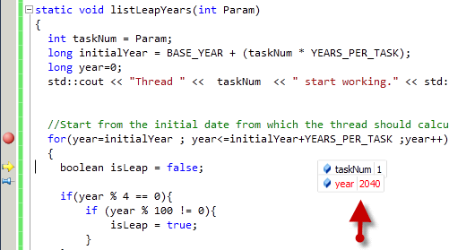
     2. Figure
     3. Breakpoint and Pinned variables on debugging
  7. Select **Debug -> Step Over** (**F10**) several times to see how the pinned variables change.
     1. **Note:** After you keep stepping to debug a few year values you will notice how other threads interrupt the execution, at any time during the debugging, making you to lose the sequence of events. This happens because the four threads in our application are being executed simultaneously by each of the four cores of the demo machine.
     2. **Note:** On a single-threaded application, stepping through the code could be easily used in order to identify the bug. But under a multithreaded program, any thread is eligible. This provokes the behavior that you just experienced: while you step on the debugged code, you are jumping between threads. This jumping makes very difficult to understand the control flow and the diagnostic information of the current state in the application.
     3. Now, we have to make use of the extra capabilities of the Parallel debugger.
  8. Remove the breakpoint by **clicking** over the breakpoint (red circle on the right side) that you set on the **For** statement (around line 55).
     1. 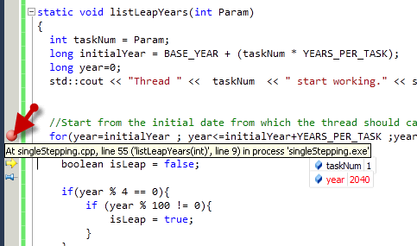
     2. Figure
     3. Removing the breakpoint
  9. Now, set a new breakpoint on the first **if** condition around line 59.
     1. 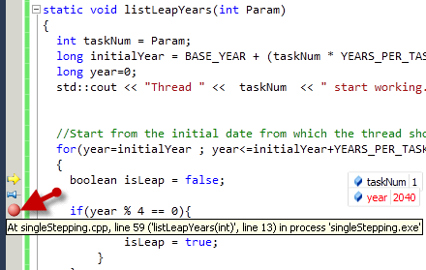
     2. Figure
     3. Setting a new breakpoint
  10. Right click over the new breakpoint (red circle on the right side), and select **Condition...** .
      1. 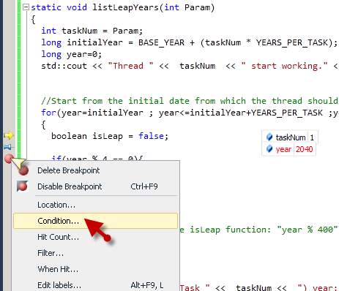
      2. Figure

Conditional Breakpoint

* 1. On the Breakpoint Condition window, type **year == 2000**
     1. 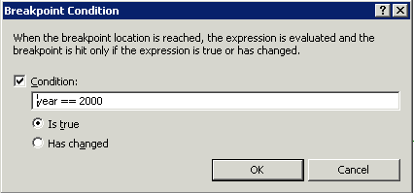
     2. Figure

Conditional Breakpoint set to year 2000

* + 1. **Note:** This will make the debugger to stop the execution when this 400 divisible year is found. For the purpose of this lab, we are only interested in the year 2000. But if you expand the range of years to be analyzed, you should also expand the range of breakpoint conditionals. For example: if your years range were from 1500 to 2500 you could add the three not listed leap years, in order to minimize wait time before it breaks.
    2. 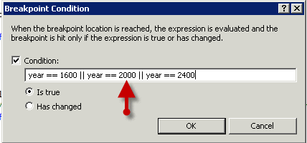
    3. Figure

Setting the conditional breakpoint for multiple conditions

* 1. Press **Ok.**
  2. Select **Debug -> Continue** or press **F5**.
     1. **Note:** Maybe you will need to press F5 again to jump to the year 2000. In that case, repeat the action until you see the year 2000 on the year DataTip.
  3. Select **Debug->Windows->Parallel Stacks**.
     1. 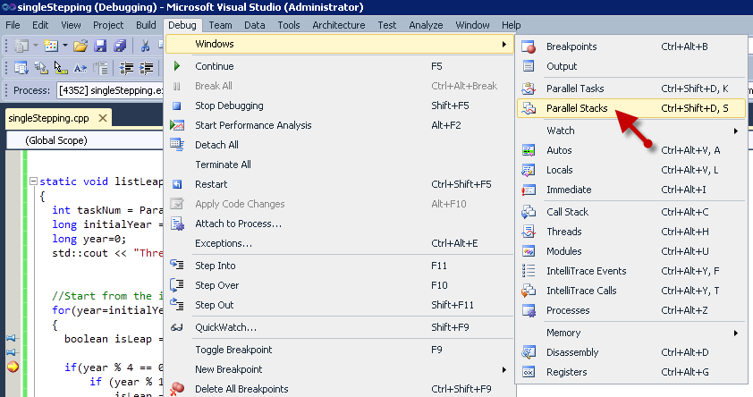
     2. Figure

Open Parallel Stacks window

* + 1. **Note:** Make sure that **Threads** is selected in the box at the upper-left corner.
    2. 
    3. Figure

Parallel Stacks - Threads view

* + 1. **Note:** The Parallel Stacks window provides a consolidated view of what's happening in our program when we break. By using the Parallel Stacks window, you can view multiple call stacks (inside each of the boxes) at the same time in one view. In order to view the thread IDs and names of the threads that share the same box, hover over the header (4 Threads). The current thread is displayed in bold. The yellow arrow indicates the active stack frame of the current thread. To get more information you can also hover your mouse over it.
  1. Close the Parallel Stacks window.
  2. Select **Debug->Windows->Parallel Tasks** 
     1. 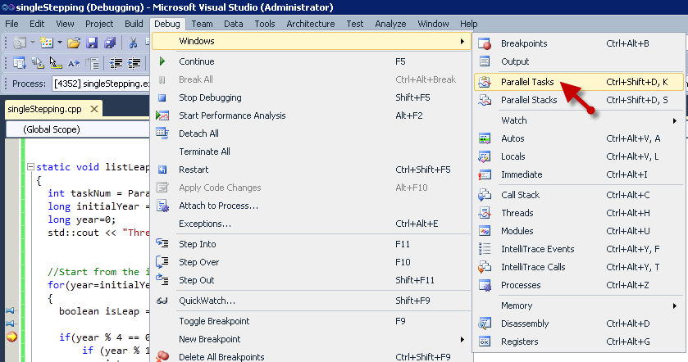
     2. Figure

Opening Parallel Tasks window

* + 1. 
    2. Figure

Parallel Tasks window

* + 1. **Note:**  We will take advantage of the debugger's ability to freeze and thaw threads in order to single-step just the current thread. The debugger allows us to specify that frozen threads won't run until we thaw them. The new Parallel Tasks window makes it easy to find the thread that we want to be allowed to continue.
  1. On the **Parallel Tasks** window, right click on the Task which id is marked with the yellow arrow. The yellow arrow means specifies which is the current task.
  2. From the popup menu, select **Freeze All Threads But This** .
     1. 
     2. Figure

Freeze All Threads But This - Menu Option

* + 1. **Note:**  This action will freeze the other irrelevant threads. Now we can single step our application in order to identify our application's bug.
  1. Use **Debug -> Step Over** or **F10** to follow the code down to the **if(year / 400 == 0)** conditional line around line **66**.
     1. **Note:** Notice how this time, the debugger goes into the **sleep(1)** and after a second the control flowcontinues on the same task, not jumping to another task with a different year. This happens because the other tasks are frozen.
  2. Once more, select **Debug -> Step Over** or press **F10** to see if year 2000 is being identified as 400 divisible.
     1. 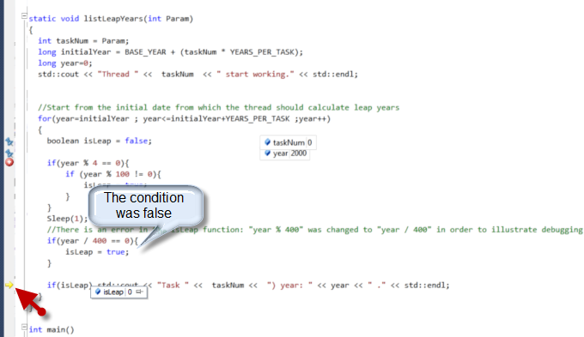
     2. Figure

Condition skipped - year 2000

* + 1. **Note:**  It seems that this is a typo error. A **'/'** or division symbol was typed instead of a **'%'** modulus. '%' or modulus should be used to identify if the remainder of dividing the year between 400 is zero (meaning that the year is 400 divisible).

### Part 3: Fixing the application

* 1. Select **Debug -> Stop Debugging** .
  2. Around line 66, change the line **if(year / 400 == 0){** to **if(year % 400 == 0){**
  3. Build and debug the application by selecting **Debug -> Start Debugging**
  4. Use **Debug -> Step Over** until you get to the fixed if conditional (**if(year % 400 == 0)**)
     1. 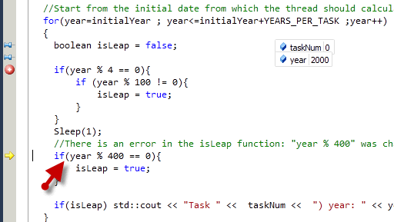
     2. Figure

Debugging the new IF conditional

* 1. Once again select **Debug -> Step Over**
     1. 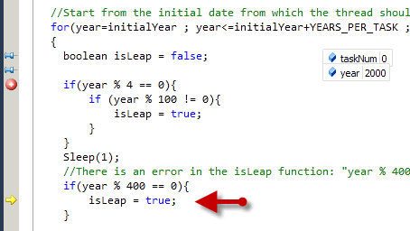
     2. Figure

Year 200 is being identified as a Leap Year

* + 1. **Note:** This time the condition is true, and the year 200 is identified as a Leap year.
  1. Select **Debug -> Continue**. in order to continue running the application.
     1. 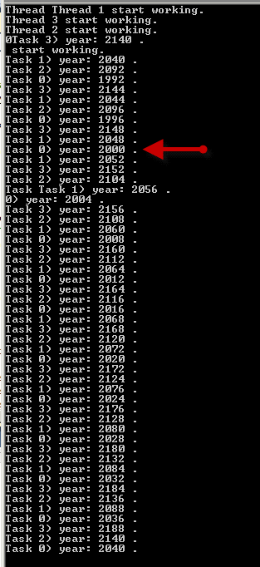
     2. Figure

Years divisible by 400 are now being identified as leap years.

* + 1. **Note:** Theyear 2000 and every other leap year will be shown by our application now.
  1. Close any running instances of the program once you verify the results.
  2. If you finish early, try the extra credit.

### Part 4: Extra Credit

* 1. Using the Threads window, you can examine and control threads in the program you are debugging. Select **Debug -> Windows -> Threads** . From the Threads window, you can set the active thread, and freeze or thaw the execution of each individual thread. Try debugging this application using this Threads window. Compare how each of the analyzed views will help you better on real coding situations. Remember, multiple tasks may run on the same thread.
  2. 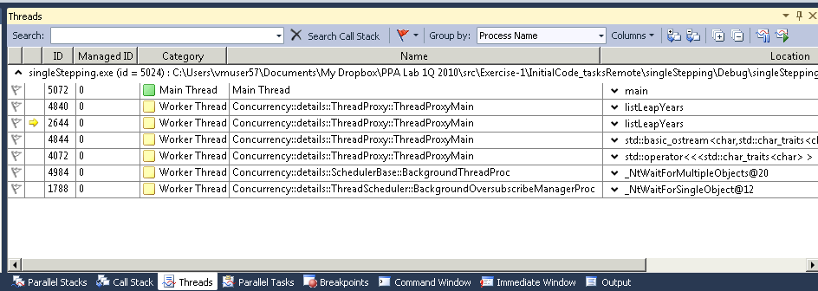
  3. Figure
  4. Threads View
  5. 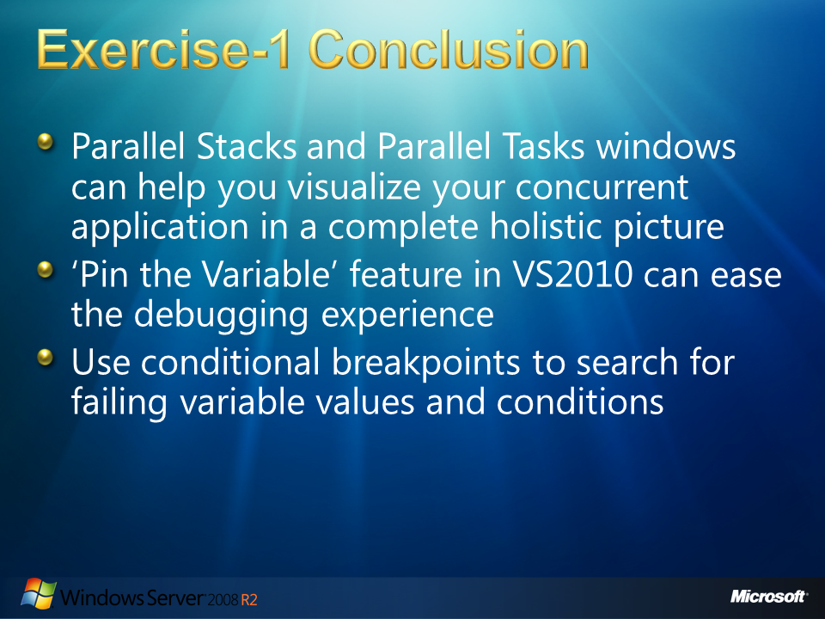
  6. Figure

### Exercise-1 Conclusion

* 1. Parallel Stacks and Parallel Tasks windows help us visualize our concurrent application in a complete holistic picture by allowing us to Freeze and thaw threads These new parallel debugging tools, included on Visual Studio 2010 (Premium and Ultimate) us to evaluate the effects of a instruction in complete isolation. This isolation helps us understand the real behavior of our program. This freezing capability makes it possible to use single stepping by the Step Into, Step Over, and Step Out debugger actions.
  2. Debugger new capabilities such as ‘pin a variable value to the source’ help us to easily debug our application under parallel programming. This feature let us have the variables values at hand, while preserving a convenient visual position. This is very useful as it help us locate the variable uses and its value at any moment during single stepping debugging.
  3. Another important feature that helps us saving valuable time while debugging, especially under parallel debugging, is the conditional breakpoint. This is a powerful tool to search for known failing variable values and conditions, previously identified by the programmer.
  4. 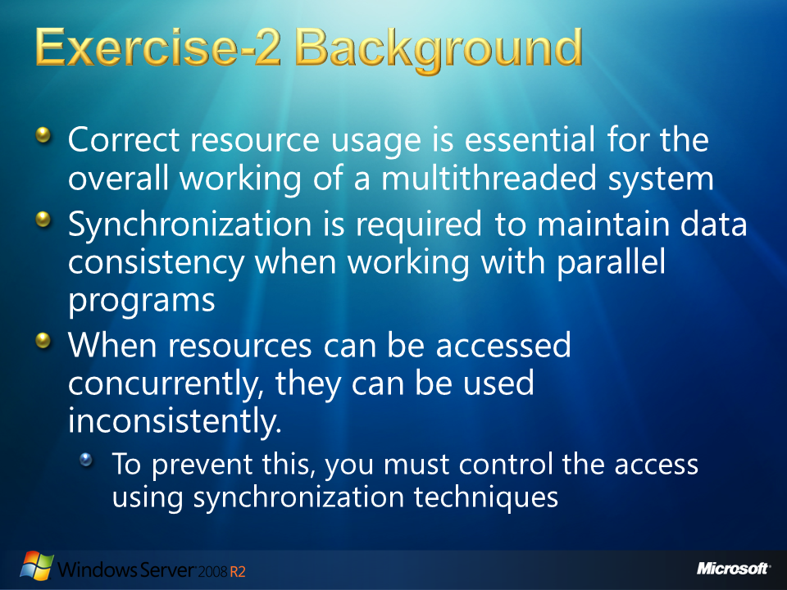
  5. Figure

# Exercise-2 Background

* 1. **Resources** have always been a concern in concurrent programming. Oftentimes, a number of processes share access to system resources such as memory, processor time, or network bandwidth. Correct resource usage is essential for the overall working of a multithreaded system. When working with parallel programming we usually find that these resources require access policies in order to avoid threads using them simultaneously. Synchronization is required to maintain data consistency when working with parallel programs.
  2. In a multithreaded server, it is possible for shared resources to be accessed concurrently. Besides scope object attributes, shared resources include in-memory data such as instance or class variables, and external objects such as files, database connections, and network connections. When resources can be accessed concurrently, they can be used inconsistently. To prevent this, you must control the access using synchronization techniques.
  3. 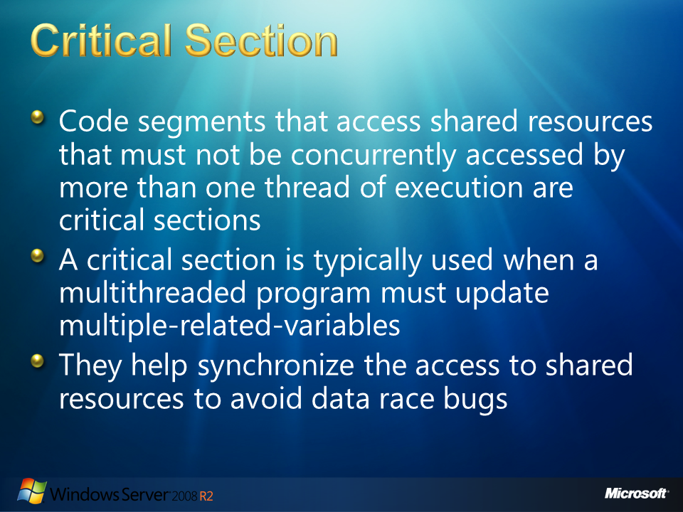
  4. Figure

## Critical Section

* 1. The code segments that access shared resources that must not be concurrently accessed by more than one thread of execution are known critical sections. A critical section will usually finish execution in a fixed time. A thread, task or process will only have to wait a fixed time for a locked resource to be free.
  2. Some synchronization mechanism is required at the entry and exit of the critical section to ensure exclusive use. A critical section is typically used when a multithreaded program must update multiple-related-variables, avoiding another thread to make conflicting changes to the same data. A critical section may be used to ensure a shared resource that can only be accessed by one process at a time.
  3. How critical sections are implemented varies between operating systems. The simplest method, known as the **brute-force** approach, is to prevent any change of processor control inside the critical section. On single processor systems, this can be achieved by disabling interrupts when entering into the critical section, avoiding system calls that can cause a context switch, while inside the section; and restoring interrupts to their previous state on exit. Any thread of execution entering any critical section anywhere in the system will, with this implementation, prevent any other thread, including an interrupt, from getting the CPU and therefore from entering any other critical section or, indeed, any code whatsoever, until the original thread leaves its critical section.
  4. 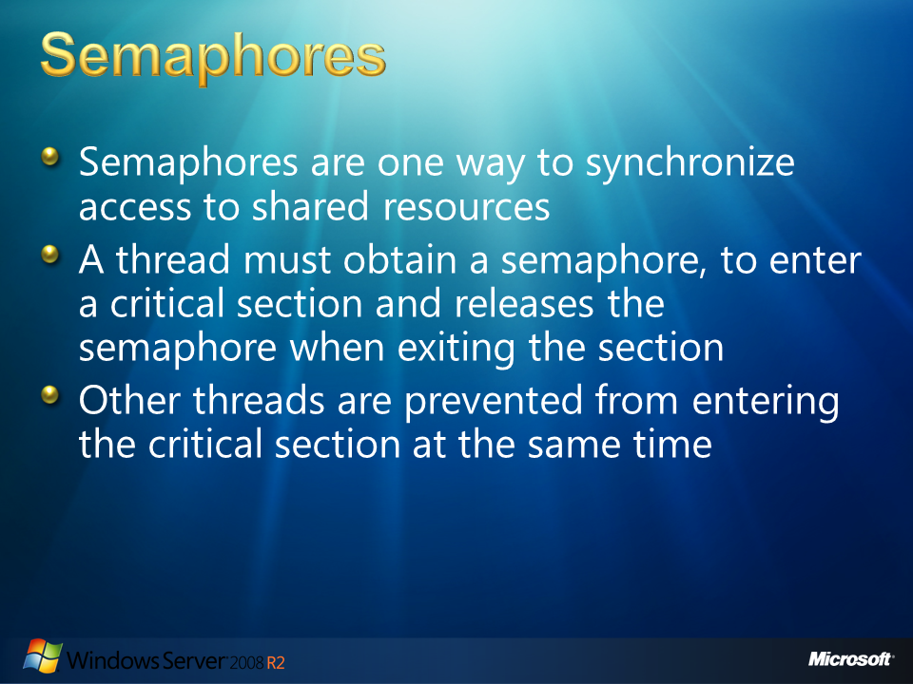
  5. Figure

## Semaphores

* 1. One way to synchronize access to the critical section is by using semaphores. In this approach, a thread must obtain a semaphore, to enter a critical section and releases the semaphore when exiting the section. Other threads are prevented from entering the critical section at the same time as the original thread, but are free to gain control of the CPU and execute other code, including other critical sections that are protected by different semaphores.
  2. 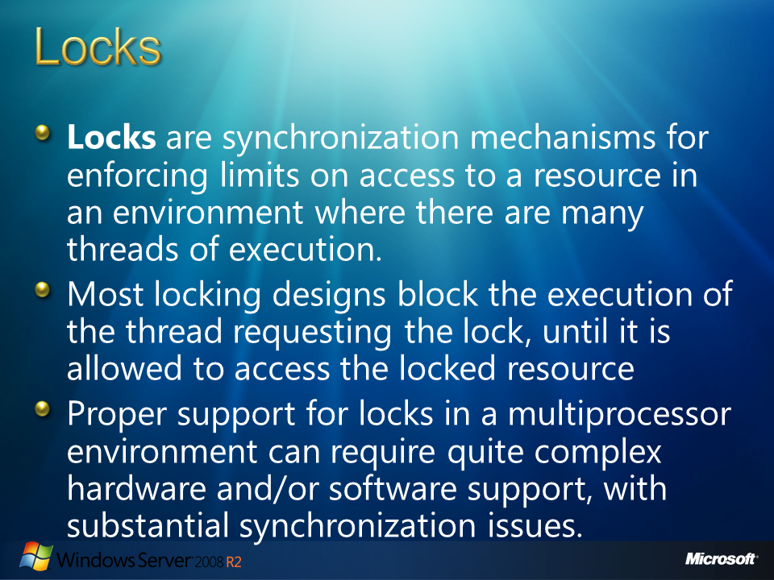
  3. Figure

## Locks

* 1. **Locks** are synchronization mechanisms for enforcing limits on access to a resource in an environment where there are many threads of execution. Locks are one way of enforcing concurrency control policies. A (binary) semaphore is the simplest type of lock.
  2. A lock is known as an **advisory lock** if each thread cooperates by acquiring the lock before accessing the corresponding data. Another implementation is known as a **mandatory lock**. In this latter case, threads attempt to access resources, generating exceptions if the resource was locked. Locks are classified by the way they affect the progress of the thread when trying to access the critical section
  3. Most locking designs block the execution of the thread requesting the lock, until it is allowed to access the locked resource. A **spinlock** is a lock where the thread simply waits ("spins") until the lock becomes available. It is very efficient if threads are only likely to be blocked for a short period of time, as it avoids the overhead of operating system process re-scheduling. It is wasteful if the lock is held for a long period of time.
  4. Locks typically require hardware support for efficient implementation. This usually takes the form of one or more atomic instructions such as "test-and-set", "fetch-and-add" or "compare-and-swap". These instructions allow a single process to test if the lock is free, and if free, acquire the lock in a single atomic operation.
  5. Single processor architectures have the option of using uninterruptable sequences of instructions, using special instructions or instruction prefixes to disable interrupts temporarily, but this technique does not work for multiprocessor shared-memory machines. Proper support for locks in a multiprocessor environment can require quite complex hardware and/or software support, with substantial synchronization issues.
  6. 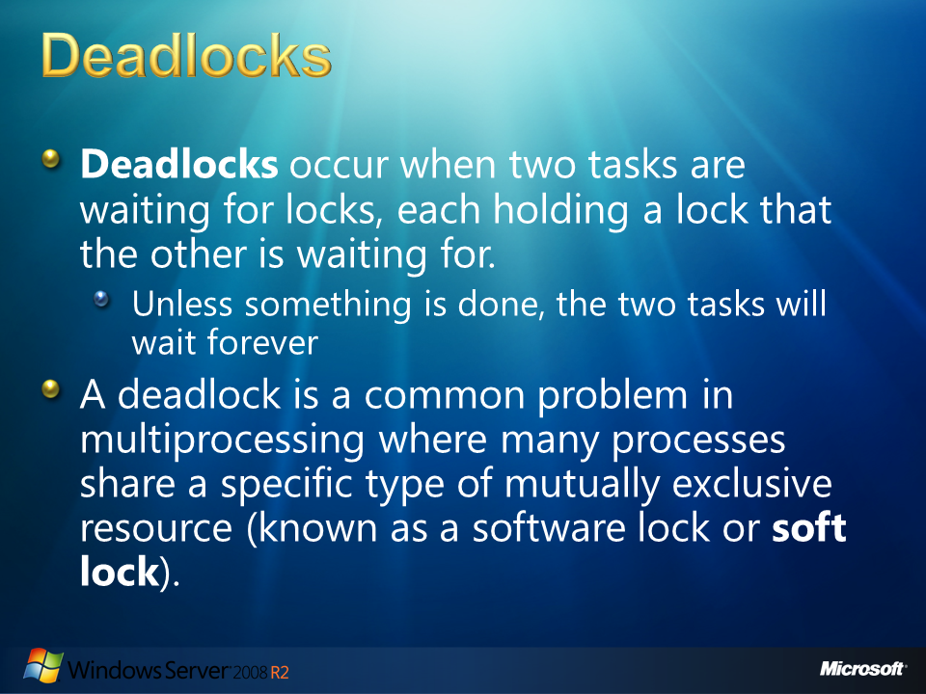
  7. Figure

## Deadlocks

* 1. In concurrency, as more than one task could attempt to execute the same code simultaneously, we have no guarantee that an operation like the following will gives us the lock control as expected:
  2. Pseudo Code
  3. if (global_lock_var == 0) ' <- More than one task could be testing this condition simultaneously
  4. global_lock_var = myPID; // lock seems to be free, let's set it
  5. The above code does not guarantee that the task has the lock because more than one task can be testing the lock at the same time. Various tasks could detect that the lock as free at the same time and could attempt to set the lock, without knowing that other tasks are also setting the lock. This kind of careless use of locks can result in **deadlock** or **livelock**.
  6. **Deadlocks** occur when two tasks are waiting for locks, each holding a lock that the other is waiting for. Unless something is done, the two tasks will wait forever. A number of strategies can be used to avoid or recover from deadlocks, both at design-time and at run-time.
  7. A **livelock** is similar to a deadlock, except that the states of the involved processes are constantly changing without any progress. For a better understanding, you have a livelock example when two very polite people meet in a narrow corridor, and each tries to move aside to let the other pass, but they end up moving each time to the same side of the corridor without making any progress.

A deadlock is a common problem in multiprocessing where many processes share a specific type of mutually exclusive resource (known as a software lock or **soft** **lock**). Deadlocks are particularly troubling because there is no general solution to avoid them.

You can exemplify a deadlock by imagining two engineers who are drawing diagrams, with only one pencil and one ruler between them. If one person takes the pencil and the other takes the ruler, the person with the pencil needs the ruler and the person with the ruler needs the pencil to finish the work. Both requests can't be satisfied, so we are in presence of a deadlock.

* 1. 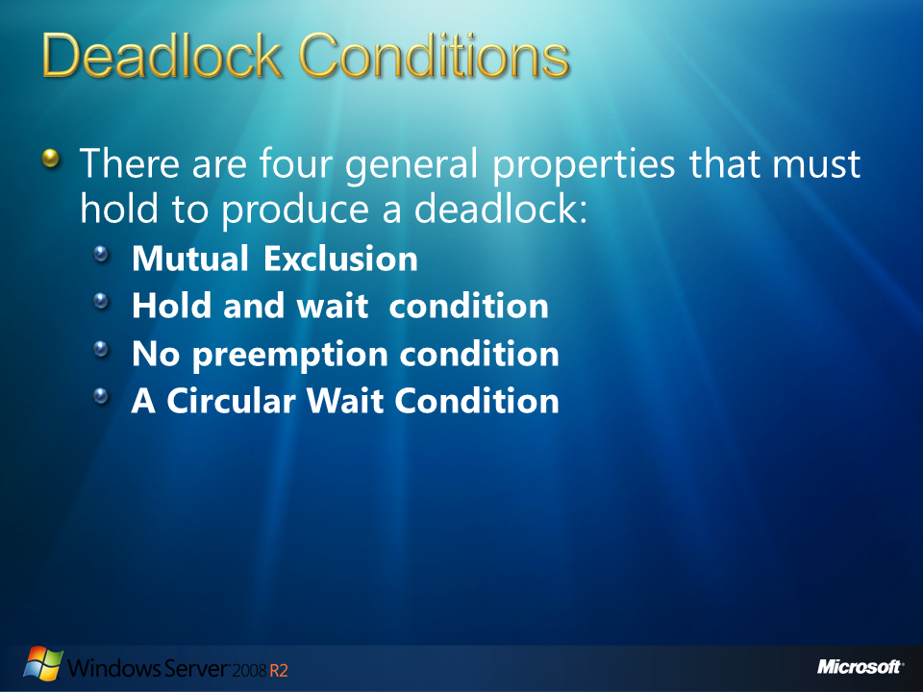
  2. Figure

## Deadlock Conditions

* 1. There are four general properties that must hold to produce a deadlock:
  2. **Mutual Exclusion:** When one thread owns a common resource, another thread cannot acquire it until it is released by the first thread (critical sections, and GUIs in Windows for example).
  3. **Hold and wait condition:** A thread holding a resource is able to perform an unbounded wait. When a thread enters a critical section, the code inside is usually free to attempt acquisition of additional critical sections. This could result in blocking if the target critical section is already held by another thread.
  4. **No preemption condition:** Resources cannot be forcibly taken away from their current owners. It is not possible to steal resources from a thread, when contention is noticed.
  5. **A Circular Wait Condition:** Occurs if a thread, in a chain of two or more threads, is waiting for a resource held by the next member of the chain.
  6. To further illustrate how a deadlock might occur, imagine the following sequence of events:
  7. Thread 1 acquires lock A.
  8. Thread 2 acquires lock B.
  9. Thread 1 attempts to acquire lock B, but it is already held by Thread 2 and thus Thread 1 blocks until B is released.
  10. Thread 2 attempts to acquire lock A, but it is held by Thread 1 and thus Thread 2 blocks until A is released.
  11. At this point, both threads are blocked and will never wake up.
  12. 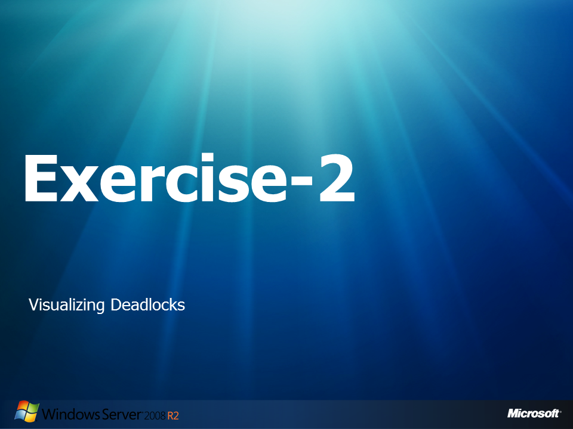
  13. Figure

## Exercise-2: Visualizing Deadlocks

* 1. On this second exercise you will work with a C Sharp application which simulates a dental care procedure , as wisdom teeth extraction. After you execute the application you will see how, under parallel execution, the careless of the shared resources results in a deadlock. You will learn how the Parallel Debugger can help you identifying deadlocks and its cause. Finally you will solve the problem and see how the application behaves.
  2. Also called third molars, wisdom teeth usually make their first appearance in young. Because most mouths are too small for these four additional molars, an extraction procedure is often necessary. Wisdom tooth extraction surgery involves removing the gum tissue that presides over the tooth, gently detaching the connective tissue between the tooth and the bone, removing the tooth, and suturing the opening. Because of these procedures an Orthodontist and an Anesthesiologist is required. Our application is intended to ask for each doctor 's availability, if both are available a wisdom teeth extraction takes place. But wait, as you have learn from this exercise background, shared resources, specially under concurrent applications, must be use carefully. Intentionally, the code didn't take the necessary care on the lock ordering, therefore, a deadlock will occur.

### Part 1: Running the application

* 1. Open **Microsoft Visual Studio 10** as administrator:
     1. 
     2. Figure
     3. Run as administrator option
  2. Navigate to **File -> Open -> Project Solution** and open the solution that will be used in this lab:

C:\Server 2008 R2 Labs\Solving Concurrency Issues\Exercise-2\VisualizingDeadlocks\VisualizingDeadlocks.sln

* 1. From the **Solution Explorer**, double click the **VisualizingDeadlocks.cs** file.
  2. Navigate to the main function and examine the source code.
     1. **Note:** The application is intended to simulate continuous wisdom teeth extractions. Each extraction is represent by the **WisdomToothExtraction()** function. This function is going to be concurrently called from multiple threads by the Parallel.Invoke method. For additional information on Parallel.Invoke, MSDN has additional information at the following URL:
     2. <http://msdn.microsoft.com/en-us/library/dd992634(VS.100).aspx>
     3. Using Parallel.Invoke, we can simply express the actions we want to run concurrently. The runtime handles all thread scheduling details, including scaling automatically to the number of cores on the host computer.
     4. As we are using parallelism and shared resources, the WisdomToothExtraction**()** function needs to be thread-safe. This function tries to use locks to achieve thread safety. First it locks the first doctor parameter and if control is gained over it, the program asks for the second parameter control. If a shared resource is held by another thread the program will wait until the resource gets released.

First, the code declares two Doctors that are going to be the Anesthesiologist and the Orthodontist. Then, it creates two parallel tasks that are going to execute the **WisdomToothExtraction ()** function concurrently. Inside the **WisdomToothExtraction ()** function , you will see the two locks for **one** and **two** corresponding for the first parameter and the second parameter, which are the share resources. Both locks are protecting the critical section of our application:

* + 1. C#

1. class VisualizingDeadlocks
2. {
3. static void Main(string[] args)
4. {
5. int succeededOperations = 0;
6. Doctor dr1 = new Doctor { Name = "Michael" , DoctorTitle = "Anesthesiologist"};
7. Doctor dr2 = new Doctor { Name = "Olivia" , DoctorTitle = "Orthodontist"};
9. while (true)
10. {
11. Parallel.Invoke(
12. () => WisdomToothExtraction(dr1, dr2, succeededOperations),
13. () => WisdomToothExtraction(dr1, dr2, succeededOperations+1));
15. succeededOperations += 2;
16. }
17. }
18. class Doctor { public string Name; public string DoctorTitle;}
20. static void WisdomToothExtraction(Doctor one, Doctor two, int PatientNumber)
21. {
22. lock (one)
23. {
24. lock (two) // BUG: lock ordering
25. {
26. Console.WriteLine("-> "+one.DoctorTitle +" "+ one.Name + " and " +two.DoctorTitle +" "+ two.Name + "\n\t\t extract wisdom teeth from patient #" + PatientNumber+"\n");
27. }
28. }
29. }
30. }
31. * 1. **Note:** In this code we are parallelizing the operations, not the data using Parallel.Invoke. In order to parallelize data or LINQ queries you you can use PLINQ. You can find additional information on LINQ at

[http://msdn.microsoft.com/en-us/library/bb397926.aspx](http://msdn.microsoft.com/en-us/library/bb397926.aspx%20)

and information about PLINQ at:

<http://msdn.microsoft.com/es-cr/dd460688(en-us,VS.100).aspx>

Another approach is to parallelize the queries and the tasks which result in overhead, degrading performance on computers with few processors, but scaling much better on computers with many processors.

* 1. **Rebuild** the solution and run the code by selecting **Debug 🡪 Start Debugging** from the main menu.
     1. 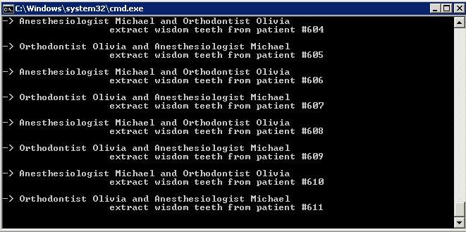
     2. Figure
     3. Application results - Visualizing Deadlocks
     4. **Note:** After a while, the application stops the output. The application still seems to be running but the output is stopped. Visual Studio shows the application as running.

### Part 2: Debugging the Application

* 1. Switch back to Visual Studio and **pause** the execution.
     1. 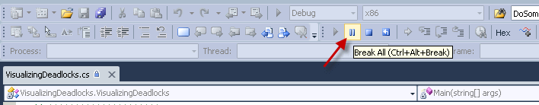
     2. Figure

Break All option pauses execution for debugging

* 1. Select **Debug->Windows->Parallel Tasks**
     1. 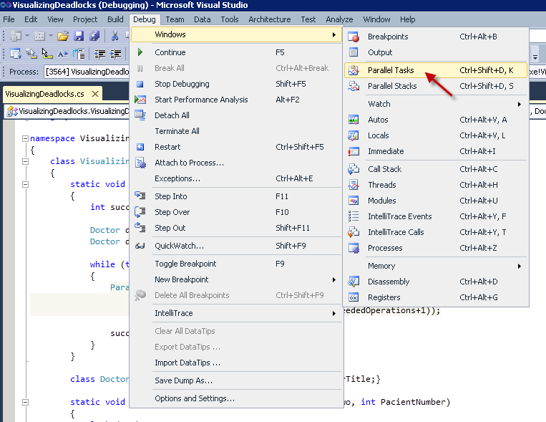
     2. Figure

Opening Parallel Tasks Window

* + 1. **Note:**  The parallel Tasks window immediately warns us that the application is deadlocked. If you hover your mouse over each of the statuses ("Waiting-Deadlock" status) you will receive additional information.
    2. 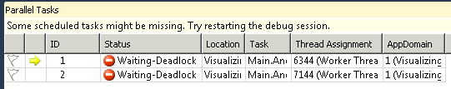
    3. Figure
    4. Parallel Tasks window
  1. Hover your mouse over each of the status.
     1. 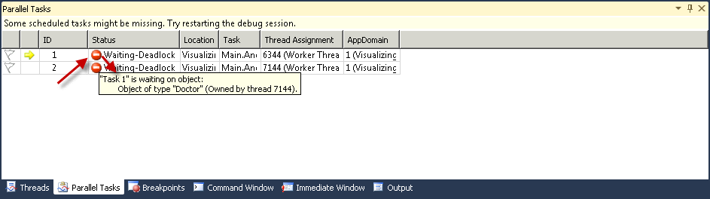
     2. Figure

Additional data by hovering the mouse- task 1

* + 1. 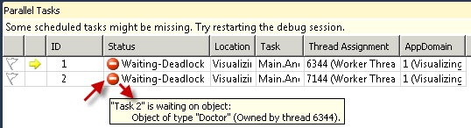
    2. Figure

Additional data by hovering the mouse - task2

* + 1. **Note:** The information provided indicates thattask 1 with thread id 6344 (this id is shown on the Thread Assignment column) is waiting for a resource of type "Doctor" that is currently own by thread 7144.
    2. On the other hand, this information also shown that task 2 with thread id 7144 is waiting for a "Doctor" resource own by thread 6344. Since each thread is waiting for the other to release a required resource, and each thread held a resource necessary for the other thread to complete the critical section, the deadlock occurred .
    3. This information on what is being waited on and which thread is holding each protected resource helps use to identify deadlocks quickly and easy.

* 1. Double click on the first task from the **Parallel Tasks** window (this is the task that has the ID value set to 1).
     1. 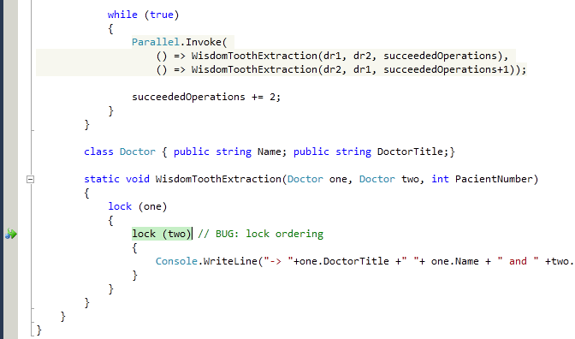
     2. Figure

First resource highlighted by Parallel Tasks

* 1. **Pin To Source** variable **one** by right clicking on the variable and selecting **Pin To Source** from the menu.
     1. 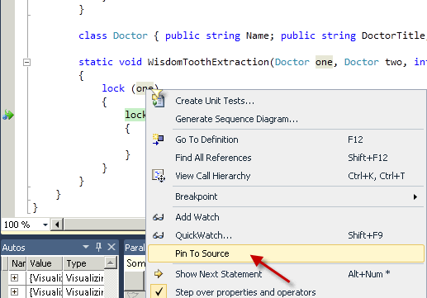
     2. Figure
     3. Pin To Source resource one
  2. Expand the node of the **DataTip** and pin its properties.
     1. 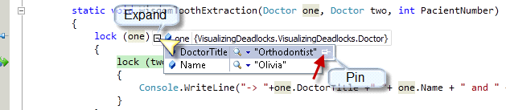
     2. Figure

Pin DoctorTitle Property

* + 1. 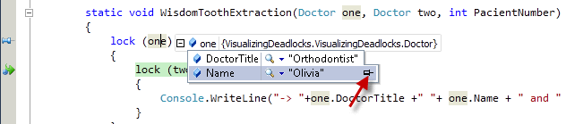
    2. Figure

Pin the Name Property

* 1. Make sure to also pin the properties of the variable **two.**
     1. **Note:** If the pinned down window of the variable **one** is on the way, you can always drag it somewhere else.
     2. 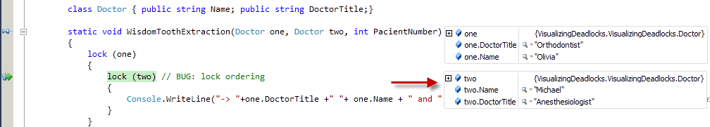
     3. Figure

Pin resource two Properties

* + 1. **Note:** Notice that task onesuccessfully gain control over resource one, corresponding to the Orthodontist Olivia, and now it is waiting for the resource two corresponding to Anesthesiologists Michael.
  1. Back on the Parallel Tasks double click on the second task.
     1. 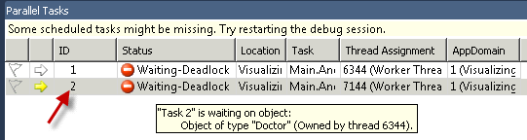
     2. Figure

Exploring second Task

* + 1. **Note:** Notice how this time the scenario is totally switched. By seeing variables one and two we can clearly notice that task two gains control of the first resource and is waiting for resource two. But this time resource one corresponds to the Anesthesiologist Michael, and this task is waiting for Orthodontist Olivia in order to continue execution.
    2. 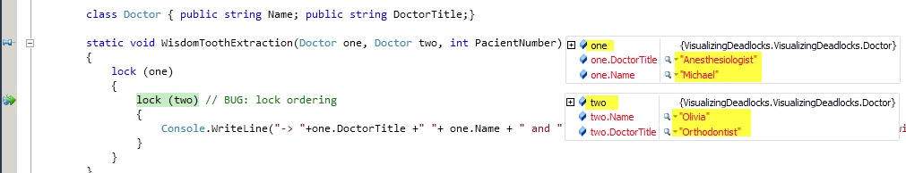
    3. Figure
    4. Task two resources
    5. **Note:** We are clearly on a **deadlock** as each task is locking a resource that the other needs in order to continue the execution and release the resource each thread had already locked.
  1. Select **Debug->Windows->Parallel Stacks**.
     1. 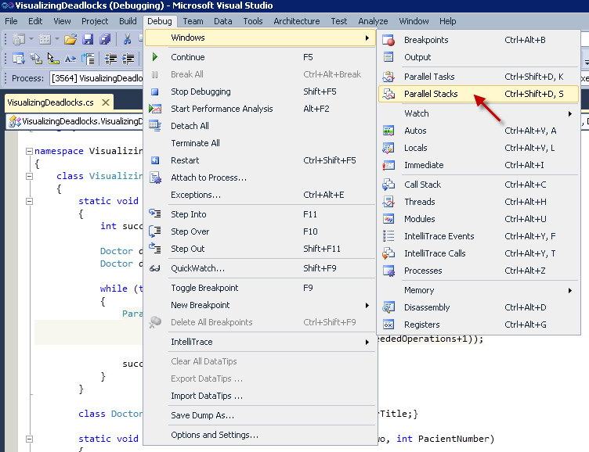
     2. Figure

Opening Parallel Stacks Window

* + 1. **Note:** The Parallel Stack visually warns us about the deadlock we are facing . If you hover your mouse over the red circle a popup will describe this symbol as a deadlock indicating the respective task id.
    2. 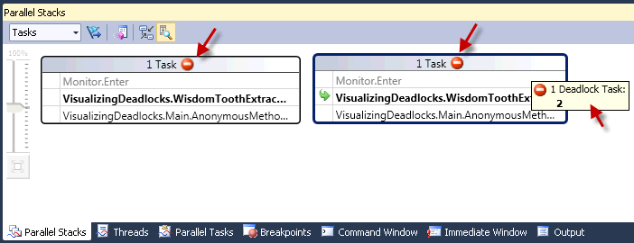
    3. Figure

Parallel Stacks showing deadlock warning

* 1. Click on the **Toggle Method View** option.
     1. 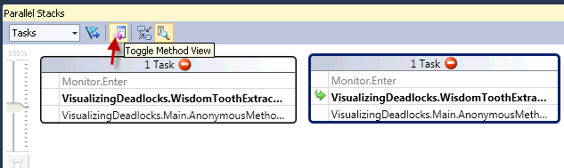
     2. Figure

Toggle Method View

* + 1. **Note:** In this view you can see how the two tasks (the two nodes at the bottom of the tree) are being created on the Main code of our application. Both are calling the **WisdomToothExtraction** functionwhich at some time also invokes a **MonitorEnter** operation. You can see how this tree representation is very similar to the traditional call stack, but a hierarchy representation is a much better approach to understand what is going on when running parallel code.
    2. 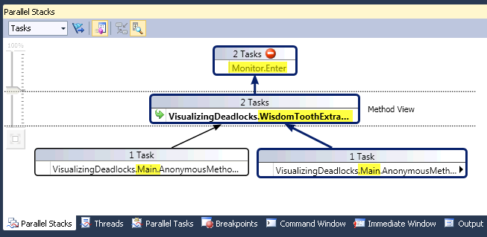
    3. Figure

Deadlock represented on the Method view

* 1. Right click on the lower right node over the line **VisualizingDeadlocks.Main.AnonimousMeth** and select **Go To Source.**
     1. 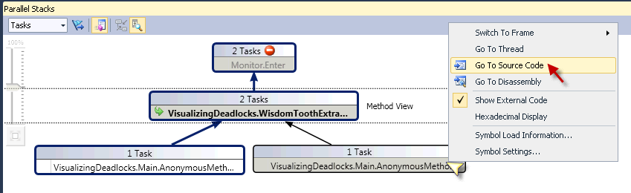
     2. Figure
     3. Go To Source Code
     4. **Note:** The cursor should now be around line 38. Here you can see how the code uses the Parallel.Invoke to concurrently start two WisdomToothExtraction functions. The first error on this logic is that both functions are receiving the same two Doctor objects, both are shared resources, which means that these operations execute concurrently on their critical section. This kind of error should not generate a deadlock by itself if the locks were working correctly.
     5. 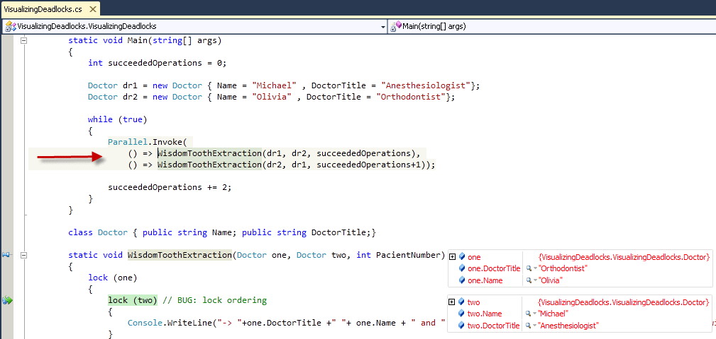
     6. Figure
     7. Parallel.Invoke mistake on parameters order
     8. **Note:** Now, pay attention to the parameters order. You will notice that the code is calling the WisdomToothExtraction function twice. On the first call it is passing dr1 first and then dr2, but on the second call dr2 is passed first and then dr1.
     9. **Note:** You can see, in the following diagram, the representation of an exact parallel execution of both calls:
     10. **Note:** 1) The first function is going to lock dr1 while the second function is concurrently locking dr2.
         1. As both resources are free both locks are possible.
         2. 2) Then, both functions are going to try the second lock, where they will found that the required resource is held by each other function, resulting in a deadlock.

### Part 3: Fix the Application

* 1. Stop the debugging and execution of the application by selecting **Debug-> Stop Debugging**.
     1. 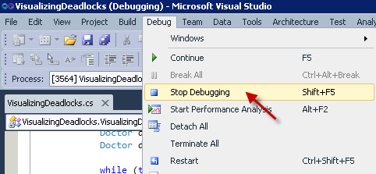
     2. Figure

Stop Debugging

* 1. Go to the **Parallel.Invoke** method near line 36
  2. Change the **doctors** parameters order from the second WisdomToothExtraction function, around line 38. This way both functions have their parameters in the same order:
     1. C#

1. Parallel.Invoke(
2. () => WisdomToothExtraction(dr1, dr2, succeededOperations),
3. () => WisdomToothExtraction(dr1, dr2, succeededOperations+1));
5. succeededOperations += 2;
6. }
7. * 1. **Note:** On a real live application you need to further investigate and analyze your application in order to find a solution that better fits you. This change is intended for educational purposes only because a stronger solution will be required if having complexes scenarios with different resources and more threads. Here we are just demonstrating that these conditions were generating the deadlock and we just want to break the deadlock and see the application running.
   1. Compile and run the application by selecting **Debug->Start Debugging**.
      1. 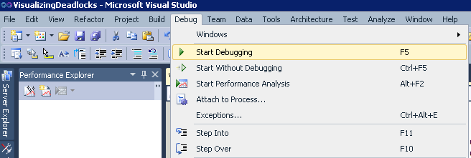
      2. Figure

Start Debugging

* + 1. **Note:** This time our application will continue executing wisdom teeth extractions without the deadlock.
    2. 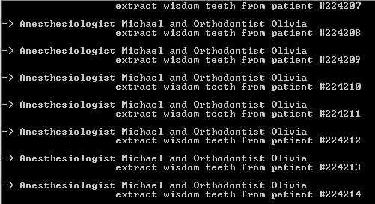
    3. Figure

Application Output - No deadlocks

* 1. After a while, switch back to Visual Studio and select **Debug->Stop Debugging.**
  2. **Work on the Extra** Credit and after you finish close all the opened windows.

### Part 4: Extra Credit

The Parallel Stacks view helps you represent the call stacks per thread or task in your application. Useful information can be obtained from this view.

Reproduce the Deadlock again on the code by changing the doctor parameters order. Debug it until you have the Parallels Stack hierarchy representation. Open the different menus by right clicking on the functions of each node and try to figure out what each line means.

* 1. 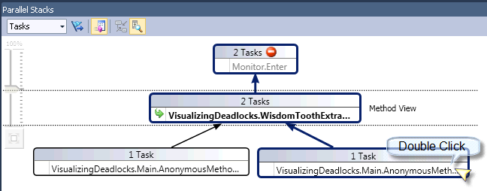
  2. Figure
  3. Parallel Stacks method view
  4. **Note:** This method view shows the Task View in Parallel Stacks, highlighting that there are two tasks, each of which is blocked in a call to Monitor.Enter (corresponding to the lock statements )

As a hint, double click on the function **VisualizingDeadlocks.Main.AnonymousMethod** to have the representation of this single-task call stack.

* 1. 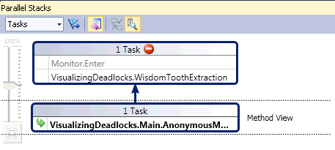
  2. Figure
  3. Single call stack over Parallel Stacks
  4. **Note:** On this particular stack representation you can see the sequence of calls from the main function were invoked by the Parallel.Invoke method on the lowest node. On top you can see the call to the WisdomToothExtraction function which is currently waiting for the Monitor.Enter, corresponding to one of the locks.
  5. 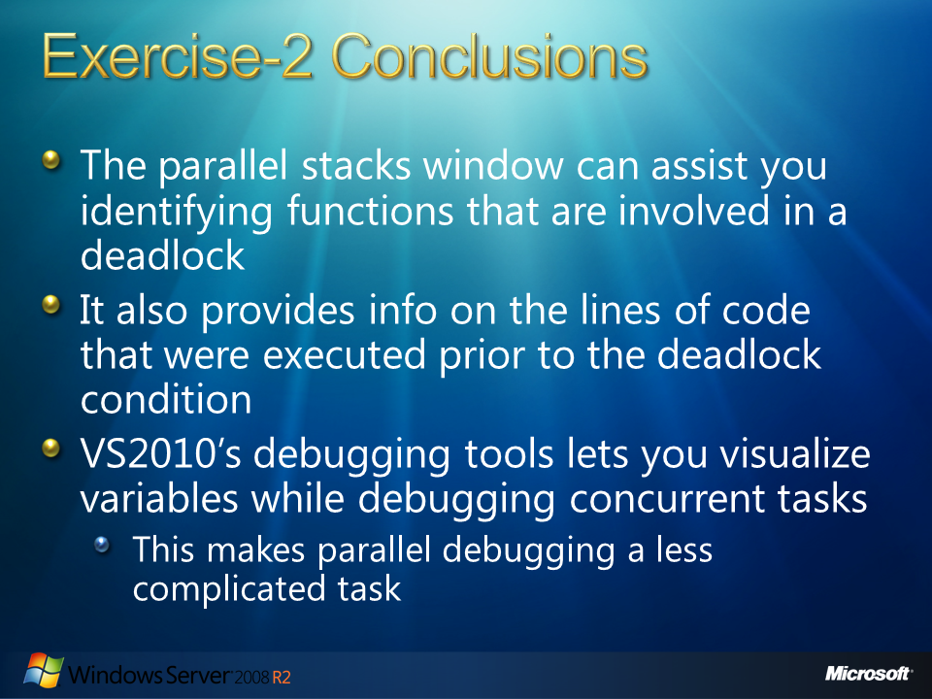
  6. Figure

### Exercise-2 Conclusion

* 1. The parallel stacks window helps us visualize application Deadlocks in a self-explanatory hierarchy representation that helps us identify the common functions that are involve in the deadlock. The parallel stacks window also provides information on the lines of code that were previously executed before the functions related to the deadlock problem. Using this view, you can navigate backwards in the call stack of each task figuring out why the shared resources are in deadlock.
  2. The Parallel Tasks window shows us explicitly the tasks that are involve in the deadlock. Hovering the mouse over its columns gives us further information on which resources each task is waiting on and which tasks are holding them.
  3. Visual Studio 2010’s new parallel debugging tools help us visualize variable values, while debugging concurrent tasks, making debugging possible without titanic debugging labors. All this information that the parallel debugging tools provide us help us to have all the available information involve in the exact instant where the deadlock occurred.
  4. 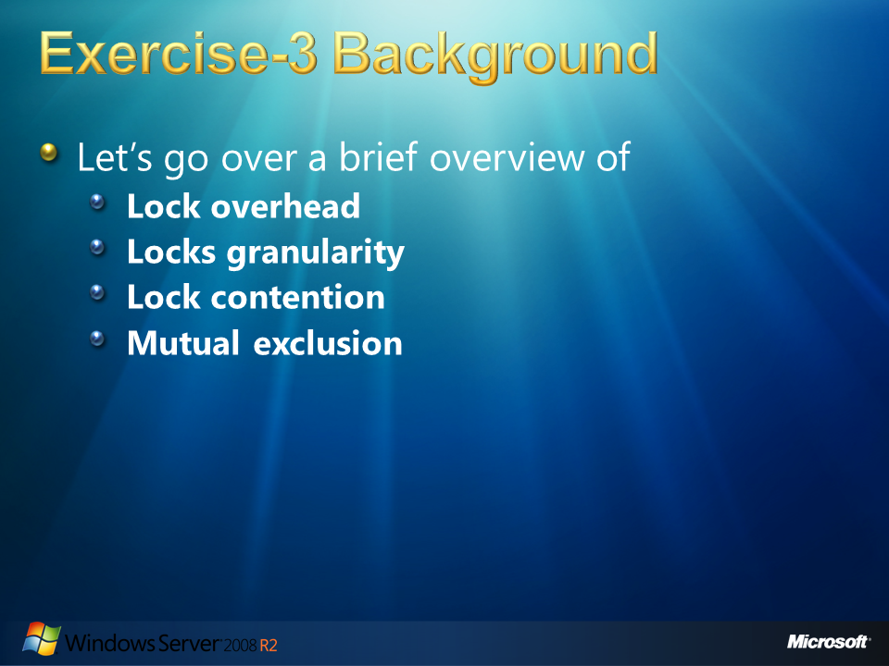
  5. Figure

# Exercise-3 Background

* 1. In the last exercise you learn about deadlocks: tasks waiting on locks, each holding a lock that the other is waiting for. We saw that unless something is done, these tasks are going to wait forever. Let’s go through some other parallelization related concepts:

## Lock overhead

* 1. Lock overhead is the computation time, memory, bandwidth, and extra resources that are required for using locks. For example the memory space allocated for locks, the CPU time to initialize and to destroy locks, and the time for acquiring and releasing locks. The more locks a program uses, the more overhead associated with the usage.

## Locks granularity

1. Locks granularity is a measure of the amount of data the lock is protecting. Choosing a small number of locks, where each lock protects large segments of data, results in less lock overhead when a single process is accessing the protected data. But it results in poor performance when multiple processes are running concurrently trying to access the protected data simultaneously. This scenario increases **lock contention**.

## Lock contention

1. Lock contention takes place when a process or thread attempts to acquire a lock held by another process or thread. The more granular the locks are, the less probable one process or thread will request a lock held by the other. An example of a bad lock granularity will be to lock an entire table for accessing just one cell; this will end in having frequent lock contention between threads that require other cells from the table.
2. You need to find a balance between decreasing lock overhead and decreasing lock contention when you are deciding the number of locks to use on parallel applications synchronization. The less granular the lock, the higher the probability that the lock will stop an unrelated process from proceeding. On the other hand, when using fine granularity, more locks (each protecting small amounts of data) increase the overhead of the locks themselves but reduces lock contention. Extra locks also increase the risk of deadlock.

## Mutual exclusion

1. Also known as **mutex** algorithms, they are used in concurrent programming to avoid the simultaneous use of common resources from critical sections. It is an object that allows multiple program threads to share the same resource, such as file access and global variables, but not simultaneously. When a program is started, a mutex is created with a unique name. After this stage, any thread that needs the resource must lock the mutex from other threads while it is using the resource. The mutex is set to unlock when the data is no longer needed or the routine is finished.
   1. 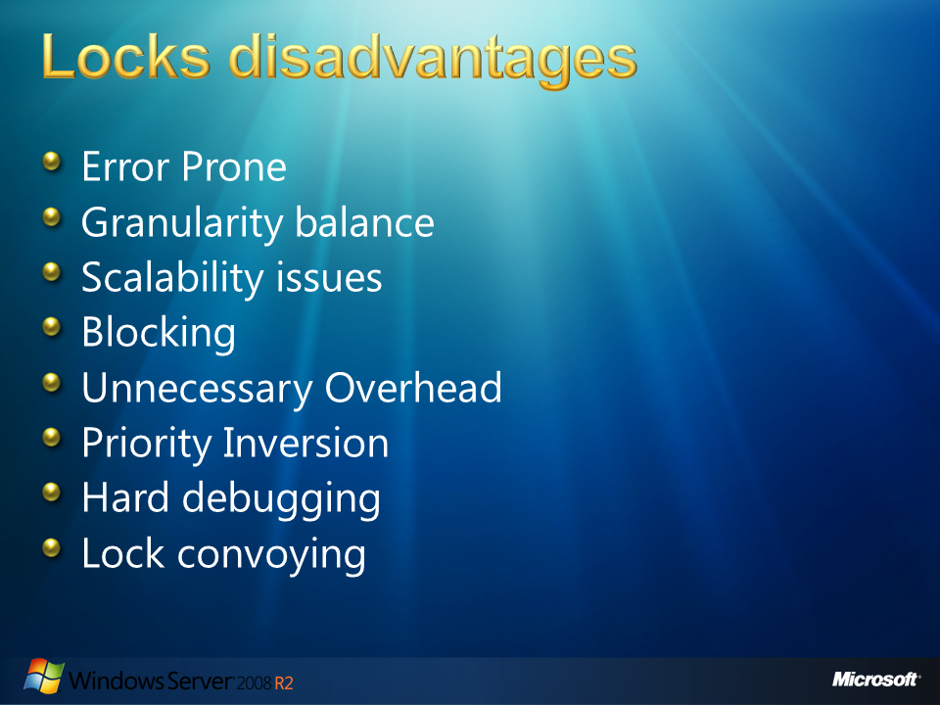
   2. Figure

## Locks disadvantages

* 1. Using locks for resource protection and thread synchronization sometimes present disadvantages:
     1. **Programming using locks is error-prone**, deadlock and livelocks are examples.
     2. **Granularity balance**: You need to deal with balancing the granularity of locked data against the costs of fine-grain locks.
     3. **Scalability problems**: Using locks usually does not scale with problem size and complexity.
     4. **Locks are vulnerable to failures**: If one thread holding a lock dies, other threads waiting for the lock could wait forever.
     5. **Using locks is a blocking method**: The thread or process has to wait until a lock held by others gets released.
     6. **Induces unnecessary overhead**: Using locks conservative, each thread has to acquire the lock whenever there is a possibility of an access conflict.
     7. **Priority inversion**: High priority threads or processes cannot proceed if a low priority thread or process is holding the common lock.
     8. **Hard debugging**: Bugs associated with locks are time dependent. They are extremely hard to repeat. Fortunately as you will see in this lab, Microsoft Visual Studio 2010 Parallel Debugging tools helps us identifying lock errors.
     9. **Lock convoying**: All other threads have to wait even if the thread holding a lock is descheduled due to a time-slice interrupt or page fault.
  2. 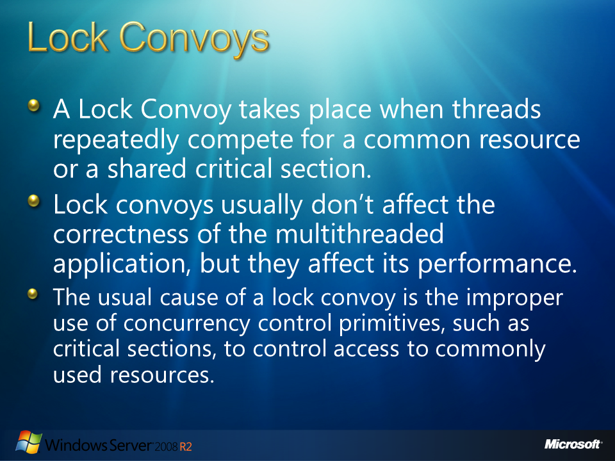
  3. Figure

## Lock Convoys

* 1. A lock convoy is a typical performance problem under parallelized applications where threads repeatedly compete for a common resource or a shared critical section. This problem occurs in certain uses of locks for concurrency control in multithreaded applications. Lock convoys usually don’t affect the correctness of the multithreaded application, but they affect its performance.
  2. The usual cause of a lock convoy is the improper use of concurrency control primitives, such as critical sections, to control access to commonly used resources.
  3. An example on how lock convoys can occur is the critical section, as implemented in Microsoft Windows operating systems. In Windows, critical sections combine a **spinlock** and an **event** to ensure mutual exclusion. A spinlock is a type of lock where the thread waits in a loop, like spinning, repeatedly checking until the lock becomes available. On low contention critical sections, the spinlock will provide mutual exclusion, falling back on the event only when a thread fails to acquire the spinlock within a certain amount of time. The problem occurs when contention is high because it is possible for many threads to fail to acquire the spinlock, entering in a waiting state, all waiting on the same event. Once the event is signaled, all threads that are waiting on the event wakes up. Now, only one thread will be allowed to acquire the critical section and continue execution. So if multiple threads were waiting on the event, just one of them acquire the critical section, but all the other threads woke only to realize that they need to keep waiting on the next event again after failing to acquire the critical section. This overhead of each of the threads that woke for nothing, significantly affect performance. This penalty also increases with the lock contention present in the critical section.

Common causes of lock convoys involving critical sections are:

The heavy use of the heap functions, which use critical sections for synchronization. (Information on heap functions can be find at the MSDN site: <http://msdn.microsoft.com/en-us/library/aa366711(VS.85).aspx> )

The use of a critical section to control the dispatching tasks to worker threads in a thread pool. Information on how to use a thread pool can be find at the MSDN site: <http://msdn.microsoft.com/en-us/library/3dasc8as(VS.80).aspx> )

* 1. 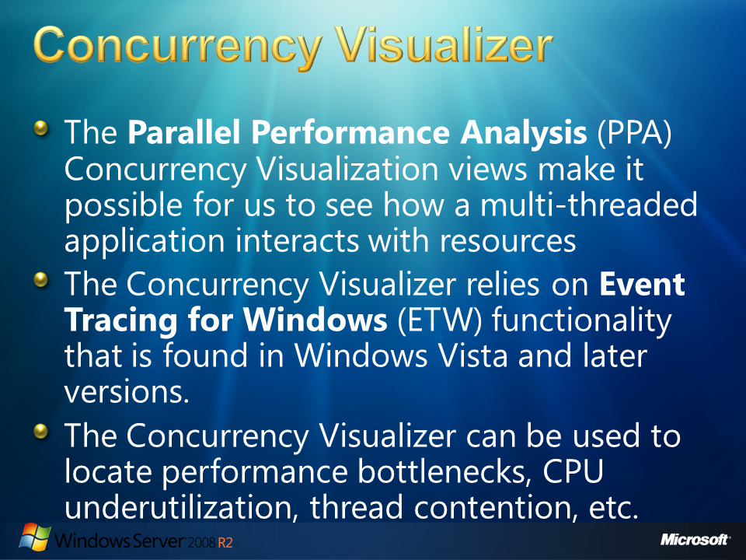
  2. Figure

## Concurrency Visualizer

The **Parallel Performance Analysis** (PPA) Concurrency Visualization views make it possible for us to see how a multi-threaded application interacts with the available hardware, the operating system, and other processors that are also running on the host machine. These views show the temporal relationships between your program threads and the system, presenting the regarded information graphically, and textually.

The Concurrency Visualizer relies on **Event Tracing for Windows** (ETW) functionality that is found in Windows Vista and later versions. ETW provides a set of event tracing features used to log and trace events that are raised by user-mode applications and kernel-mode drivers. For more information on ETW, please visit the following link: <http://msdn.microsoft.com/en-us/library/aa468736.aspx>

The Concurrency Visualizer can be used to locate performance bottlenecks, CPU underutilization, thread contention, thread migration, synchronization delays, and areas of overlapped I/O. Graphical output in the Concurrency Visualizer views is linked to call stacks and source code.

* 1. 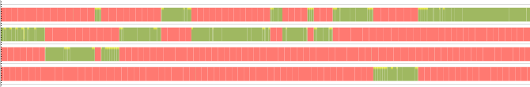
  2. Figure
  3. Lock Contention under Concurrency Visualization views

The high integration with Visual Studio 2010 enables application efficient workflows of test, build, analyze, fix, and retest.

After the application is executed, traced and logged, the Concurrency Visualizer analyzes the regarded information and presents it visually in three views:

* + **CPU Utilization View:** Describes system activity across all processors.
  + **Threads View (Parallel Performance):** Describes the interactions between threads in your program.
  + **Cores View:** Describes thread migration across cores.

For more information on the **Parallel Performance Analysis** (PPA) Concurrency Visualizer tool please visit the corresponding **MSDN** site: <http://msdn.microsoft.com/en-us/library/dd537632(VS.100).aspx>

* 1. 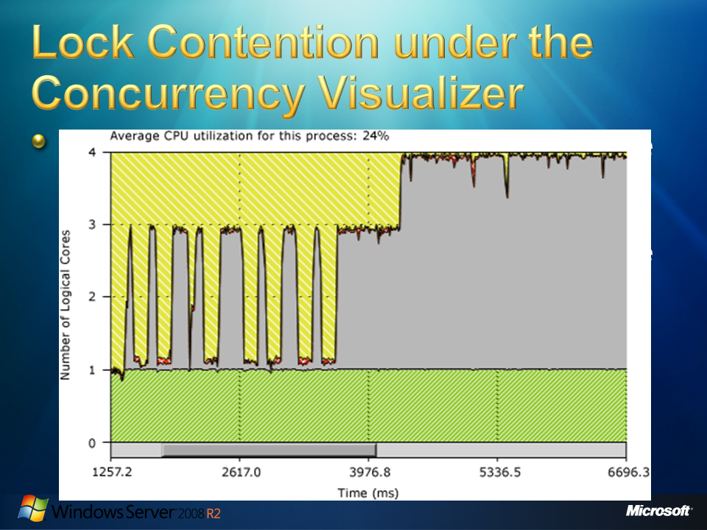
  2. Figure

## Lock Contention under Concurrency Visualizer

Sometimes, when you program a parallelized multithreaded application, it may seem to continue executing serially even though it has several threads and sufficient logical cores are available on the computer. You can notice this behavior as poor multi-threaded performance, even slower than the serial implementation.

Under Threads View, you won’t see multiple threads running in parallel; instead, you will see that only one thread is executing at a time. The Concurrency Visualizer can also expose this symptom in the CPU Utilization View, showing that the application is consuming the equivalent of one logical core (this does not mean all work it’s running on only one core. The diagram bellows shows that 25% of the CPU resources are being utilized)

* 1. 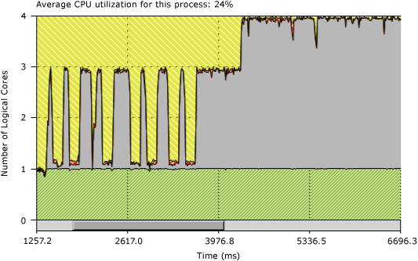
  2. Figure
  3. Lock Contention under CPU Utilization View
  4. 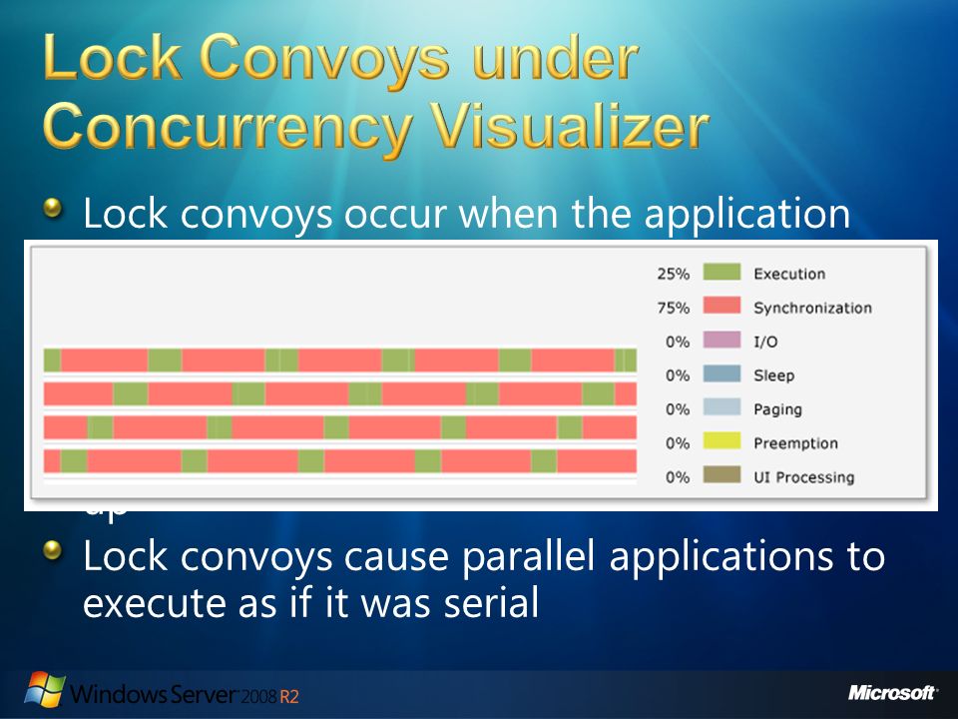
  5. Figure

## Lock Convoys under Concurrency Visualizer

1. Lock convoys occur when the application acquires locks in a first-come first-served order and the arrival rate at the lock is higher than the acquisition rate. The combination of these two conditions causes requests for the lock to start backing up.
   1. 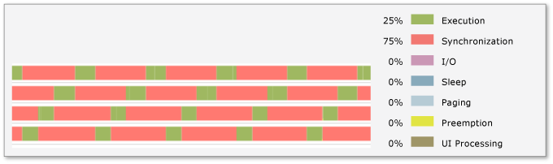
   2. Figure
   3. Lock Convoys under Concurrency Visualizer
2. When this happens, the parallelized multithreaded application executes serially even under parallelization, regardless of the amount of threads you create and the number of logical cores the computer may have. You will find poor multi-threaded performance, a bit slower than a serial implementation cause by the overhead of the locks plus the serialization of the execution. In the Threads View, you won’t see multiple threads running in parallel, only one thread executes at a given time.
3. If you click a synchronization segment in a thread, under Threads view, you can see a call stack for the blocked thread, or blocking call stack, and the thread that removed the blocking condition, or unblocking call stack. If the unblocking call stack occurs in the process you are analyzing, a Thread-Ready connector is displayed.
   1. 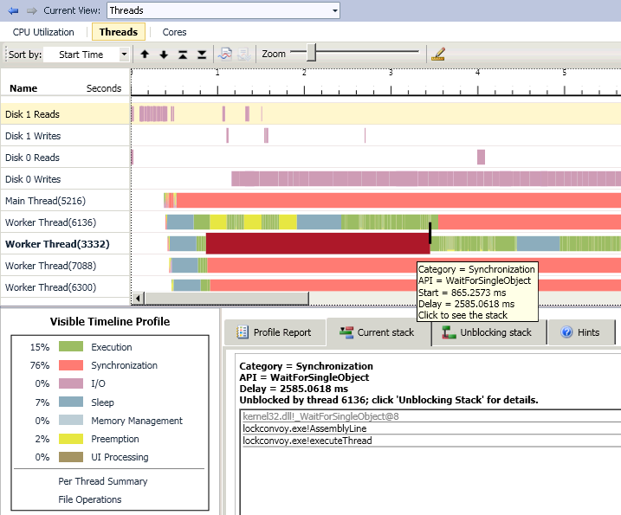
   2. Figure
   3. Threads view – Thread Ready connector
4. From this view, you can navigate to your code from the blocking and unblocking call stacks to further investigate the cause of serialization.
5. In order to avoid lock convoys you could try using 'unfair' locks, or locks that give access to the first thread to find them in unlocked states. The convoy behavior from this figure could be solved by reducing contention for the synchronization objects and using unfair locks.
   1. For additional information on Common Patterns for Poorly-Behaved Multithreaded Applications visit the MSDN site : <http://msdn.microsoft.com/en-us/library/ee329530(VS.100).aspx>
   2. A lock convoy occurs when multiple threads of equal priority contend repeatedly for the same lock. Unlike deadlocks and livelocks, the threads in a lock convoy do progress; however, each time a thread attempts to acquire the lock and fails, it loses the remainder of its scheduling quantum and a context switch is forced. The overhead of repeated context switches and underutilization of scheduling quanta degrade overall performance.

Lock convoys can sometimes be addressed by using non-locking alternatives such as lock-free algorithms or by altering the relative priorities of the contending threads. For additional information on non-locking alternatives

* 1. 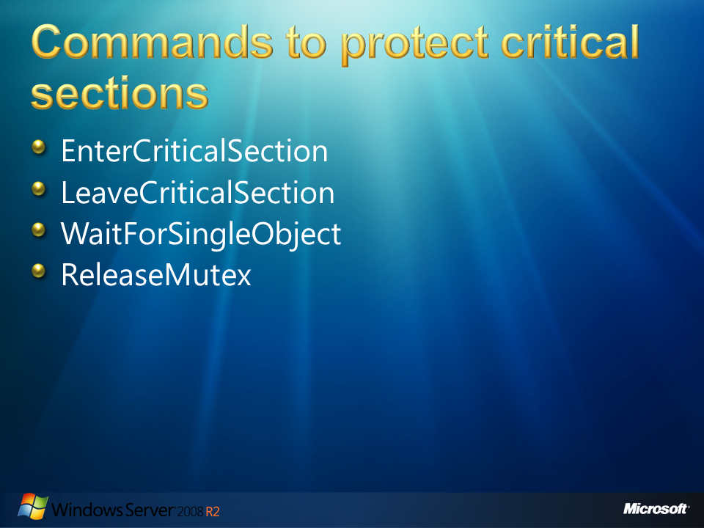
  2. Figure

## Commands to protect critical sections

* 1. Some of the commonly used commands to protect critical sections are:
  + **EnterCriticalSection**: Waits for ownership of the specified critical section object. The function returns when the calling thread obtains the ownership. The threads of a single process can use a critical section object for mutual-exclusion synchronization.
    1. C++
    2. void WINAPI EnterCriticalSection(
    3. __inout LPCRITICAL_SECTION lpCriticalSection
    4. );

The process is responsible for allocating the memory used by a critical section object declaring a variable of type **CRITICAL_SECTION**. Before using a critical section, a process thread must call **InitializeCriticalSection** to initialize the object.  
In order to enable mutually exclusive access to a shared resource, each thread must call the **EnterCriticalSection** function to request ownership of the critical section before executing any section of code with accesses to the protected resource. For additional information please visit the **MSDN** site:

* + 1. <http://msdn.microsoft.com/en-us/library/ms682608%28VS.85%29.aspx>
  + **LeaveCriticalSection**: Releases ownership of the specified critical section object.
    1. C++
    2. void WINAPI LeaveCriticalSection(
    3. __inout LPCRITICAL_SECTION lpCriticalSection
    4. );

For additional information please visit the **MSDN** site:

* + 1. <http://msdn.microsoft.com/en-us/library/ms684169%28VS.85%29.aspx>

**WaitForSingleObject**: Waits until the specified object is in the signaled state or the time-out interval elapses. The WaitForSingleObject function checks the current state of the specified object. If the object's state is non-signaled, the calling thread enters the wait state until the object is signaled or the time-out interval elapses.

* + 1. C++
    2. DWORD WINAPI WaitForSingleObject(
    3. __in HANDLE hHandle,
    4. __in DWORD dwMilliseconds
    5. );

For additional information please visit the **msdn** site:

* + 1. <http://msdn.microsoft.com/en-us/library/ms687032%28VS.85%29.aspx>
  + **ReleaseMutex**: Releases ownership of the specified **mutex** object. The ReleaseMutex function fails if the calling thread does not own the mutex object. When the thread no longer needs to own the mutex object, the ReleaseMutex function should be called so that another thread can acquire the ownership.

A thread can specify a mutex that it already owns without blocking its execution. This prevents a thread from deadlocking itself while waiting for a mutex that it already owns. However, to release its ownership, the thread must call ReleaseMutex one time for each time that it obtained ownership.

* 1. **Note:** EnterCriticalSection and LeaveCriticalSection functions use variables of **CRITICAL_SECTION** type; these methods are known as Critical Sections. The use of WaitForSingleObjec and ReleaseMutex is known as Mutex.
  2. 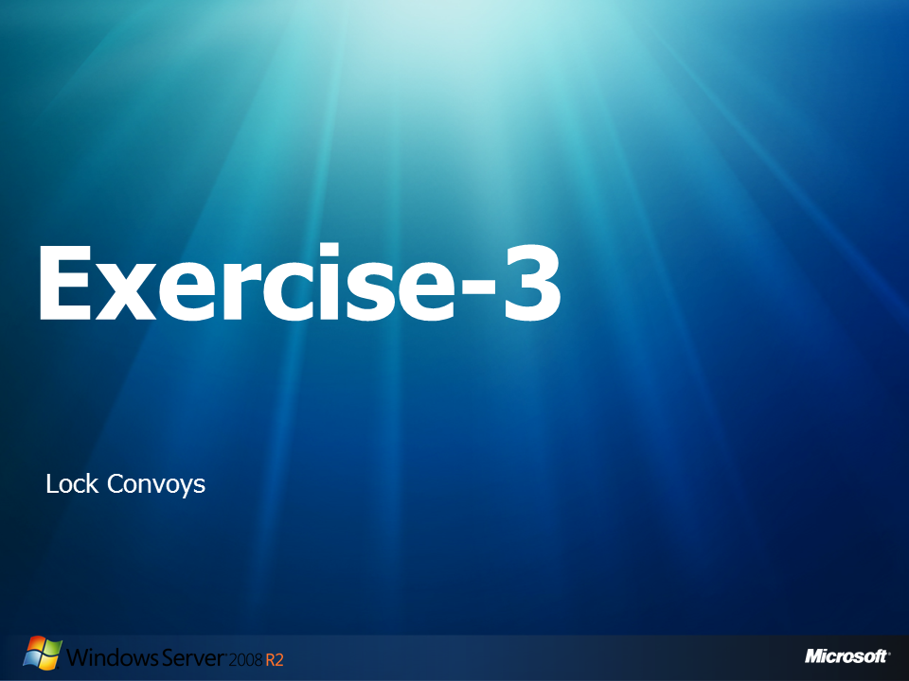
  3. Figure

## Exercise-3: Lock Convoys

* 1. Lock convoys occur when multiple threads repeatedly compete for the same protected region. On the present exercise you will run, debug and identify a lock convoy produced by multiple threads repeatedly doing some amount of work outside the protected region but then taking a lock to do additional work inside the protected region.
  2. As we discussed in the background of this exercise, performance problems might result depending on the ratio between the work inside and outside of the locked region. We are going to use the Parallel Stacks window to catch the problem during execution. Then, we will also visualize the problem, after the application’s execution, utilizing the concurrency profiler, available under Visual Studio 2010.

### Part 1: Running the application

* 1. Open **Microsoft Visual Studio 10.0** as administrator:
     1. 
     2. Figure

Run as administrator option

* 1. Navigate to **File -> Open -> Project Solution** and open the solution that will be used in this lab:
     1. C:\Server 2008 R2 Labs\Solving Concurrency Issues\Exercise-3\lockConvoy.sln
  2. From the Solution Explorer, double click the **lockConvoy.cpp** file.
     1. **Note:** This application is the representation of 4 Assembly Lines for the assembly of a special kind of machine. In this scenario, our Assembly line is intended to create a certain number of these machines. There are two important phases on the creation of each machine: assembling the hardware and installing the software. Hardware assembling is supposed to take 100 milliseconds per machine. On the other hand, installing the software is a complex process, for these illustrative example machines, and it takes 1 second for the first installing stage, then the assembly line must wait for half a second and continue installing for an extra second. The main problem is that the owner wants to keep strict control of the number of assembled machines, and each machine must indicate its corresponding creation number when created. This creation number is a share resource and it is assigned to each machine as soon as it’s assemble is started.
  3. Navigate to the **main** function and examine the source code.
     1. C++

1. int main()
2. {
3. CONST int MAX_THREADS = 4;
5. HANDLE hThread[MAX_THREADS];
6. DWORD dwID[MAX_THREADS];
7. DWORD dwRetVal = 0;
8. int param[MAX_THREADS];
10. InitializeCriticalSection(&g_CriticalSection); //For Critical Section use
11. hMutex = CreateMutex(NULL,FALSE,NULL); //For Mutex use
    * 1. **Note:** First the code initializes a Critical Section and a Mutex. Further in the exercise, we will use them to demonstrate different behaviors and their representations on the debugger tools.
      2. C++
12. //release the threads.
13. for(int i = 0; i< MAX_THREADS;i++){
14. param[i]=i+1;
15. hThread[i] = CreateThread(NULL,0,(LPTHREAD_START_ROUTINE)executeThread,&param[i],0,&dwID[i]);
16. std::cout << "Assembly Line " << i+1 << " created on Thread " << dwID[i] << std::endl;
17. }
19. //wait for all threads to complete before continuing
20. dwRetVal = WaitForMultipleObjects(MAX_THREADS, hThread, TRUE, INFINITE);
21. //close handles
22. for(int i = 0; i< MAX_THREADS;i++)
23. CloseHandle(hThread[i]);
24. std::cout << "Assembly Lines finished working " << std::endl;
25. Sleep(4000);
26. return 1;
27. }
    * 1. **Note**: Then, the code creates 4 threads using the CreateTread function. This function will create each thread using the code found on the executeThread() function. After the threads execute the code, they will wait for them to finish using the **WaitForMultipleObjects** function. Finally, the code closes each thread handle, prints an ending message and after 4 seconds it finishes the execution.
      2. C++
      3. long WINAPI executeThread(long lParam)
      4. {
      5. int threadNum = *((int*)lParam);
      7. AssemblyLine(threadNum);
      8. std::cout << "Thread " << threadNum << " finished." << std::endl;
      9. return 0;
      10. }
      11. **Note:** The **executeThread** function, as you can see in the code, calls the **AssemblyLine** function and after it finishes, it prints a message specifying that the thread has finished. It also prints the thread id to help us identify each thread and its associated assembly line, during debugging.
      12. C++
      13. void AssemblyLine(int Param)
      14. {
      15. int assemblyLineID = Param;
      16. int current_number = 0;
      18. std::cout << "Assembly Line " << assemblyLineID << " start working." << std::endl;
      19. Sleep(300);
      20. //Lock convoy:
      21. #ifdef LOCK_CONVOY_EXAMPLE
      22. while(i_serialNumber<10){
      24. assembleHardware();
      26. WaitForSingleObject(hMutex,INFINITE); //For Mutex use
      27. installingSoftware();
      28. Sleep(500);
      29. installingSoftware();
      30. std::cout << "Assembly Line " << assemblyLineID << " finish creating machine:" << i_serialNumber << std::endl;
      32. i_serialNumber++;
      33. ReleaseMutex(hMutex); //For Mutex use
      34. }
      35. #endif
      36. ...
      38. **Note:** The **AssemblyLine** function starts by printing its id number and then, it sleeps for 300 milliseconds simulating the time for the assembly line to start working. After sleeping, the assembly line will create machines until the shared resource **i_serialNumber** gets the goal indicated in the while stop condition (in this case 10).
      39. First, the assembly machine will invoke **assembleHardware** function, which simulates the job required for assembling the hardware on each machine.
      40. Secondly, the code will try to enter on the locked restricted area corresponding to the critical code section where the share resource is going to be used. This restricted area is protected by a **Mutex** by using functions: **WaitForSingleObject(hMutex,INFINITE)** and **ReleaseMutex(hMutex)**. If a thread gains the access to this lock, other threads that attempt to enter this code at the same time will have to wait until the first thread release the lock using ReleaseMutex.
      41. If the thread gains access to the critical section, it will proceed with the installation of the software by calling the **installingSoftware** function. It will sleep for half a second and simulate again the installation of the resultant software. Having completed all these processes, the assembly line prints a message showing that a new machine was created, indicating the corresponding machine’s serial number. Finally, the assembly line increments by one the serial number and releases the Mutex.
      42. C++
      43. static void assembleHardware() {
      44. unsigned long int t=GetTickCount()+(100L*1);//wait awake for 0.1 second
      45. while(GetTickCount() < t ){ /* Wait !!!*/ } //simulates 0.1 second of continuous work
      46. }
      47. **Note:** The **assembleHardware** function simulates the time for the Assembly line to assemble the hardware of each machine. To achieve this goal, this function implements a busy waiting cycle, where the process will keep cycling until a specific amount of time passes. In this case the interval of work is going to be 100 milliseconds. Contrary to the sleep, busy waiting uses the process time slice assigned to it, it simulates continuous process job and can be interrupted when the process time slice gets over, and continues when it gains processor control again.
      48. **Sleep** function puts the thread to sleep (wait while the CPU is being used by other processes) until the scheduler wakes it up. It puts a thread to sleep for a specified time, during which the thread will waste no CPU time.

Spinning or busy waiting is an alternative way of waiting without sleeping. It keeps the CPU busy, and prevents other threads from using the CPU until the spinning thread finishes its timeslice and it is preempted. Spinning has the advantage of being able to stop at the very moment the stop condition is achieved. This happens because it continuously checks for the condition. No time is needed for the process to be woken up because the process is already awake. It doesn't invoke the CPU instructions required to go to sleep and to wake up again.

* + 1. C++
    2. static void installingSoftware(){ // Simulates the time for installing software on each machine
    3. unsigned long int t=GetTickCount()+(1000L*1);//wait awake for 1 second
    4. while(GetTickCount() < t ){ /* Wait !!!*/ } //simulates 1 second of continuous work
    5. }

**Note:** **InstallingSoftware** function also uses the busy waiting or spinning technique to simulate the time for installing software on each machine.

* 1. **Rebuild** the solution and run the code by selecting **Build🡪Rebuild Solution** and then **Debug🡪Start Without Debugging** , from the main menu.
     1. 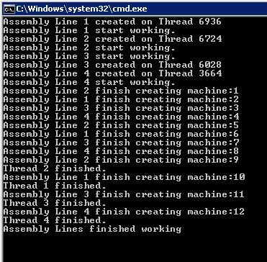
     2. Figure
     3. Application results - LockConvoy
     4. **Note:** You should notice that even when each of the four Assembly Lines start working in parallel, and each of them create a very similar amount of machines, each machine takes a long time to be created. It seems that after an assembly line finishes a machine another assembly line starts working on its machine. If we consider that according to the specification each machine takes less than 3 seconds to be completely assembled, having four assembly lines (threads of execution) does not seem to be increasing the overall production.
  2. Close the window once the program finishes execution.

### Part 2: Debugging the Application

* 1. Switch back to Visual Studio and select **Debug 🡪 Start Debugging**, from the main menu.
     1. **Note:** Wait until the Assembly Lines have created three or four machines.
     2. 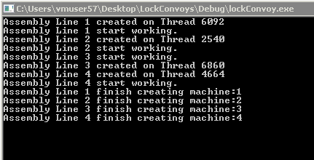
     3. Figure

Output with 4 machines created

* 1. Switch back to Visual Studio and **pause** the execution.
     1. 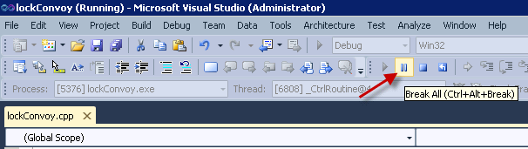
     2. Figure

Break All option pauses execution for debugging

* 1. Select **Debug🡪Windows 🡪Parallel Stacks**.
     1. 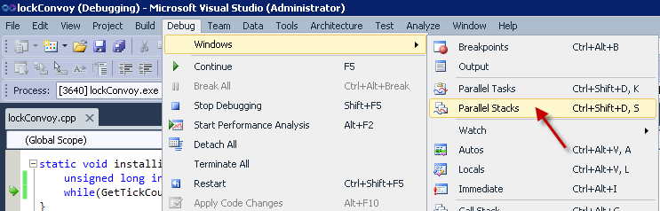
     2. Figure
     3. Opening Parallel Stacks Window
     4. **Note:** Make sure that you have the **Threads** view selected.
  2. 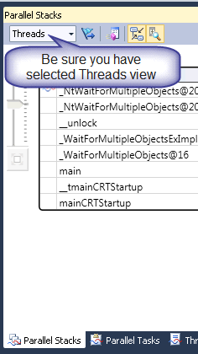
  3. Figure
  4. Threads View selected
     1. **Note:** On the Parallel Stacks, on this particular application you will identify different possible scenarios, as we will see, but the most probable scenario is going to be the one shown on this next figure. If you got a different scenario you can continue execution by selecting **Debug 🡪 Continue** and pause again. At any moment, if your application gets to the end you can start it and debug it again.
     2. 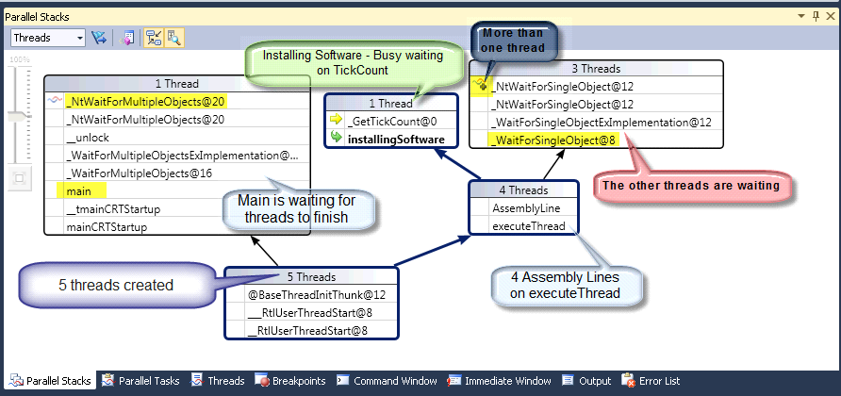
     3. Figure
     4. Parallel Stacks view showing a possible Lock Convoy
     5. **Note:** In this scenario you can see that five threads were created. One corresponds to the main function and 4 are the threads we created to simulate each of the four assembly lines of our application. Your view could also present other threads which are created on background of your application, but for the purpose of this lab you can ignore them.
     6. The thread corresponding to the main function is waiting for the four created threads to finish. You can identify this thread because it contains the word **main** in its call stack. This main word corresponds to the main function call. If you go up on the same thread’s call stack you will find that this main thread is currently on a **_NtWaitForMultipleObjects** operation. This corresponds to our call to **WaitForMultipleObjects** function on the main.
     7. 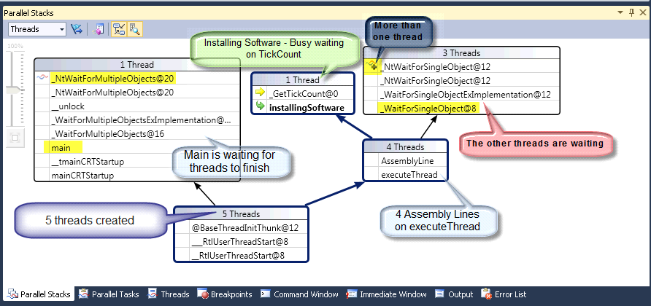
     8. Figure

Main Thread – Waitingfor

* + 1. **Note:** As this function is a WINAPI call, its code is not going to be defined on our code, but if you wish you could double click on the **main** word on the thread stack to be redirected to the main source code, exactly on the **WaitForMultipleObjects** function invocation.
    2. 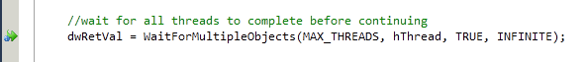
    3. Figure

WaitForMultipleObjects function

* + 1. **Note:** Back on the Parallel Stacks window, you can see that four threads are executing the **executeThread** function which then called the **AssemblyLine** function. This box is divided in one thread that is executing the **installingSoftware** function, and three threads that are waiting.
    2. 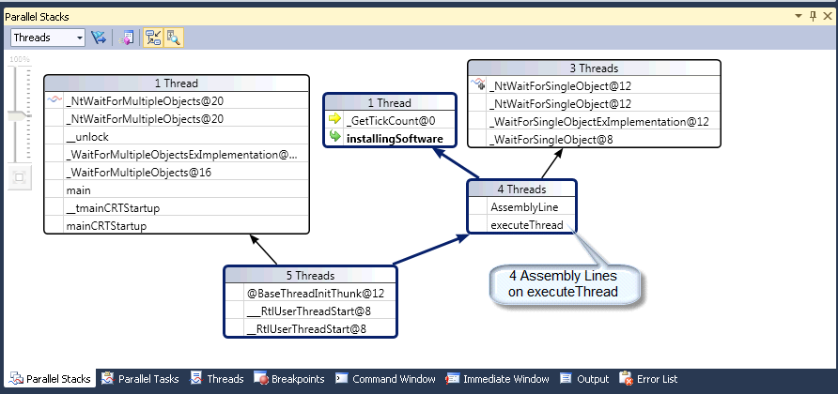
    3. Figure

Threads on executeThread function

* + 1. **Note:** If you go further on the stack of the thread that is executing the **installingSoftware** function, you can see that it is currently getting the tick count (**_GetTickCount** WINAPI call).
    2. 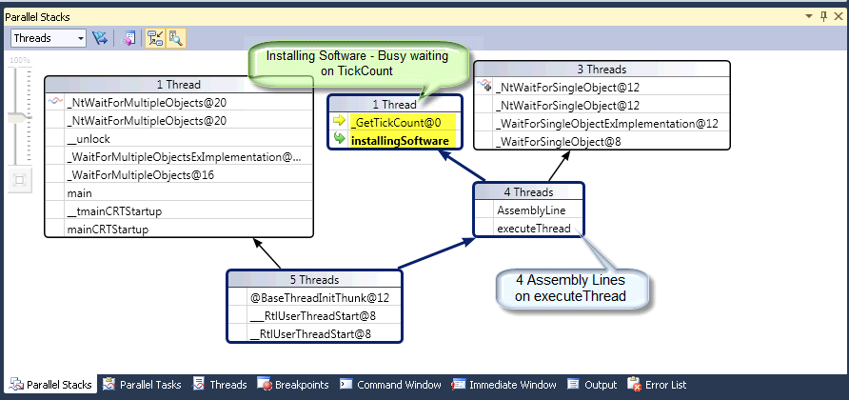
    3. Figure

InstallingSoftware on WINAPI call

* + 1. **Note:** If you double click on the installingSoftware call of the stack the corresponding code will be shown.
    2. 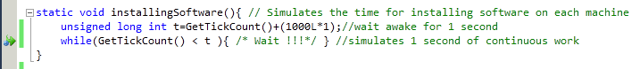
    3. Figure

GetTickCount call

* + 1. **Note:** If you right click on the **GetTickCount** WINAPI function and select **Go to Definition**, the WinBase.h file will show you the WINAPI declaration.
  1. 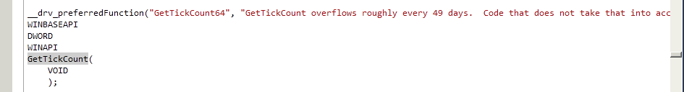
  2. Figure
  3. WinBase.h file
     1. **Note:** The other three threads, on the Parallel Stacks, are waiting for the thread with the Mutex control.
     2. 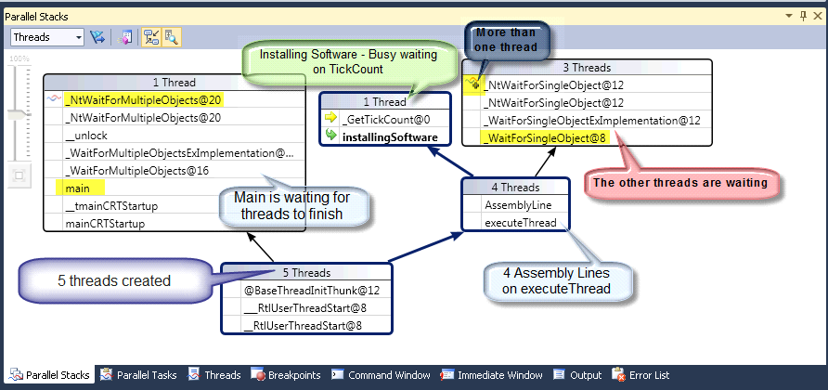
     3. Figure
     4. Three threads are waiting
     5. **Note:** If you right click over AssemblyLine and select **Go to Source Code** you will see the code where each thread tries to enter the Mutex : **WaitForSingleObject(hMutex,INFINITE)** . This means that one thread gained the Mutex and the other three are still waiting.
     6. 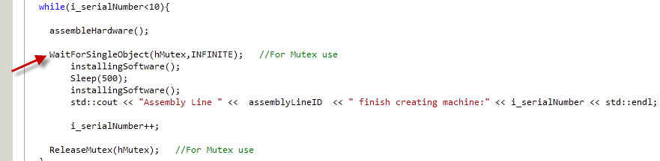
     7. Figure

WaitForSingleObject call

* + 1. **Note:** If you repeat this debugging for several times you will find similar results, meaning that something strange is happening with our parallel application, where the four threads seems to arrive at similar times to the critical section, where just one thread gains the control. But also this thread with the control seems to have this control for a long period of time.
  1. **Note:** Another possible scenario is to find a thread on the **assembleHardware** function. You can visualize this scenario by mere coincidence or you can add a breakpoint inside the assembleHardware function:
     1. 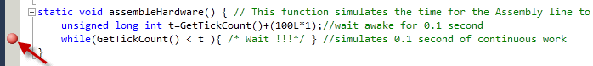
     2. Figure
     3. Inserting a breakpoint on assembleHardware
     4. **Note:**  You could then continue debugging and when the application pauses you will find a scenario like the following.
     5. 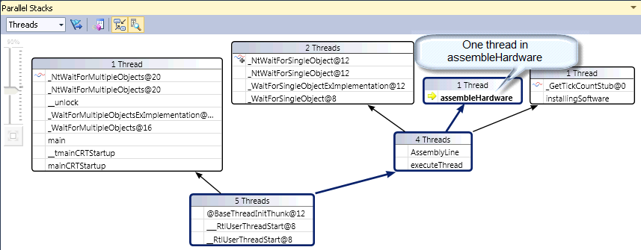
     6. Figure

One thread on assembledHardware function

* 1. Select **Debug🡪Stop Debugging**.

### Part 3: Using the Performance Profiler Analyzer

* 1. Select **Analyze**🡪**Launch Performance Wizard…**
     1. 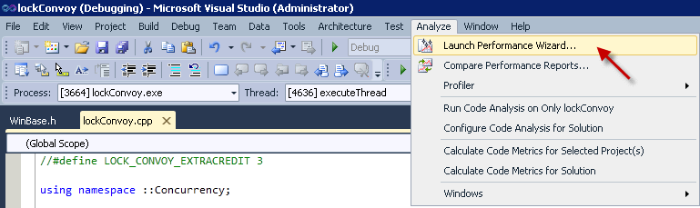
     2. Figure

Launch Performance Wizard option

* 1. On the **Performance Wizard** window select **Concurrency** and then **check** the option for **Visualize the behavior of a multithreaded application**.
     1. 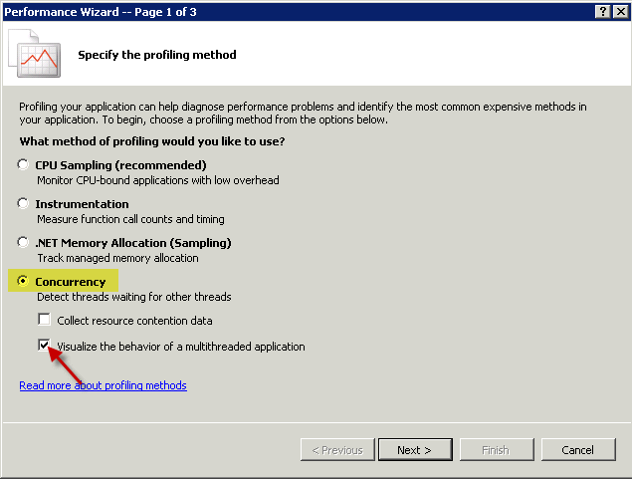
     2. Figure
     3. Visualize the behavior of a multithreaded application
  2. Click **Next**.
  3. On the second Page, also click **next**.
     1. 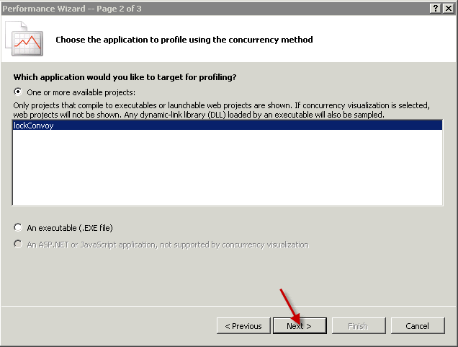
     2. Figure

Next on page 2

* 1. On page 3, make sure that the **Launch profiling after the wizard finishes** option is select and click **Finish.**
     1. 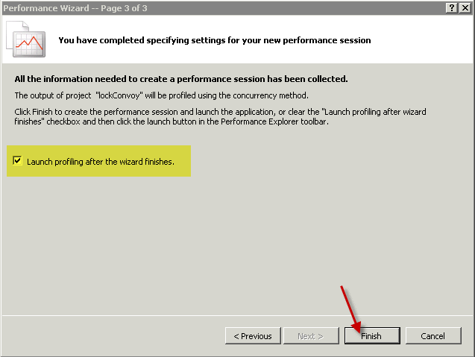
     2. Figure

Click finish on third page

* + 1. 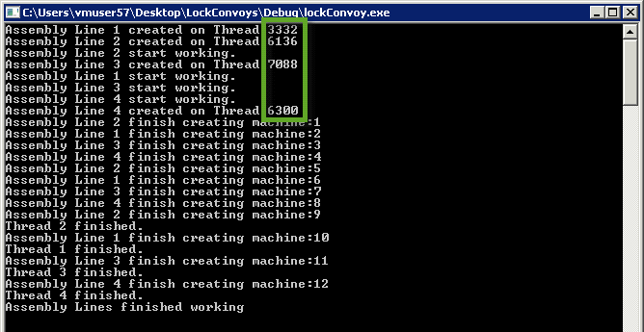
    2. Figure

Application running – Threads id’s selected

* + 1. **Note:** The application executes as usual but it is being analyzed and after a while the Concurrency Visualization window shows the results. Three views are available: CPU Utilization, Threads, and Cores view.
    2. 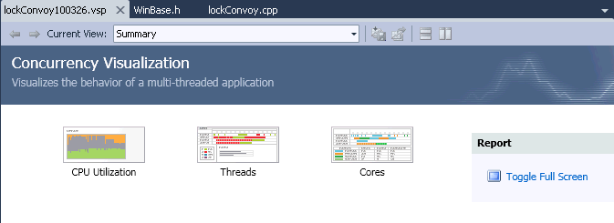
    3. Figure

Concurrency Visualization window

* 1. Click on the **CPU Utilization view**
     1. 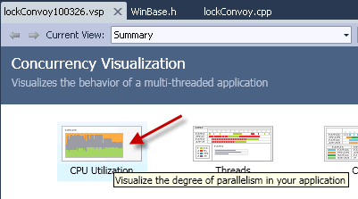
     2. Figure
     3. CPU Utilization option
     4. **Note:** The CPU Utilization view indicates, in green color, how much CPU our application utilizes during its execution, from the 4 core CPU power available on the demo machine. The green area indicates idle process, and the yellow color corresponds to the CPU utilization of other threads running on the demo machine at the same time of our application.
     5. 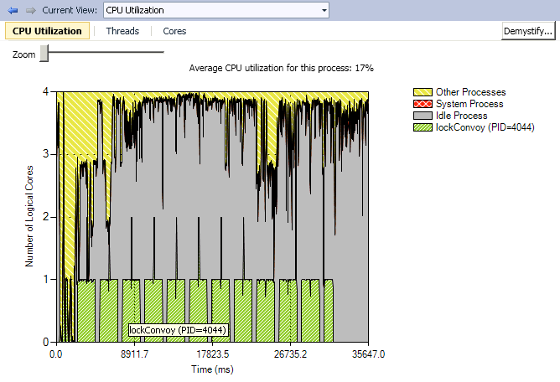
     6. Figure
     7. CPU Utilization view

**Note:** From these results we can clearly see that our parallel application is not utilizing the complete four cores power of our demo machine. The legend indicates, in this example, an Average CPU utilization for our lockConvoy process is of 17%. It seems that, according to the green area, our multithreaded application only uses one CPU unit of power. You can also see that periodically the execution stops for a period of time and then resumes.

These results match completely with the information we got from the Parallel Stacks window and the code analysis. It seems that the idle time (gray area) during execution corresponds to the half second where we invoke the **sleep** function, between the two **installingSoftware** functions, in the code.

The Sleep function puts the thread to wait while freeing the CPU to be used by other processes. During the sleep our threads waste no CPU time. By this time we have a better picture of our application, and we have identified a poor behavior on our multithreaded application. Now, we must figure out why our application behaves this way, and find a possible solution.

* 1. Select the **Threads** view.
     1. 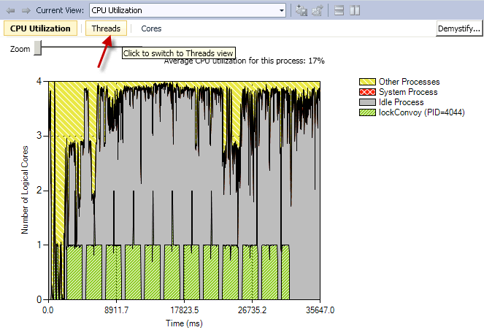
     2. Figure
     3. Threads View option
     4. 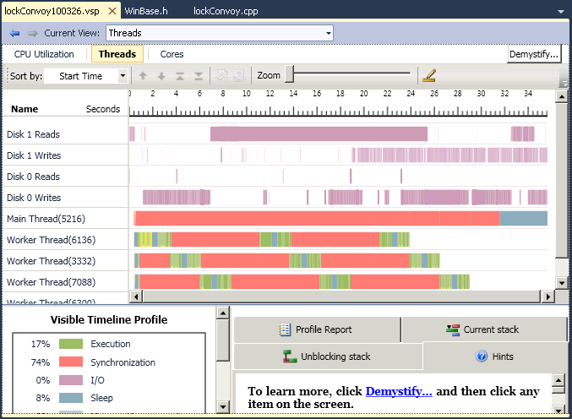
     5. Figure
     6. Threads view
  2. Click on **View🡪Full Screen**.
     1. 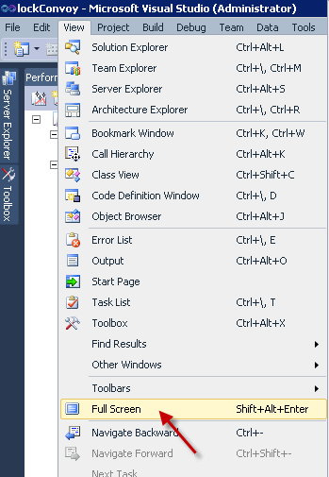
     2. Figure
     3. Full Screen option
     4. **Note:** On this view you can see how the threads running on the machine were executed and what they do on each stage of their execution. You can see threads corresponding to other processes like: disk reads and writes. If you want you can right click on those processes and hide them.
     5. 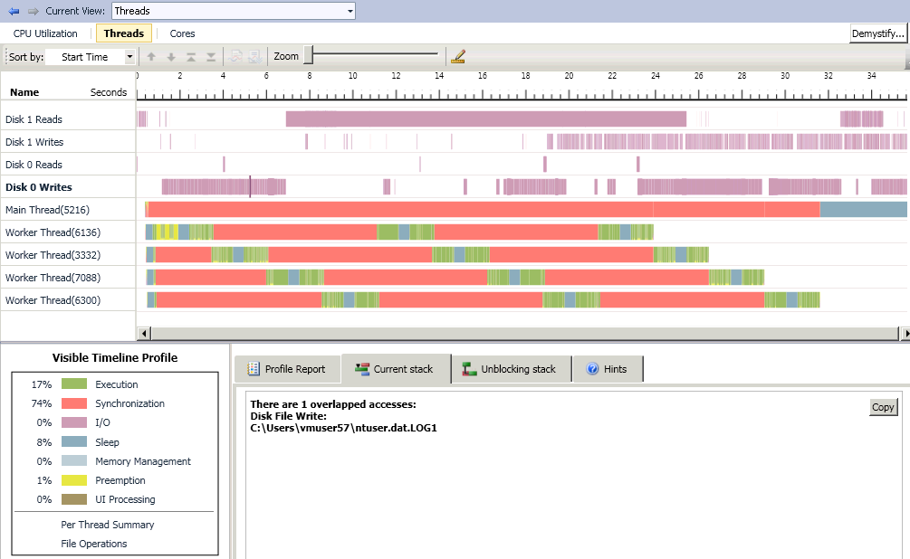
     6. Figure
     7. Threads view – application’s global picture
     8. **Note:** The first thing you will notice is a stair step behavior on the execution of each thread. In green you can see how when the first thread is executing, others threads seems to be on a synchronization phase. Once the thread finishes the next thread starts its execution phase, and so on. Then the cycle starts again. This is a typical behavior of a bad use of critical sections and locks. The legend indicates us that around 74% of the analyzed execution was spent on Synchronization and just 17% corresponds to effective process execution.
     9. A good hint to start understanding the application’s behavior is the gray area between each execution. You can see how each execution is made up of a green section, then a gray section and ends with a green section. Again this matches completely with our code. We call the assembleHardware function, secondly the installingSoftware function, and then we invoke a sleep, and finally the second installingSoftware function again.
  3. Click on a gray area between a stair step execution.
     1. 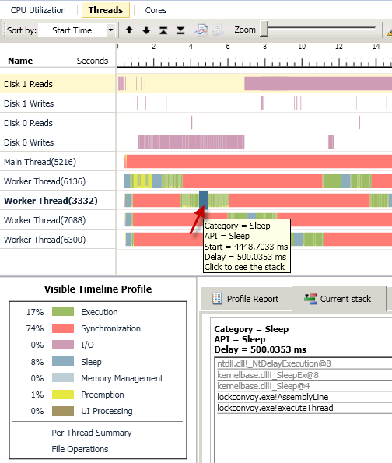
     2. Figure

Threads view shows the Stack for the selected area

* + 1. **Note:** The information presented by the data tip and the Current Stack tab confirms our hypothesis. These gray areas corresponds to the sleep calls inside the **lockconvoy.exe!AssemblyLine** function.
  1. Zoom in the view until you can appreciate two steps of execution as in the following picture:
     1. 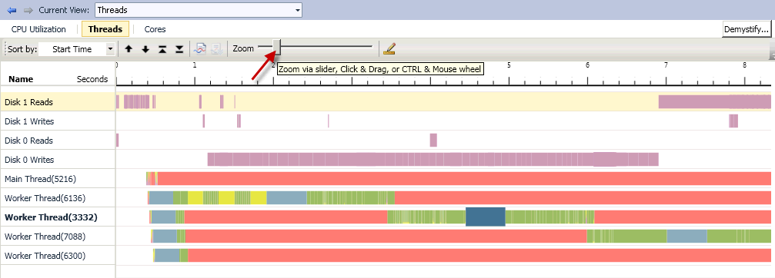
     2. Figure
     3. Threads view zoom
     4. **Note:** On this zoomed view, you can see how each period of execution starts a little bit before the previous thread finish its execution period.
  2. Click on the first green area of the second thread execution period, as shown in the following picture:
     1. 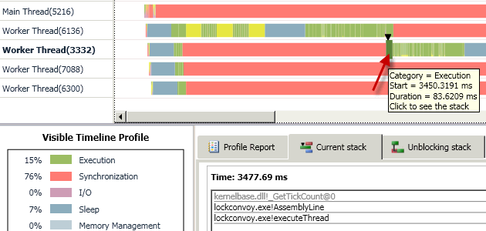
     2. Figure
     3. Second thread execution
     4. **Note:** You can see on the Current stack how this execution period corresponds to the execution of the AssemblyLine function, properly on a GetTickCount.
  3. Click on the red area on the right of this execution period.
     1. 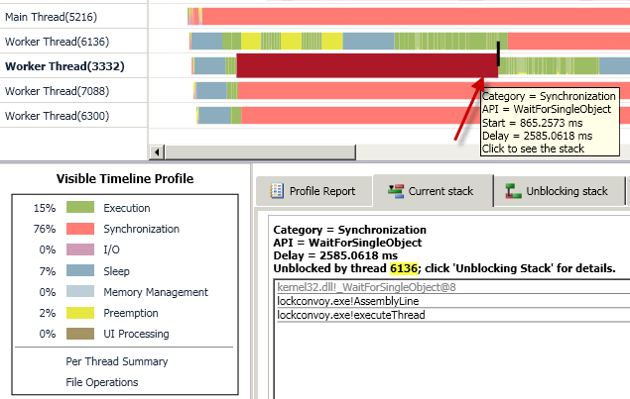
     2. Figure
     3. Threads view – Synchronization
     4. **Note:** This informationreveals us that this thread (3332 in this example) was waiting for a lock until thread 6136 released it. We can also see that after thread 6136 released the lock (a Mutex in our case) it continued executing for a while.
     5. By the size of the red highlighted area you can deduce that the first thread took control of the Mutex the mayor part of this execution phase. If you analyze the rest of the execution phases and their synchronization periods you will find similar results.
  4. Double click on the **lockconvoy.exe!AssemblyLine** line in the **Current stack** tab.
     1. 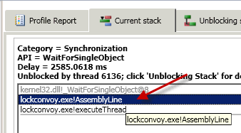
     2. Figure
     3. Current stack - View source
     4. **Note:** You will be redirected to the corresponding **AssemblyLine** code, where you will see the **WaitForSingleObject** function call that is provoking the synchronization waiting.
     5. 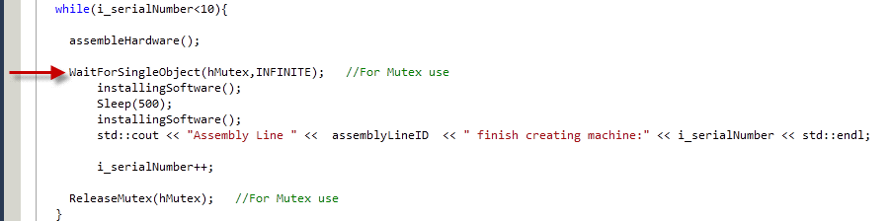
     6. Figure

Poor behavior responsible code

* + 1. **Note:** Using all the knowledge we get from the code analysis, the Parallel Stacks information and the Parallel Performance Analyzer views, we can get to a conclusion.
    2. The little periods of time running in parallel, on every thread, corresponds to the assembleHardware function which is out of the Mutex. This function consumes relative little time as it takes only 100 milliseconds.
    3. 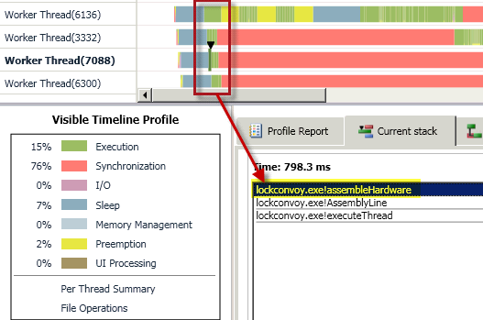
    4. Figure
    5. Assemble Hardware running in parallel
    6. **Note:**  Inside the Mutex:
       1. 1) An installingSoftware function (1 second of execution) is called;   
           2) Follows a Sleep function (half a second sleeping) is called. At this moment, even on a single core machine, other process should take advantage of processor time. The problem is that the available threads are waiting for the Mutex locked by this sleeping thread. Therefore, all the threads should also wait.   
           3) After sleeping, another installingSoftware function is executed.   
           4) A successful message is shown with the new machine corresponding serial number.  
           5) The serial number is incremented.
       2. Finally, the Mutex is released and the next thread can continue its execution while the other threads wait on a synchronization stage.
  1. 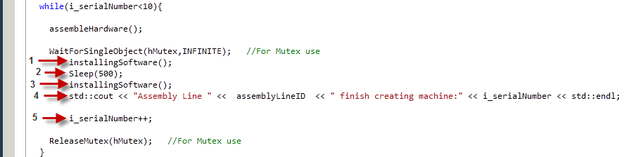
  2. Figure
  3. Code inside the Mutex
     1. **Note:** By analyzing the code you will understand that we are unnecessarily protecting a big critical area, even when the shared resource (the serial number) is not used on all the code, until steps **4** and **5**. This seems like the scenario of a lock contention on an important amount of code where the contention area could be reduced.
     2. The code out of the lock is little while the code inside the lock is very significant. Also, all the threads are constantly trying to access the critical section creating a high demand. These two factors are the cause of our lock convoy problem
  4. Back on the Parallel Performance Analyzer results, Select Cores view
     1. 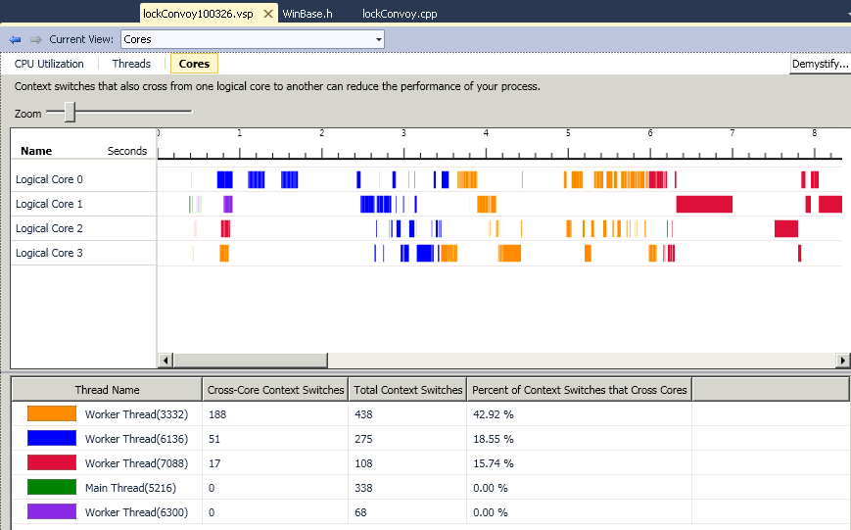
     2. Figure
     3. Cores View
     4. **Note:** Cores view shows you the context switches that cross from a logical core to another. In this representation of our application you can also appreciate that there are periods in time where the four cores free.

### Part 4: Fix the application

* 1. Switch back to the **lockConvoy.cpp** source code
  2. Scroll the code up until you get to the Preprocessor declarations around line **22**.
     1. C++

1. #define LOCK_CONVOY_EXAMPLE 1
2. //#define LOCK_CONVOY_FIX 2
3. //#define LOCK_CONVOY_EXTRACREDIT 3
   1. Comment out the **LOCK_CONVOY_EXAMPLE** and uncomment the **LOCK_CONVOY_FIX**
      1. C++
4. //#define LOCK_CONVOY_EXAMPLE 1
5. #define LOCK_CONVOY_FIX 2

//#define LOCK_CONVOY_EXTRACREDIT 3

* + 1. **Note:** This action will enable an alternate solution to our Mutex problem:
    2. C++

#ifdef LOCK_CONVOY_FIX

1. while(i_serialNumber<100){
3. assembleHardware();
5. WaitForSingleObject(hMutex,INFINITE); //For Mutex use

**current_number**=i_serialNumber;

1. i_serialNumber++;
2. ReleaseMutex(hMutex); //For Mutex use
3. installingSoftware();

Sleep(500);

1. installingSoftware();
2. std::cout << "Assembly Line " << assemblyLineID << " finish creating machine:"
3. << current_number << std::endl;
4. }
5. #endif
   * 1. **Note**: In this new code you can see that we reduce significantly the size of the critical section, by using a temporal variable (**current_number**) in order to remember the serial number. Immediately we increment the serial number and release the shared resource by releasing the lock to make other threads able to use it.
     2. We changed the while stop condition to 100 to give you some time for debugging, otherwise the application will finish too fast when you want to see the Parallel Stacks window
   1. Remove any breakpoints you may have in your source code..
   2. Switch back to Visual Studio and select **Debug 🡪 Start Debugging**, from the main menu.
      1. 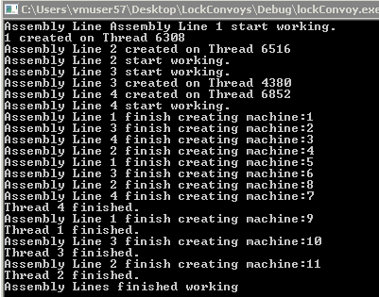
      2. Figure

Application changes results

* 1. During execution, switch back to Visual Studio and **pause** the execution.
  2. Select **Debug🡪Parallel Stacks**.
     1. **Note:** You will find that now more than one thread could be on the installingSoftware function. Keep running and pausing to confirm this.
     2. 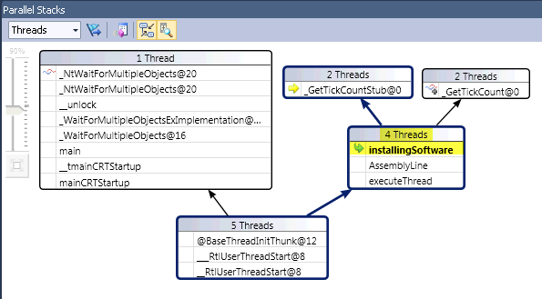
     3. Figure

Parallel Stacks – More threads running in parallel

* + 1. 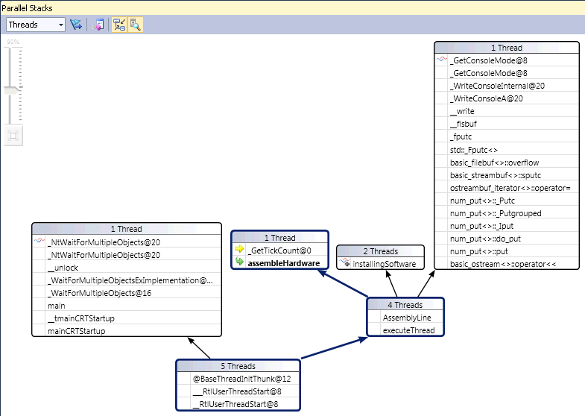
    2. Figure

Parallel Stacks – printing and assembleHardware

* + 1. 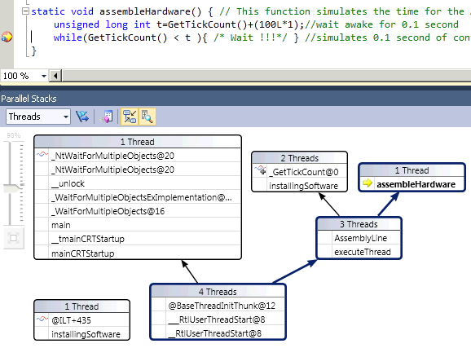
    2. Figure
    3. Threads view – InstallingSoftware and assembleHardwareusing break
    4. **Note:** You will notice that each time you break the execution and analyze the results under Parallel Stacks all the threads are now executing and not waiting for the critical section.
  1. Select **Debug🡪Stop Debugging**.
  2. Select **Analyze🡪Launch Performance Wizard…**
  3. On the **Performance Wizard** window select **Concurrency** and then **check** the option for **Visualize the behavior of a multithreaded application**.
  4. Click **Next**.
  5. On the Page 2, also click **Next**.
  6. On page three, make sure that the **Launch profiling after the wizard finishes** option is select and click **Finish.**
     1. 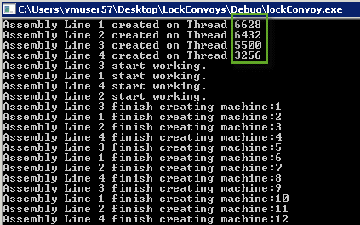
     2. Figure
     3. Execution Threads ids
     4. **Note:** The application executes and after a while the Concurrency Visualization window shows the results.
  7. Click on the **CPU Utilization** view
     1. 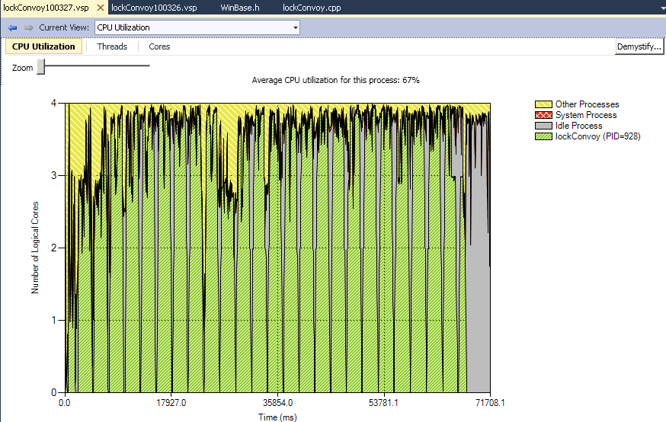
     2. Figure
     3. Cores View
     4. **Note:**  This time you can see how the application is now taking advantage of the four cores processor power of our demo machine. The legend at the top of the chart indicates a 67% of average CPU utilization for our process.
  8. Select the **Threads** view.
     1. 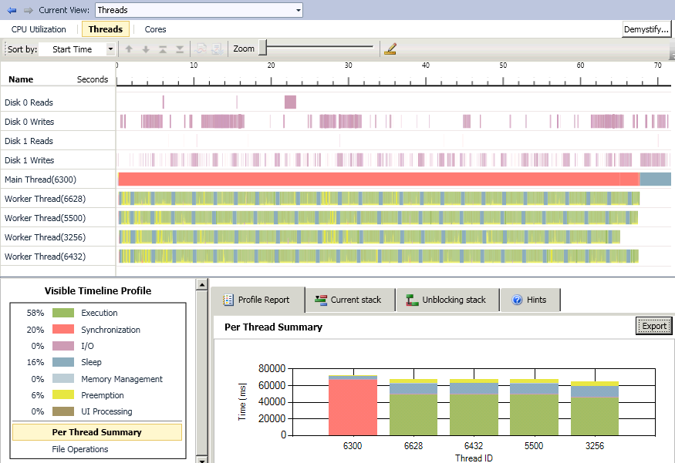
     2. Figure
     3. Threads view – Lock Convoy fixed
     4. **Note:** On this view you can notice how all the threads are now executing as concurrently as possible. Green areas are combined with preemption (yellow) and sleep (in gray), but no synchronization is visible in the graphic. The legend indicates a 58% execution with 20% of Synchronization, mostly corresponding to the main thread that is waiting for the end of the application, 16% of sleep and 6% of preemption. This time you can see, visually represented, that this synchronization is ok because it is letting us execute more operations in less time by taking advantage of this parallelization.
     5. The Profile Report Summary confirms the right use of our implementation using parallelization. On this tab you can see a per thread summary. You can compare the threads id with the ones shown on the execution of the application.
  9. Select the **Cores** view.
     1. 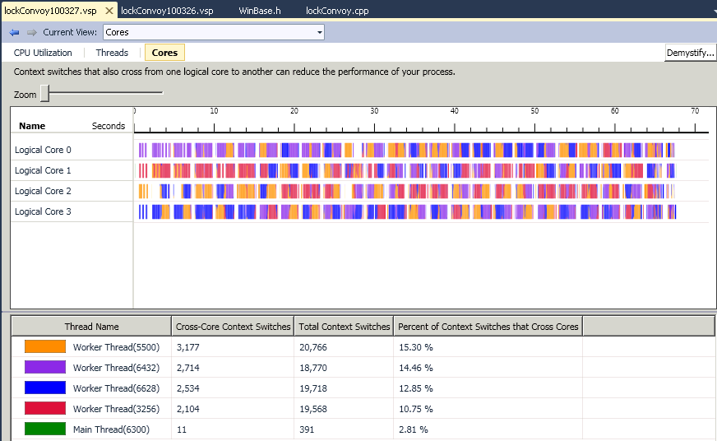
     2. Figure
     3. Cores view
     4. **Note:** Even on the cores view you can appreciate how the application is well utilizing the four cores available on this demo machine.
  10. After doing the Extra credits close all the windows.

### Part 5: Extra Credit

Under Critical Sections the first task to obtain the lock control, have the most chances to obtain it again if it is necessary. This happens because it is the first thread available after the lock is release, while the other need to be awake. This special behavior of Critical Section locks results in lock contention. Identify this behavior using the Parallel debugger tools. The Parallel Stacks and the Parallel Performance Analyzer will show you the new behavior of the application.

In order to use Critical Sections comment out the LOCK_CONVOY_FIX preprocessor declaration and uncomment the LOCK_CONVOY_EXTRACREDIT definition.

* 1. C++

//#define LOCK_CONVOY_EXAMPLE 1

//#define LOCK_CONVOY_FIX 2

#define LOCK_CONVOY_EXTRACREDIT 3

This will enable the original code with the lock convoy, but this time the assembleHardware is commented in order to simulate a situation where the critical area is always required by all the threads, including the one that has just released it.

* 1. C++

#ifdef LOCK_CONVOY_EXTRACREDIT

while(i_serialNumber<10){

//assembleHardware();

EnterCriticalSection(&g_CriticalSection); //For Critical Section use

installingSoftware();

Sleep(500);

installingSoftware();

std::cout << "Assembly Line " << assemblyLineID << " finish creating machine:" << i_serialNumber << std::endl;

i_serialNumber++;

LeaveCriticalSection(&g_CriticalSection); //For Critical Section use

}

#endif

Try to identify and visualize this lock contention plus critical sections problem using the parallel debugger and the concurrent profiler

* 1. 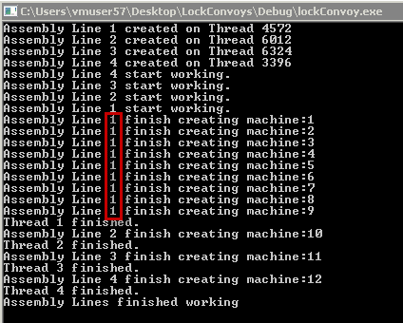
  2. Figure
  3. Execution under lock contention
  4. 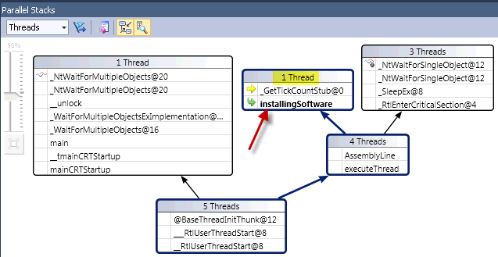
  5. Figure
  6. Parallel Stacks under lock contention
  7. 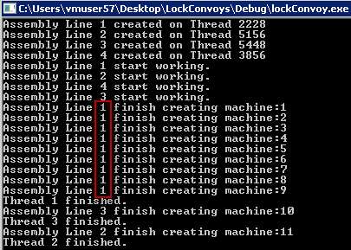
  8. Figure
  9. Threads ids running for Parallel Performance Analyzer
  10. 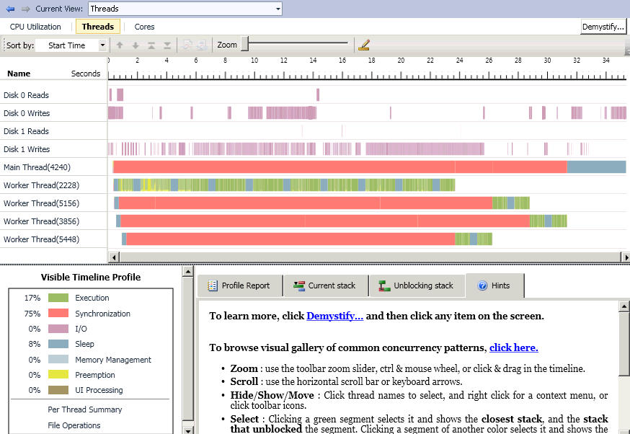
  11. Figure
  12. Threads View under lock contention

You could investigate on a non/locking algorithm or find a solution as a critical section size reduction to solve the problem.

* 1. 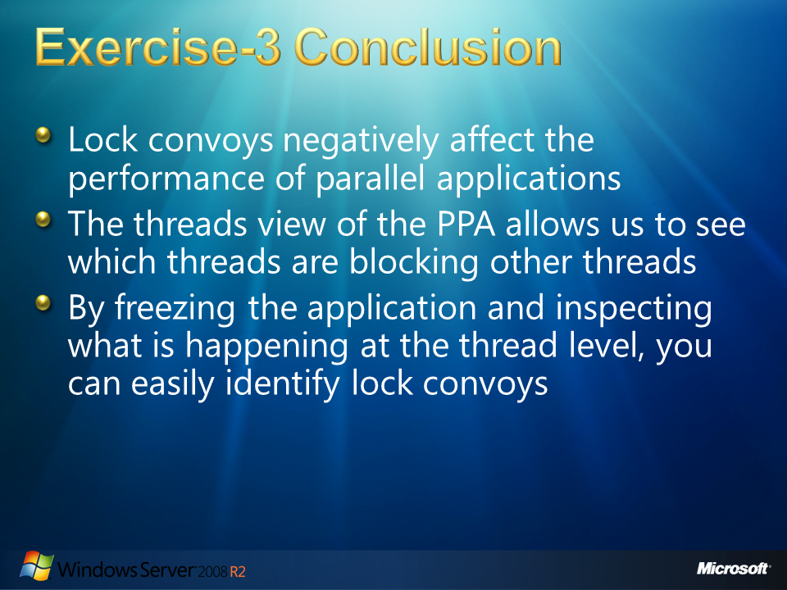
  2. Figure

### Exercise-3 Conclusion

Lock convoys cause multithreaded applications executes serially even though several threads and sufficient logical cores are available. Threads view, under Parallel Performance Analyzer gives us the information on which thread is blocking other threads and visually shows us if the waiting time is small or huge, fair or unfair. You can see the profile report on the threads view to have another representation of each thread overall work.

* 1. Lock convoys occur when multiple threads repeatedly compete for the same protected region and that region contains an important amount of computation or holds for an important time.
  2. We saw how even if a thread goes to sleep inside a lock other threads will wait until the locking threads wakes up and finish its critical section.
  3. Parallel debugging tools such as the Parallel Stacks helps us to understand parallelized thread stacks in a particular moment by freezing the application. You can use this window to follow back all the history of each thread. Having a complete idea of what is happening in each moment we can run and break the application several times to identify parallelization problems. Conditions such as the lock convoys can be traced using the Parallel Stacks because their behavior tends to be so frequent that each time you break the application, chances are that some threads will be in a lock convoy situation. Once the lock was fixed convoy problem it was finding a thread waiting for the lock was not a common condition in our application.
  4. 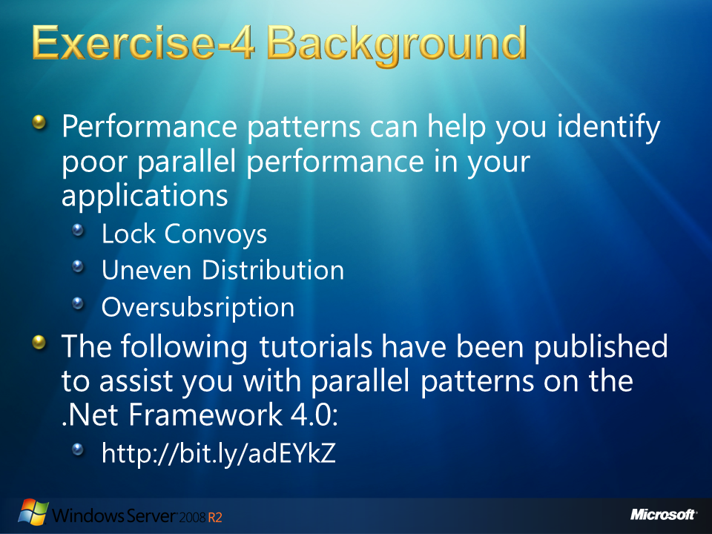
  5. Figure

# Exercise-4 Background

* 1. Performance patterns are one of the most important things you must pay attention when tuning a multithreaded application. There is a set of common poor performance patterns that most developers could encounter when programming a multithreaded applications. For example, the following issues can be easily identified by observing their behavior in the PPA: serialization, lock convoys, uneven workload distribution, and oversubscription. Some of these poor parallel performance patterns are analyzed in this lab but you can find further information of these patterns on the Rogues Gallery at the MSDN site: <http://msdn.microsoft.com/en-us/library/ee329530(VS.100).aspx>

1. Microsoft has also published two tutorials on the parallel patterns in the .Net framework 4, one for Visual Basic and the other covering C#. These guides provide an introduction to the potential pitfalls of parallel programming and how to avoid them: <http://www.microsoft.com/downloads/details.aspx?FamilyID=86b3d32b-ad26-4bb8-a3ae-c1637026c3ee&displaylang=en#filelist>
   1. 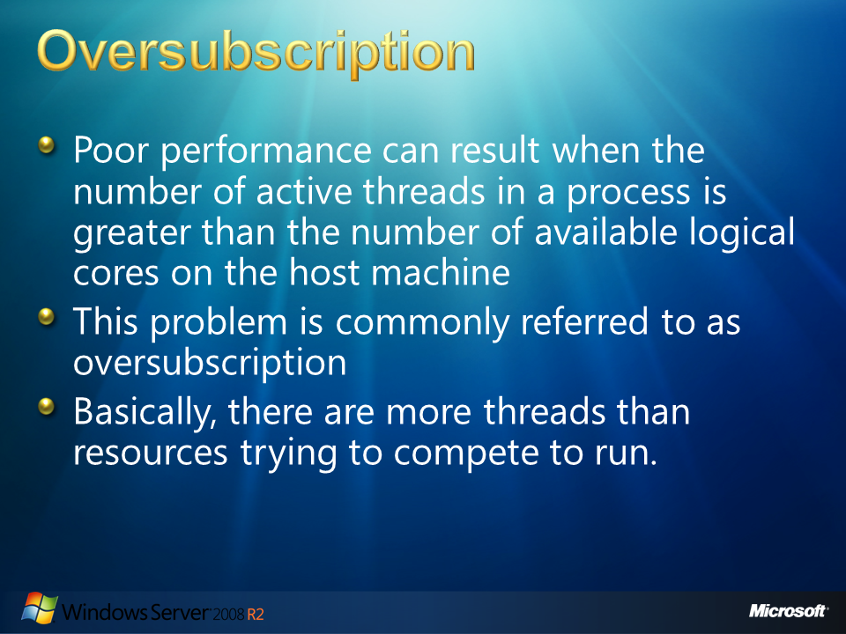
   2. Figure

## Oversubscription

* 1. Poor performance can result when the number of active threads in a process is greater than the number of available logical cores on the host machine. This problem is commonly known as **oversubscription**. When a greater number of threads are trying to run on a less number of available logical cores, over-decomposition of the workload leads to additional unnecessary context switches.
  2. 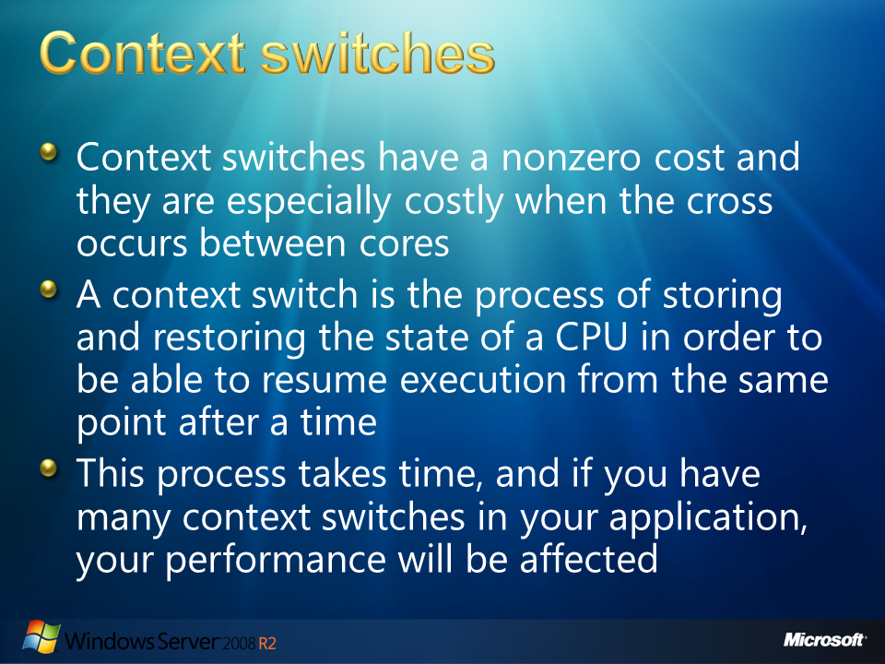
  3. Figure

## Context switches

* 1. Context switches have a nonzero cost and they are especially costly when the cross occurs between cores. A context switch is the process of storing and restoring the state of a CPU in order to be able to resume execution from the same point after a time. Context switching enables multiple processes to share a single CPU resource or to jump between cores on systems with multiple cores. Switching from one process to another requires a certain amount of time for doing the administration (for example, saving and loading registers and memory maps, and updating tables and lists).
  2. 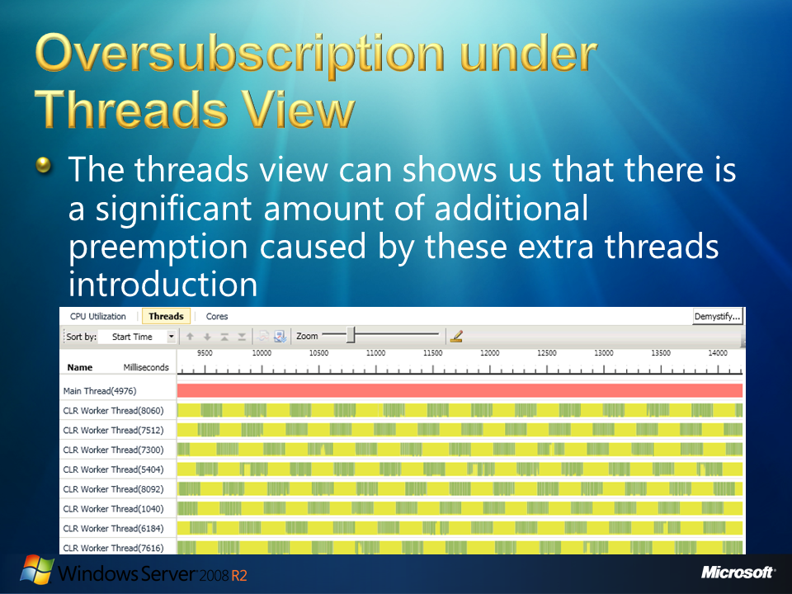
  3. Figure

## Oversubscription under Threads View

* 1. Oversubscription presents a significant preemption banding in all active threads. The threads view can shows us that there is a significant amount of additional preemption caused by these extra threads introduction. An important portion of thread time is spent waiting for resources to be available.
  2. 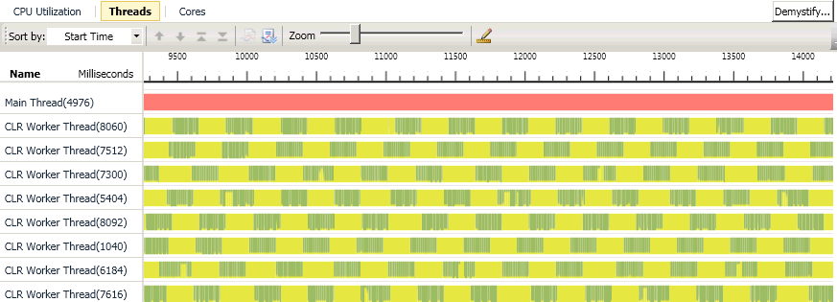
  3. Figure
  4. Threads view - preemption caused by extra threads.
  5. Even under the right amount of threads there is a bit of preemption due to the CPU contention of other processes running on the system. But, due to the increased context switching caused by the additional number threads, the extra-threaded implementation could run slower. If your algorithm lends itself to parallelization and there is no necessity to create more threads than there are cores, probably it will be best to avoid oversubscription unless further analysis proves you that oversubscription will give you better results. For example, one thread per CPU is a good idea on CPU-bound computations. But, if your program interleaves synchronous IO with the computations, the fraction of time spent by the thread waiting could be use by other oversubscribed threads. Only careful measurements can provide you with the right number of threads when tuning oversubscription on your application and Visual Studio 2010 provides you with the necessary tools.
  6. A large percentage of time being spent in Preemption may indicate that the process is asking the system to execute more concurrent threads than the number of logical cores. You can see this percentage on the legend of the Threads View in the Parallel Performance Analyzer. But be careful, this may also indicate that other processes on the system are consuming resources that were assumed to be available to this process.
  7. 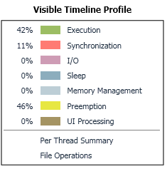
  8. Figure
  9. Threads view Legend - Significant preemption banding

When evaluating oversubscription on your application, you must:

* + Consider that the overall system may be oversubscribed. Other processes on the system may be preempting your threads. In order to analyze this behavior, hover over a preemption segment in the threads view, a tooltip will identify the thread and the process that preempted the thread. This will not necessarily be the process that executed during all the preemptions, but trying on different preemption areas will provides you a hint about what is behind the preemption.
  + Evaluate how your process determines the number of threads to use. If your process is directly calculating the number of active parallel threads, consider modifying the algorithm to better account for the number of available logical cores on the system. Libraries like the Concurrency Runtime, the Task Parallel Library, or PLINQ, perform the work of calculating the number of threads for you.
  1. 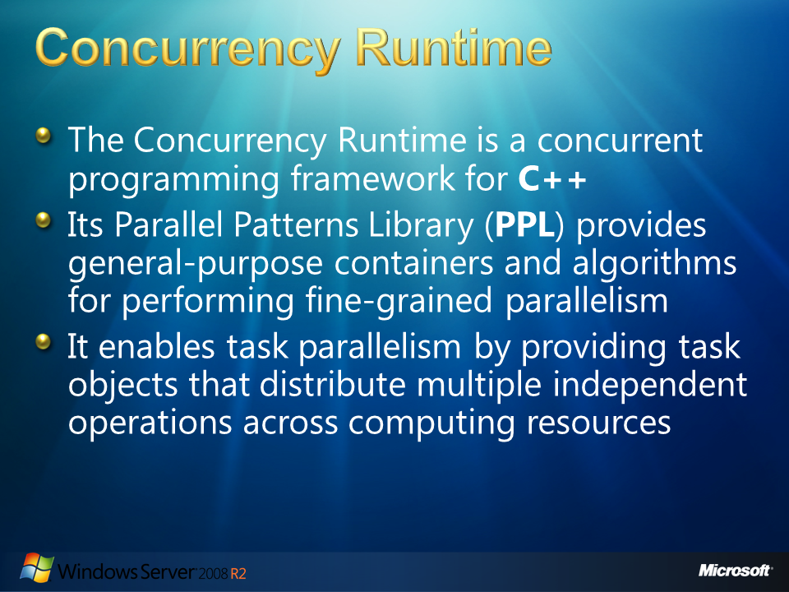
  2. Figure

## Concurrency Runtime

The Concurrency Runtime is a concurrent programming framework for **C++**. The Concurrency Runtime simplifies parallel programming helping you to write robust, scalable, and responsive parallel applications. Its Parallel Patterns Library (**PPL**) provides general-purpose containers and algorithms for performing fine-grained parallelism. The PPL enables imperative data parallelism by providing parallel algorithms that distribute computations on collections or on sets of data across computing resources. It enables task parallelism by providing task objects that distribute multiple independent operations across computing resources. For example, you can use the **parallel_for** algorithm to transform an existing **for** loop to act in parallel. Information on the Concurrency Runtime is available at the MSDN site:

<http://msdn.microsoft.com/en-us/library/dd504870%28VS.100%29.aspx>

* 1. 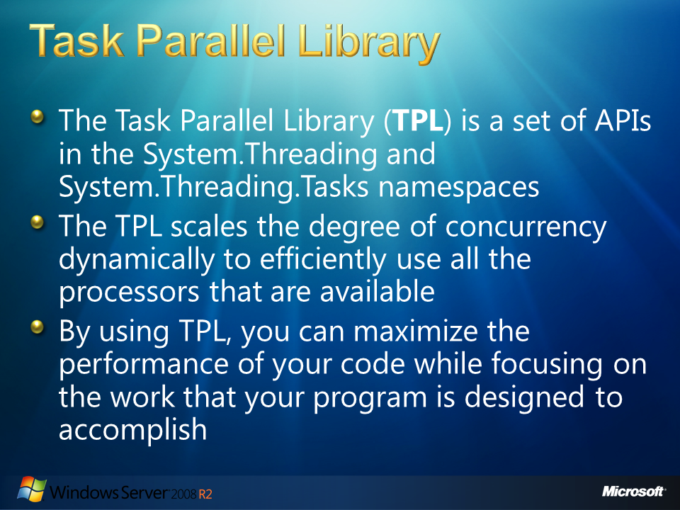
  2. Figure

## Task Parallel Library

The Task Parallel Library (**TPL**) is a set of public types and APIs in the System.Threading and System.Threading.Tasks namespaces in the .NET Framework version 4. The purpose of the TPL is to simplify the process of adding parallelism and concurrency to applications. The TPL scales the degree of concurrency dynamically to efficiently use all the processors that are available. In addition, the TPL handles the partitioning of the work, the scheduling of threads on the ThreadPool, cancellation support, state management, and other low-level details. By using TPL, you can maximize the performance of your code while focusing on the work that your program is designed to accomplish.

Not all codes are suitable for parallelization. For example, if a loop performs only a small amount of work on each iteration, or it doesn't run for many iterations, then the overhead of parallelization can cause the code to run more slowly. Information on the TPL can be found on the MSDN site: <http://msdn.microsoft.com/en-us/library/dd460717(v=VS.100).aspx>

The **Parallel.Invoke** method, for example, provides a convenient way to run any number of arbitrary statements concurrently.

* + 1. C#

1. Parallel.Invoke(  
    () => DoSomeWork(),  
    () => DoSomeOtherWork()  
   );

The number of Task instances that are created by Parallel.Invoke is not necessarily equal to the number of delegates that are provided. The TPL may employ various optimizations, especially with large numbers of delegates. For information on Parallel.Invoke visit the MSDN site: <http://msdn.microsoft.com/en-us/library/dd537609(v=VS.100).aspx>

* 1. 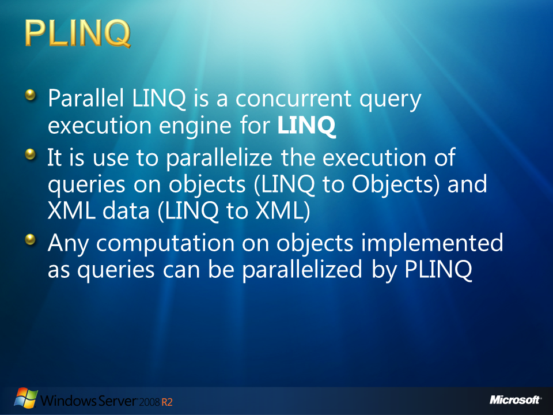
  2. Figure

## PLINQ

* 1. Parallel LINQ is a concurrent query execution engine for **LINQ**. It is use to parallelize the execution of queries on objects (LINQ to Objects) and XML data (LINQ to XML). **PLINQ** is intended for exposing data parallelism using queries. Any computation on objects implemented as queries can be parallelized by PLINQ. Information on PLINQ is available at the MSDN site: http://msdn.microsoft.com/en-us/magazine/cc163329.aspx
  2. 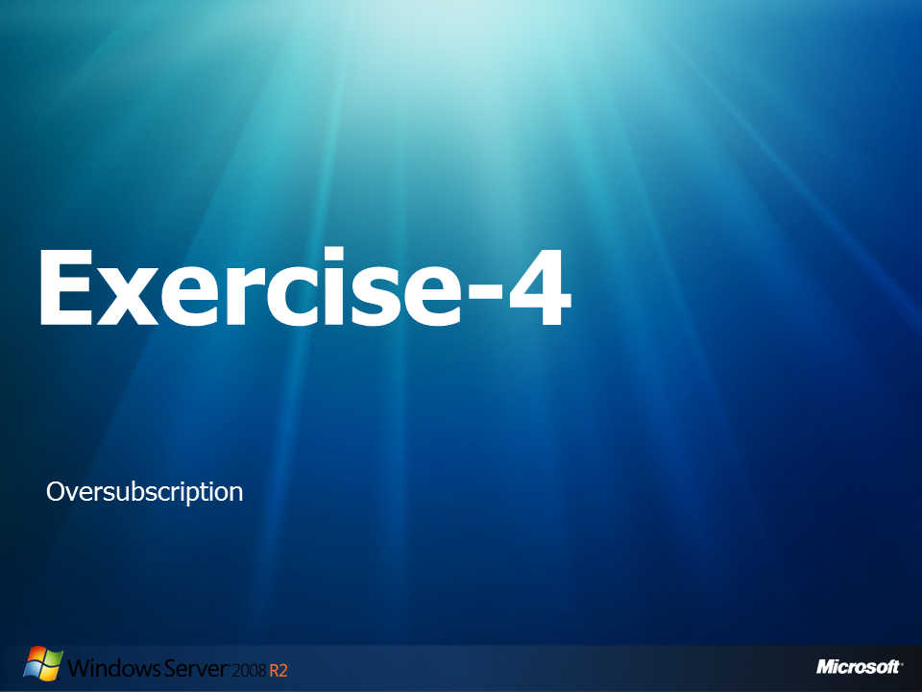
  3. Figure

## Exercise-4: Oversubscription

* 1. In this exercise, we will analyze an application that apparently uses the available CPUs power from the host machine efficiently. Then, we will analyze the application using the Parallel Debugger and the Parallel Performance Analyzer. We will identify an oversubscription pattern. We will start tuning the application up. After modifications, you will see how the application starts using the available cores power more efficiently, by tuning the number of threads created for the calculations.
  2. You will see how identify the preemption caused by oversubscription, how to identified the pattern of oversubscription, and how to use the debugging tools from the Visual Studio 2010, in order to gather the most information of the application, to understand the big picture.

### Part 1: Running the application

* 1. Open **Microsoft Visual Studio 10.0** as administrator:
     1. 
     2. Figure
     3. Run as administrator option
  2. Navigate to **File -> Open -> Project Solution** and open the solution that will be used in this lab:
     1. C:\Server 2008 R2 Labs\Solving Concurrency Issues\Exercise-4\Oversubscription.sln
  3. From the Solution Explorer, double click the **Program.cs** file.
     1. **Note:** This application is going to calculate PI numbers for an indicated global amount of times. In order to finish these calculations efficiently threads are being used. The problem for use is to determine how many threads we should use. In order to calibrate the application, and identify oversubscription we will use the Threads View from the concurrency visualizer.
  4. Navigate to the **main** function of the **MainThread** class and examine the source code.
     1. C#

public static int count=1;

public static int Max_count = 100;

const int ThreadCount = 8;

public static void Main()

{

Stopwatch watch = new Stopwatch();

Thread[] t = new Thread[ThreadCount];

//Take the time for the excecution

watch.Start();

Console.WriteLine("Main thread starting.");

//Create the threads and start execution

for (int k = 0; k < ThreadCount; k++)

{

string name = "Thread #" + (k + 1);

MyThread mt1 = new MyThread(name);

t[k] = mt1.thrd;

}

// wait for all the Threads to finish

for (int k = 0; k < ThreadCount; k++)

{

t[k].Join();

}

...

* + 1. **Note:** First we create an array of threads. 8 threads of type MyThread are created. We wait until all threads have finished invoking the **Join** method on every created thread.
  1. Navigate to the **run** function defined in the **MyThread** class and examine the source code.
     1. C#

// Entry point of thread.

void run()

{

int num_steps = 100000000; //Number of PI decimal digits to calculate

double localcount = 0.0;

Console.WriteLine(" " + thrd.Name + " starting.");

while(true)

{

//Each thread calculates PI numbers, until MainThread.Max_count PI numbers have been calculate between all the threads

localcount = MainThread.count++;

if (localcount <= MainThread.Max_count)

{

double sum = 0.0;

double step = 1.0 / (double)num_steps;

//Calculate PI number:

for (int i = 0; i < num_steps; i++)

{

double x = (i + 0.5) * step;

sum = sum + 4.0 / (1.0 + x * x);

}

Console.WriteLine(localcount + ") In " + thrd.Name + ", PI is " + step * sum);

}

else break;

}

Console.WriteLine(thrd.Name + " terminating.");

}

* + 1. **Note**: Every time a thread of the **MyThread** class is created, it will loop calculating the PI number on each cycle until the amount of calculated Pi numbers gets up to **MainThread.Max_count**. The PI number is calculated by a **for** loop (highlighted in the previous code) and the PI number is then printed to the console.
  1. **Rebuild** the solution and run the code by selecting **Build🡪Rebuild Solution** and then **Debug🡪Start Without Debugging**, from the main menu.
     1. 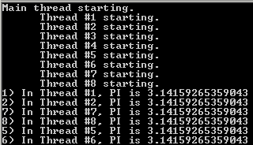
     2. Figure
     3. Normal Execution – Begins
     4. 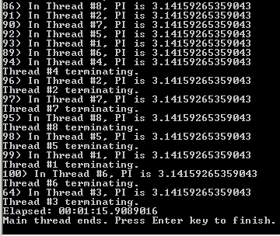
     5. Figure

Normal Execution – Ends

* + 1. **Note:** Even when everything seems to be working fine, it is always good to see our application behavior under the Threads View. This will provides us with a big picture where we could identify known patterns or possible tune-ups.
  1. Press **Enter** to finish the execution once the program finishes.

### Part 2: Debugging the Application

* 1. Switch back to Visual Studio and select **Debug 🡪 Start Debugging**, from the main menu.
     1. **Note:** Wait until the application has created the 8 threads and the threads have started calculating PI numbers.
     2. 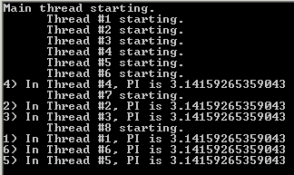
     3. Figure

8 threads were created

* 1. Switch back to Visual Studio and **pause** the execution.
     1. 
     2. Figure

Break All option pauses execution for debugging

* 1. Select **Debug 🡪 Windows 🡪Parallel Stacks**.
     1. 
     2. Figure
     3. Opening Parallel Stacks Window
     4. **Note:** Make sure that you have the **Threads** view selected.
  2. 
  3. Figure
  4. Threads View selected
     1. **Note:** On the Parallel Stacks, on this particular application, you can see how two threads were created (HostPrc.RunParkingWindowThread and SystemEvents.WindowThreadProc). These are properly of the use of threads on the application. The Main thread is waiting for the child threads to finish on the **join**. Finally, our 8 threads are executing the PI calculation.
     2. 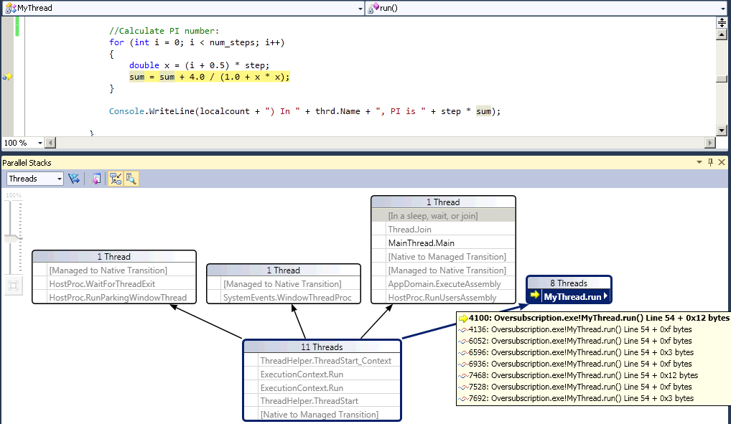
     3. Figure
     4. Parallel Stacks – Threads
     5. **Note:** Just by this scene we can see how 11 threads are being created. 8 of them are highly demanding processor computations. The current demo machine has 4 cores, so we could know by now that more threads than cores are being executing at this moment. Now we must proceed to understand the pattern of our application under the threads view in order to see if we are using the right amount of threads or to discover that this oversubscription is not the proper approach.
  5. Select **Debug🡪Stop Debugging**.

### Part 3: Using the Performance Profiler Analyzer

* 1. Select **Analyze**🡪**Launch Performance Wizard…**
     1. 
     2. Figure
     3. Launch Performance Wizard option
  2. On the **Performance Wizard** window select **Concurrency** and then **check** the option for **Visualize the behavior of a multithreaded application**.
     1. 
     2. Figure

Visualize the behavior of a multithreaded application

* 1. Click **next**.
  2. On the Page 2, also click **next**.
     1. 
     2. Figure

Next on page 2

* 1. On page three, make sure that the **Launch profiling after the wizard finishes** option is select and click **Finish.**
     1. 
     2. Figure

Click finish on third page

* + 1. **Note:** The application executes while it is analyzed.
    2. 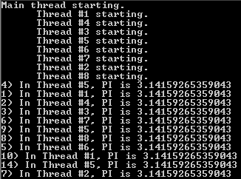
    3. Figure

Application running

* 1. Press the **Enter** key as soon as the application finishes.
     1. **Note:** After a while the Concurrency Visualization window shows the results.
  2. Click on the CPU Utilization view
     1. 
     2. Figure

CPU Utilization option

* + 1. **Note:** The CPU Utilization view indicates a very good use of the 4 cores available on our Demo machine. The Average CPU utilization, for our application process, is indicated as 87%. Normally, this percentage is a good indicator, meaning that this demo machine required all its processing power for our application. But under oversubscription we will also find highly demand of the available CPUs.
    2. 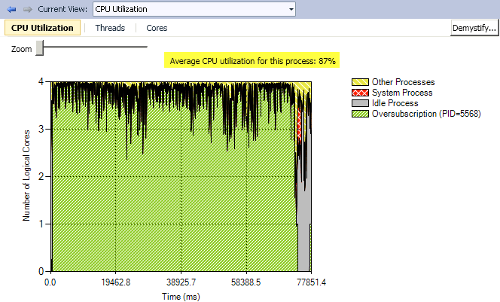
    3. Figure

CPU Utilization view – high demand of the CPU power

* 1. Click on the Threads view.
     1. 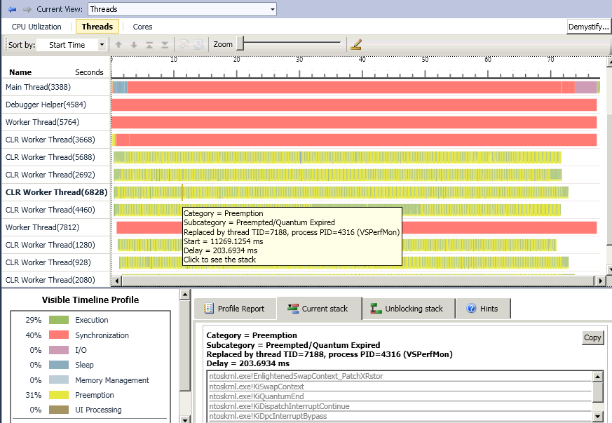
     2. Figure
     3. Threads View – Showing preemption
     4. **Note:** The Threads view shows the 8 threads we created (identified as CLR Threads). This view tells us that a lot of preemption took place on our threads execution. Yellow indicates preemption and you can see more yellow than green (indicating execution) along the threads life. The Visible Timeline Profile legend, at the lower left, indicates a total preemption of 31%, 40 % of synchronization and just 20% of execution. Having this big picture we know that calibration could be applied to the amount of threads created by our application.
     5. You could also zoom in this view and click on execution or preemption areas to see the current stack, from which you can jump to the responsible code, on the **Current stack** tab; or select a Synchronization area to see the unblocking stack on the **Unblocking stack** tab. Try to explore all this information, understanding as much information of your application will give you the right perspective in order to better tune your application.
  2. Click on the **Cores** view.
     1. 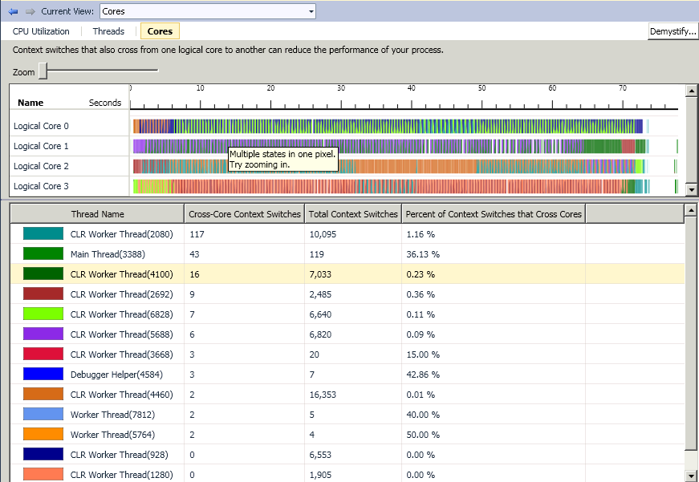
     2. Figure
     3. Cores View – Multiple threads on each logical cores

**Note:** The cores view shows us that this demo machine is executing lots of threads on every logical core. You can see how this could probably be an effect of the preemption we identified on the previous view. **Cross-Core Context Switches** column shows us the context switches between logical cores for each thread, remember these are especially costly. Pay attention to the **Total Context Switches** column, and the **Percent of Context Switches that Cross Cores** column.

### Part 4: Tune up the application

* 1. Switch back to the **Program.cs** file on Visual Studio.
  2. On the **MainThread** class change the **ThreadCount**  number from 8 to 4.
     1. 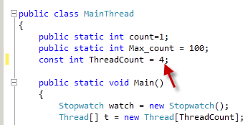
     2. Figure
     3. Using 4 Threads instead of 8
  3. Save the file.
  4. Use **Build🡪Rebuild Solution** to compile the code.
  5. Select **Debug🡪Start Without Debugging**
     1. 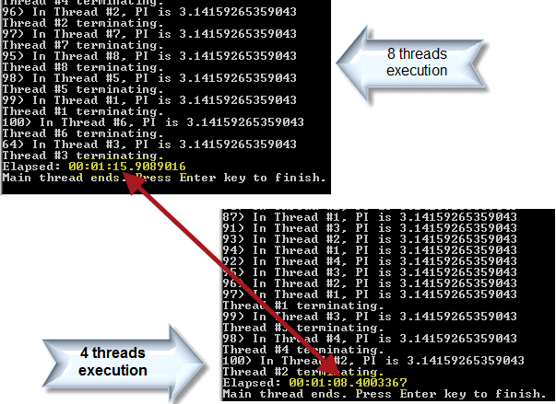
     2. Figure
     3. Application execution using 4 threads
     4. **Note:** The application executes faster when using fewer threads.
  6. Press the **Enter** key to finish the execution.
  7. Switch back to Visual Studio and select **Debug 🡪 Start Debugging**, from the main menu.
     1. **Note:** Wait until the application has created the threads and have calculated some PI numbers.
  8. Switch back to Visual Studio and **pause** the execution.
     1. 
     2. Figure

Break All option pauses execution for debugging

* 1. Select **Debug🡪Parallel Stacks**.
     1. **Note:** Make sure that you have the **Threads** view selected.
     2. 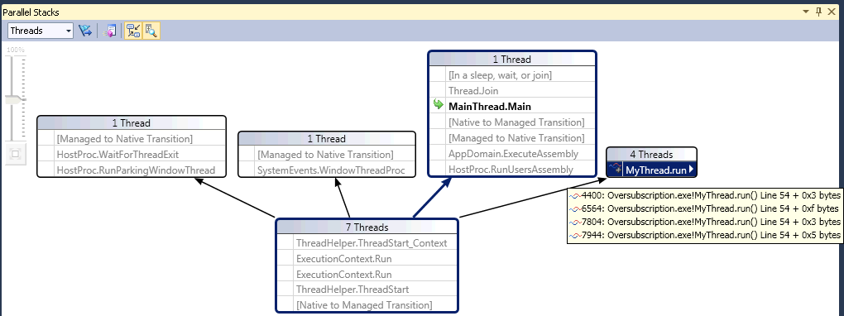
     3. Figure
     4. Parallel Stacks – 4 threads created for the calculation
     5. **Note:** This time the Parallel Stacks window shows 4 threads created for the PI calculations. The symbol near the **MyThread.run** method indicates the concurrent execution of the four threads. We know our demo machine has 4 cores; it should be able to execute the four threads without any problem.
     6. You can explore further on this view, jump to the code and analyze other states of execution by continuing execution and breaking it until you understand the new behavior.
  2. Select **Debug🡪Stop Debugging**.
  3. Select **Analyze🡪Launch Performance Wizard…**
  4. On the **Performance Wizard** window select **Concurrency** and **check** the **Visualize the behavior of a multithreaded application** option.
  5. Click **Next**.
  6. On the Page 2, also click **next**.
  7. On page three, make sure that the **Launch profiling after the wizard finishes** option is select and click **Finish.**
  8. Press **Enter** key as soon as the application finish.
     1. **Note:** Wait until the Concurrency Visualization window shows the results.
  9. Click on the CPU Utilization view
     1. 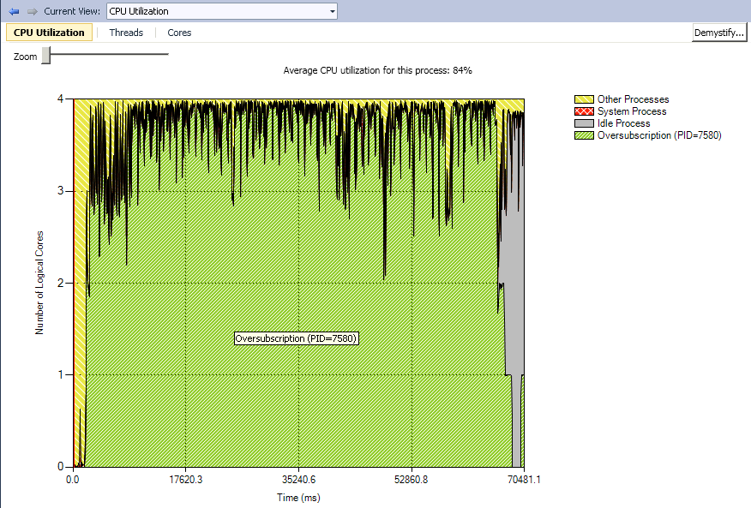
     2. Figure
     3. CPU Utilization under 4 threads
     4. **Note:** This time the Average CPU utilization for the process seems to be very similar. This percentage could vary depending on the time you spend before pressing the Enter key at the end of the application execution. One possibility in order to reduce noise when analyzing your applications could be to temporarily remove these kinds of interactions with users. This way, you will directly analyze the behavior of the area of the code you are interested in.
  10. Click on the Threads view
      1. 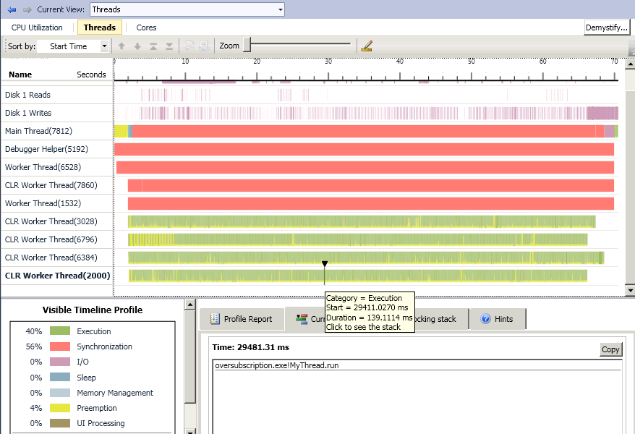
      2. Figure
      3. Threads view using 4 threads
      4. **Note:** This time the preemption was reduced from 31% to 4%. Execution increased from 29% to 40%. The green areas are visually greater than the yellow areas. Synchronization has increased from 40% to 56%, this increase suggests us that further analysis is required in order to understand the reason or in order to better tune up our application.
      5. You can still identify preemption on this demo machine, probably caused by the **Disk1 Reads** and **Disk1 Writes** , the firsts two threads on the figure. Using the zoom tool, selecting one of those I/O areas (I/O is represent by this color accordingly to the legend), and going to the **Current stack** tab will give you an idea of what is happening.
      6. 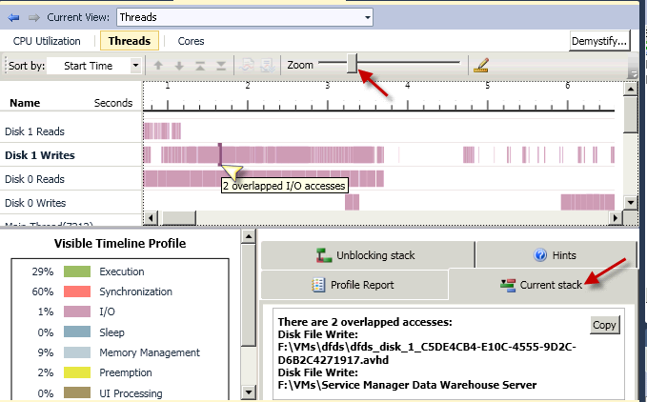
      7. Figure 165
      8. Disk1 Writes seems to be used by a Virtual Machine
      9. **Note:** On the demo machine where this lab was executed, a Virtual machine is contending for resources. Our application may be preempted because of processes from this virtual machine. Probably on your lab machine you will not find a virtual machine, but maybe other applications could be preempting your application try to use the same procedure in order to figure it out.
  11. Click on the **Cores** view
      1. 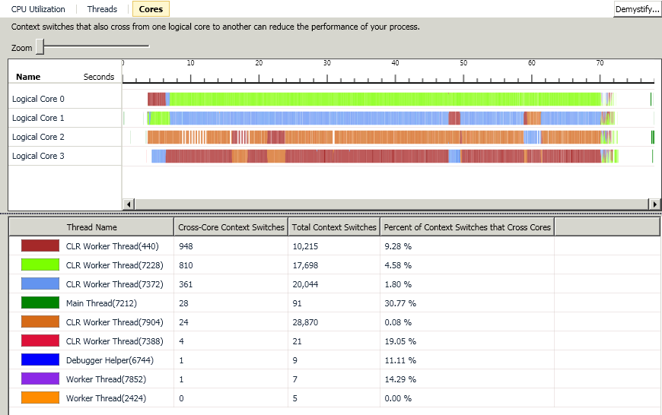
      2. Figure
      3. Cores view under 4 threads
      4. **Note:** On this Cores view, you can visually appreciate a better distribution of the threads on the logical CPUs. Each thread, represented by each color, seems to be executed on a more regular pattern among the logical cores.

### Part 5: Extra Credit

Tuning up an application requires deep analysis and comprehension of the patterns and how the amount of threads affects the pattern and the application performance. Try the following changes, compare the runtime times and analyze their patterns under the Parallel Performance Analyzer:

* 1. Comment out the **Console.WriteLine** around command near line 57. Analyze how it impacts in the overall performance of the application. Also, analyze the impact of this change in the threads preemption using the Concurrency visualizer. Does the change really impact performance? Would the program function better if we had a thread dedicated to console writes?
  2. Try to use different number of threads on **ThreadCount** constant near line 72. Maybe you could tune up the application to obtain better performance.
  3. Imagine what would happen if we join oversubscription problems with lock convoys. Each time a thread attempts to acquire the lock and fails, it loses the remainder of its scheduling quantum and a context switch is forced.   
     The overhead of repeated context switches and underutilization of scheduling quanta degrade overall performance. This could result in lots of threads waking up and failing, in the attempt to acquire the lock.   
     The thread having the lock may also be preempted and have to wait some time while the extra threads context switches takes place.  
     Add a Mutex to protect the code inside the While near line 40 and analyze the results under the concurrency analyzer.  
     1. C#

1. // Entry point of thread.
2. void run()
3. {
4. int num_steps = 100000000; //Number of PI decimal digits to calculate
5. double localcount = 0.0;
6. Console.WriteLine(" " + thrd.Name + " starting.");
7. while(true)
8. {
9. **<lock Mutex Here>** // Generating lock contention
10. localcount = MainThread.count++;
11. if (localcount <= MainThread.Max_count)
12. {
13. double sum = 0.0;
14. double step = 1.0 / (double)num_steps;
16. //Calculate PI number:
17. for (int i = 0; i < num_steps; i++)
18. {
19. double x = (i + 0.5) * step;
20. sum = sum + 4.0 / (1.0 + x * x);
21. }
23. Console.WriteLine(localcount + ") In " + thrd.Name + ", PI is " + step * sum);
24. **<release Mutex Here>** // Generating lock contention
25. }
26. else break;
27. }
28. Console.WriteLine(thrd.Name + " terminating.");
29. }

Remember to use more threads than available cores (for the demo machine used in this lab 8 could be a good idea). You could recognize lock convoy patterns generated by the multiple threads accessing the lock contention code area.

* + 1. C#

public static int count=1;

public static int Max_count = 100;

const int ThreadCount = 8;

public static void Main()

{

Try to use different number of threads and try to reduce lock contention; try to tune up the application lock and threads number to obtain better performance.

* 1. 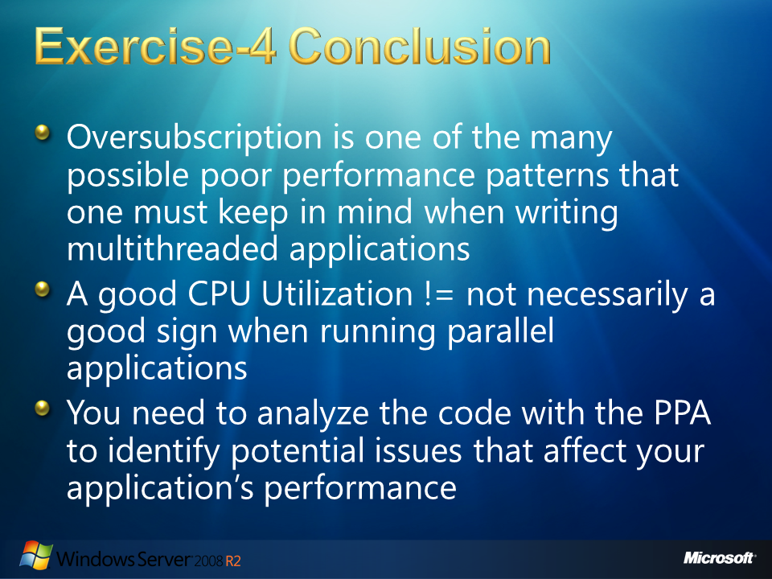
  2. Figure

### Exercise-4 Conclusion

* 1. Oversubscription is one of the many possible poor performance patterns that one must keep in mind when writing multithreaded applications.
  2. It is important to be aware of whether the application is affected by such a poor performance pattern and the Concurrency Visualizer is a great way to quickly identify if your application is afflicted by such a pattern.
  3. Even when you see a good APU utilization under the CPU Utilization view it is possible that the application invests too much CPU power in the overhead of preemption and context switches. As further as we deeply understand the behavior of our application, the better tuning we will be able to apply.
  4. Context switches between logical CPU can also suggest performance improvements opportunities.
  5. The Parallel Stacks window helps us to understand threads creation, and helps us to see that other threads are implicitly created when working under parallelism. We must take care of these threads and the threads created by other processes that run at the same time of our application because these threads may also generate oversubscription.
  6. Sometimes oversubscription improves our application performance. When threads in our application constantly read or write to the disk, or interact with the user, or interrupt as in a sleep, it’s a good opportunity to apply oversubscription of threads to increase performance and throughput.
  7. 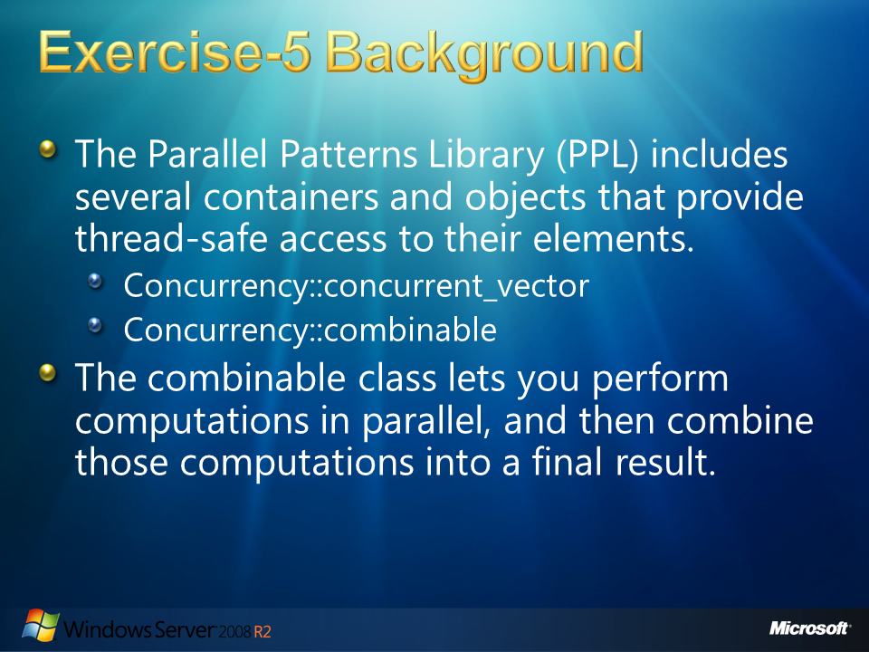
  8. Figure

# Exercise-5 Background

The Parallel Patterns Library (PPL) includes several containers and objects that provide thread-safe access to their elements.

A concurrent container provides concurrency-safe access to the most important operations. The functionality of these containers resembles those that are provided by the Standard Template Library (STL). For example, the Concurrency::concurrent_vector class resembles the std::vector class, except that the concurrent_vector class lets you append elements in parallel. Use concurrent containers when you have parallel code that requires both read and write access to the same container.

A concurrent object is shared concurrently among components. A process that computes the state of a concurrent object in parallel produces the same result as another process that computes the same state serially. The Concurrency::combinable class is one example of a concurrent object type. The combinable class lets you perform computations in parallel, and then combine those computations into a final result. Use concurrent objects when you would otherwise use a synchronization mechanism, for example, a mutex, to synchronize access to a shared variable or resource.

* 1. 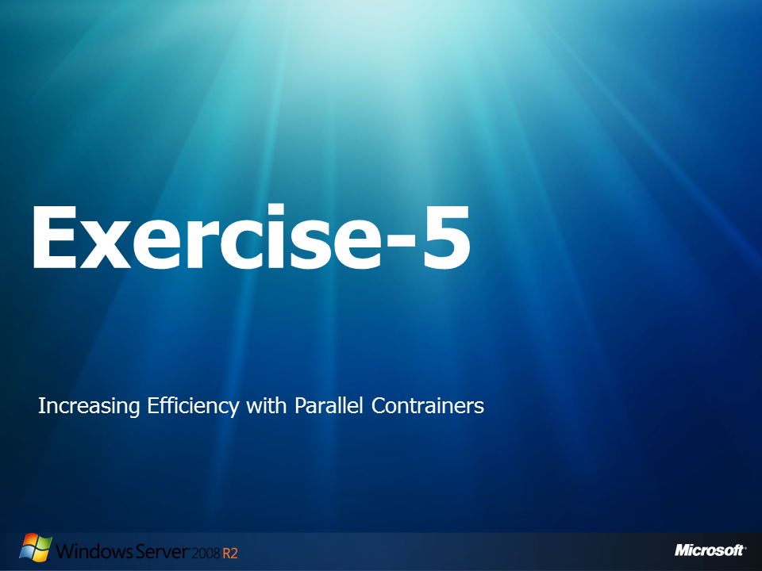
  2. Figure

## Exercise-5: Increasing Efficiency with Parallel Containers

1. In this exercise you will work with a C++ application to visualize how oversubscription would be displayed in the PPA. The application to be used adds all the numbers that are prime from an array and displays the final results in the end. As you will see, even something as trivial as this can impose concurrency issues with the correctness of your application. Furthermore, even after fixing correctness issues other factors may show up that could seriously hinder the performance of your application.

### Part 1: Fixing the Data Race

* 1. Open **Microsoft Visual Studio 10.0** as administrator.
  2. Open the solution that will be used in this lab by double clicking the following file:
     1. C:\Server 2008 R2 Labs\Solving Concurrency Issues\Exercise-5\Exercise-5.sln
  3. From the **Solution Explorer**, double click the **Exercise-5.cpp** file.
  4. Navigate to the main function and examine the source code.
     1. **Note:** The code starts off by generating an array filled with numbers. The sequential version of this array will run first, and will try to find the sum of the all the primes in the array. Once the serial version runs, the parallel version that uses the Concurrency Runtime will run. This method uses a parallel_for_each to spread the work into different sections to run. At this point, you should be able to infer what the problem is with the parallel approach.
  5. **Rebuild** the solution and run the code a couple of times by selecting from the main menu **Debug 🡪 Start Without Debugging**.
     1. **Note:**  Make sure you have a Task Manager open to visualize the work done by the processors.
  6. Compare the results of the parallel sum between the runs – are they the same?
     1. 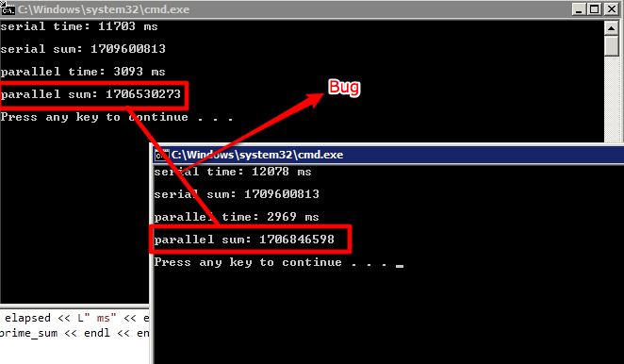
     2. Figure

Different Results Between Each Run

* 1. Close any command windows that the program may have opened.
  2. Let’s quickly fix the code by inserting a critical region into our code. Scroll down around line 61 and insert the following line below the comment that reads” // Now perform the same task in parallel”:
     1. C#
     2. critical_section mutex;
  3. Right before the **sum** variable is modified inside the parallel_for_each, lock the mutex by typing the following line:
     1. C#
     2. mutex.lock();
  4. Write the following line after the line in which the sum variable is modified:
     1. C#
     2. mutex.unlock();
  5. Run the application again by selecting **Start without Debugging** from the **Debug** menu. Do you get the correct result this time? Do you notice any other problems with the application?
     1. **Note:** Even though we got rid of the data race condition that was causing our application to give the incorrect result, our parallel version is taking a lot more time than before. Let’s use the Parallel Performance Analyzer (PPA) to gain a better insight to what the problem might be.
  6. 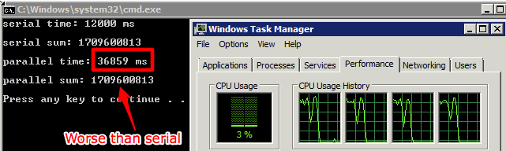
  7. Figure
  8. Performance Issue with Parallel Version

### Part 2: Running the PPA

* 1. Close any command window that Visual Studio may have opened when running the performance tests of the application.
  2. From Visual Studio’s **Analyze** menu, select **Launch Performance Wizard** as shown in the figure below:
     + 1. 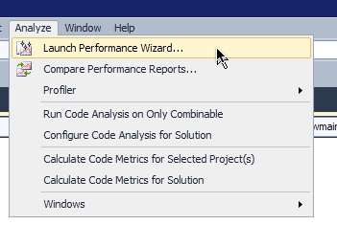
       2. Figure
       3. Launching the Performance Wizard
  3. Select the **Concurrency** radio button and then mark the option to **Visualize the behavior of a multithreaded application** and click **Next:**
     + 1. 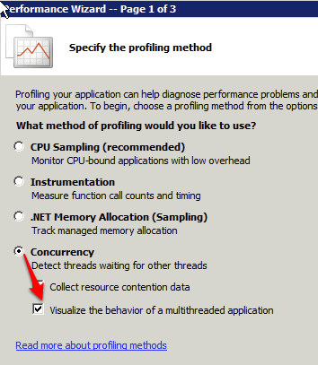
       2. Figure
       3. Selecting the option to visualize the behavior of the application
  4. On the next screen, make sure the **Combinable** project is selected and click **Next**.
  5. On the last screen of the wizard, click the **Finish** button to begin the data collection phase.
  6. Once the PPA finishes, you will be presented with the summary window and the 3 possible views of the application’s profiling: CPU Utilization, Threads, and Cores.
  7. Double-click the CPU Utilization Window
     1. 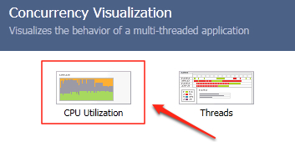
     2. Figure
     3. The available profiling views
  8. In this view, we can clearly see how the first part of the exercise only utilizes a core from the available resources. We can also visualize how the parallel version takes a lot more time than the serial version:
     1. 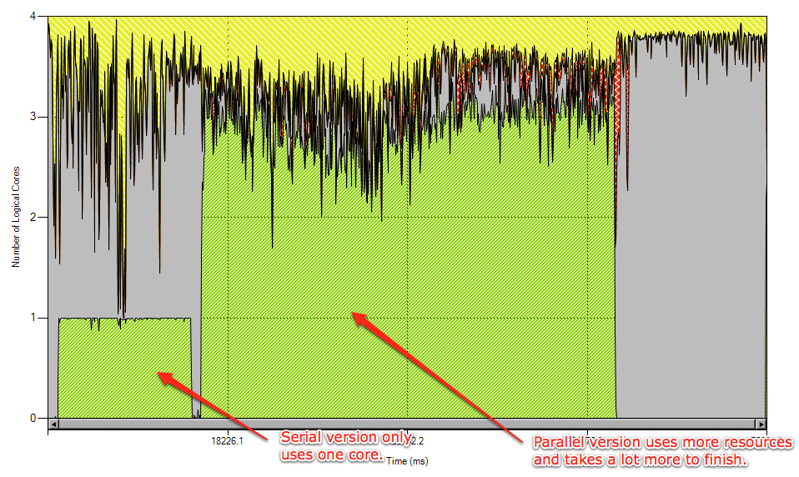
     2. Figure

The CPU Utilization view displays the problem’s behavior, but we need more information to find what is causing this behavior.

* 1. Switch over to the Cores view from the **Current View** menu:
     1. 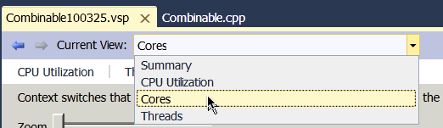
     2. Figure
     3. Select the Cores View
  2. In this view, you can see which are the threads that were carrying out work when you program was running. Write down the process IDs of the threads that ran when the application ran in parallel:
     1. 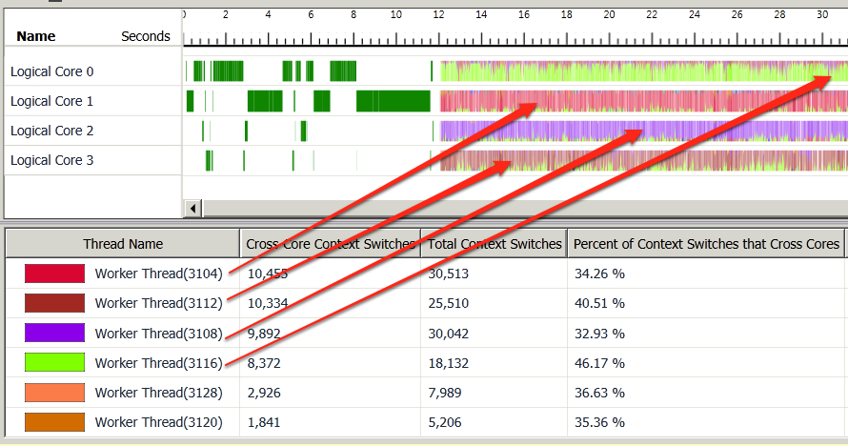
     2. Figure
     3. Match the colors of the legend to the main threads
  3. Switch over to the Threads view.
  4. Hide all the Disk Writes and all threads with the exception of the thread IDs you found in step 13.
  5. Drag the Zoom slider to about 75% as shown below:
     1. 
     2. Figure
     3. Move the slider to the right to about 75%
  6. You should now clearly visualize the problem. All the red that is being displayed is time spent on synchronization. In this case, all 4 threads are waiting for another thread to exit the critical section, and this causes the massive delay that we saw in our program.
     1. 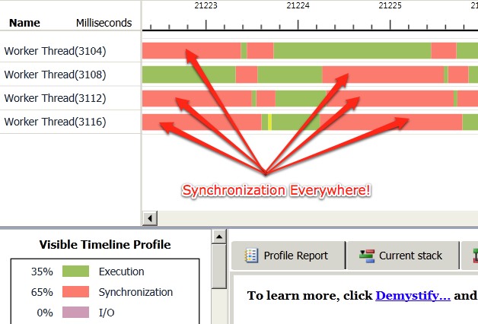
     2. Figure
     3. All threads are spending a great deal of time on synchronization

### Part 3: Fixing the Synchronization Problem

1. Switch back to the **Combinable.cpp** C++ source code.
2. Scroll down to where the sum variable is defined (around line 60).
3. Comment out the sum declaration by placing two forward slashes in front of the line:
   * 1. C++
     2. //int sum = 0
4. Below this line, type the following Combinable class declaration:
   * 1. C++
     2. combinable<int> sum;
     3. **Note:** The combinable<T> object is intended to provide thread-private copies of data, to perform lock-free thread-local sub-computations during parallel algorithms.
5. Delete the following lines of code from the code:
   * + **critical_section mutex;** (around line 63)
     + **mutex.lock();** (around line 66)
     + **mutex.unlock();** (around line 68)
6. Modify the line where the sum is calculated by invoking the local() function on the sum variable:
   * 1. C++
     2. sum.local() += (is_prime(i) ? i : 0);
     3. **Note:** The local method indicates the local instance of the thread’s variable. In other words, it will change the copy of the sum variable that each thread has.
7. Finally, modify the line where prime_sum is calculated by carrying out the following change:
   * 1. C++
     2. prime_sum = sum.combine(plus<int>());
     3. **Note:**  The combine function will carry out the specified operation (in this case and addition, specified by the plus) of all the local copies of the sum variable. This last step is necessary to join the results of each thread into one final result.
8. Compile the code by selecting **Build** 🡪 **Rebuild Solution** to make sure no errors were made.
9. Run the code one more by selecting **Debug** 🡪 **Start Debugging**.
10. Open the task manager and observe the behavior of the processors:
    * 1. 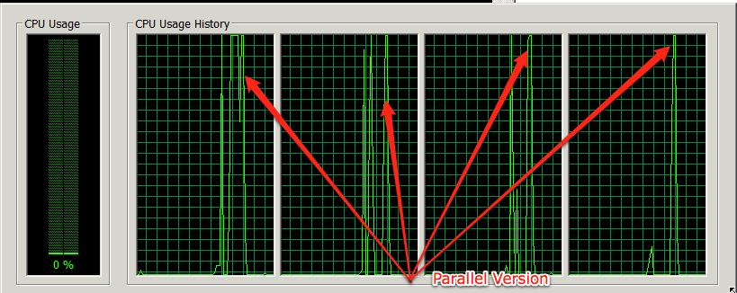
      2. Figure
      3. The parallel version runs for a very short period
11. After the changes we made to the source code, the parallel version is extremely fast and it still yields the correct result:
    * 1. 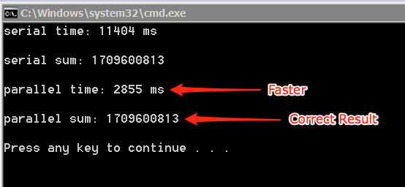
      2. Figure
      3. The parallel version is a lot faster after the combinable changes
    1. 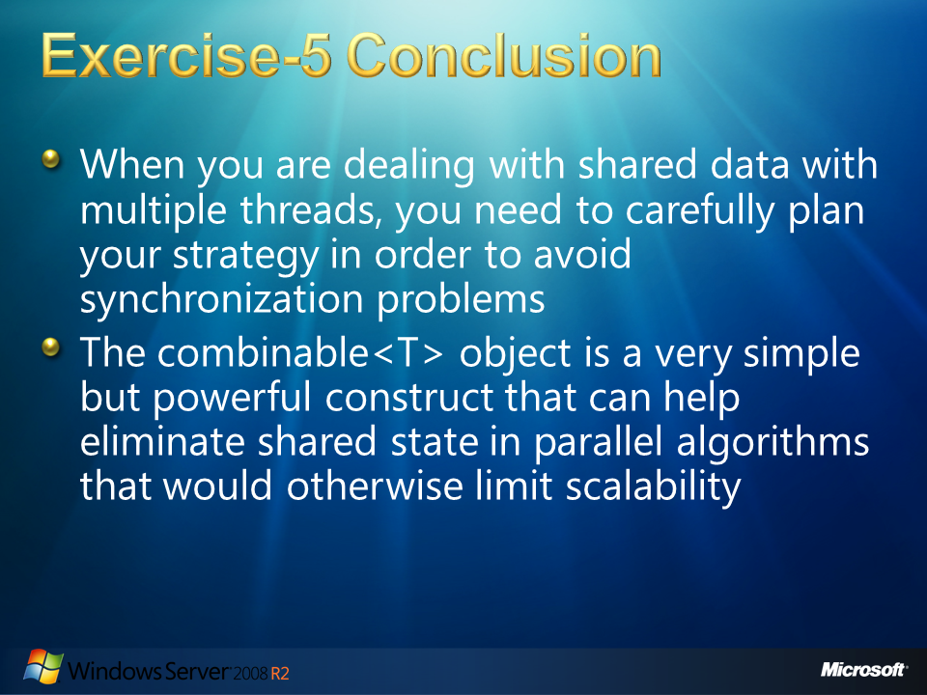
    2. Figure

## Exercise-5 Conclusion

* 1. In this exercise we experienced first-handedly the complexities that may arise when parallelizing code. In the beginning, we saw how easy it was to cause an incorrect behavior of the behavior by adding parallelism. We then saw one way to fix it, but unfortunately this brought more problems that caused the parallel application to perform slower than the serial counterpart. When you are dealing with shared data with multiple threads, you need to carefully plan your strategy in order to avoid synchronization problems.
  2. The combinable<T> object is a very simple but powerful construct that can help eliminate shared state in parallel algorithms that would otherwise limit scalability. It adds very little extra complexity, and can be many times faster than alternative solutions that require traditional synchronization primitives. While it is optimized for use with the Microsoft Parallel Pattern Library, it also works just fine in any other parallel algorithm, whether it’s built on OpenMP or your own hand-rolled threading.
  3. 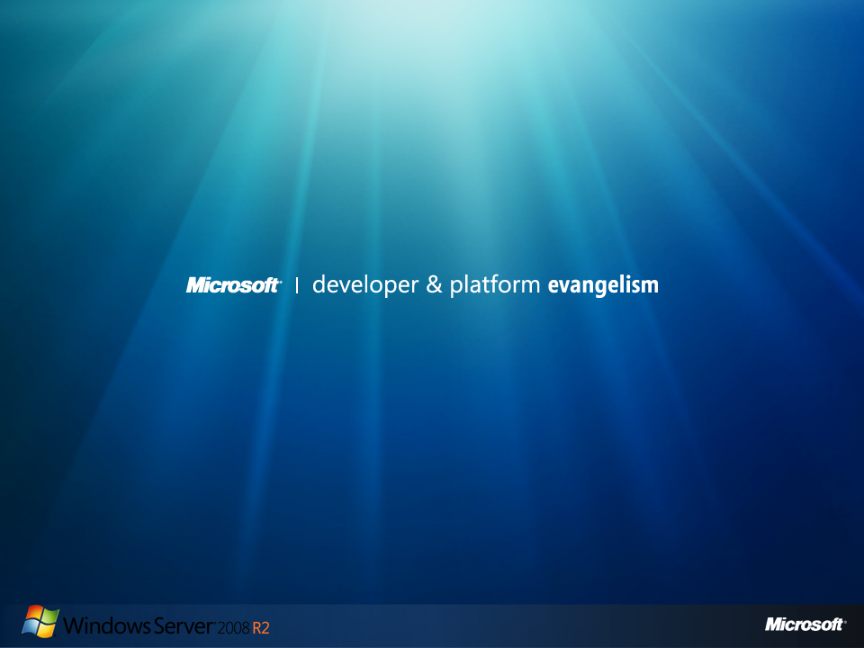
  4. Figure